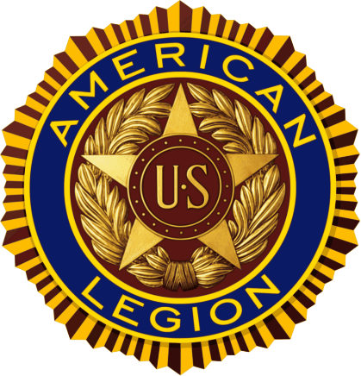

History of
Post 112
The American Legion
Department of Georgia
For July 1, 2024, to June 30, 2025
By Ernie Oventrop, Post Historian


TABLE OF CONTENTS
TOPIC | PAGE
Table of Contents | 2
Introduction | 3
Preamble to the Constitution of the American Legion | 4
Explanation of the Preamble to the Constitution of the American Legion | 5
Chapter 1 - Roster of 2024-2025 Post Officers | 6
Chapter 2 - Roster of Post Chairman | 7
Chapter 3 - One Year Post History | 8-15
Appendix I - Organizational Chart | 16
Appendis II - Past Commanders | 17
Appendix III - Election Results | 18
Appendix IV - Post Constitution | 19-22
Appendix V - Post By-Laws | 23-29
Appendix VI - Munutes of the Executive Committee Meetings | 30-42
Appendix VII - Minutes of the General Membership Meetings | 43-55
Appendix VIII - Monthly Newsletters | 56-79
Index | 80

INTRODUCTION
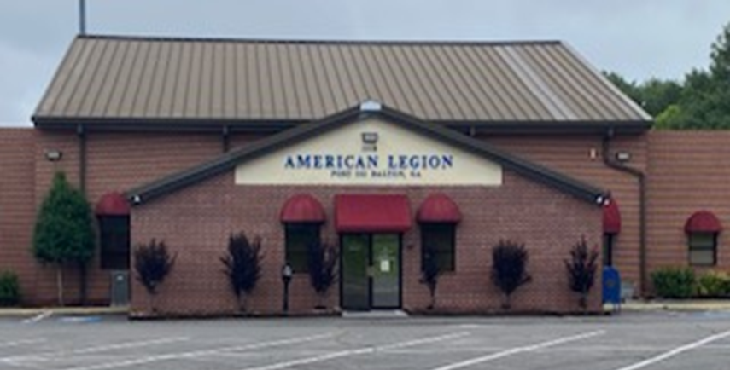

The American Legion was chartered by Congress in 1919 as a patriotic veteran’s organization. Focusing on service to veterans, servicemembers and communities, the Legion evolved from a group of war-weary veterans of World War I into one of the most influential nonprofit groups in the United States. Membership swiftly grew to over 1 million, and local posts sprang up across the country. Today, membership stands at nearly 2 million in more than 13,000 posts worldwide. The posts are organized into 55 departments: one each for the 50 states, along with the District of Columbia, Puerto Rico, France, Mexico, and the Philippines.

Over the years, the Legion has influenced considerable social change in America, won hundreds of benefits for veterans and produced many important programs for children and youth.

American Legion Post 112 is located at 1118 N Glenwood Avenue, Dalton Georgia. Since their charter in 1920, American Legion Post 112 has been welcoming Veterans from all branches of the Armed Forces. Today, they continue to welcome all military personnel serving our country. Joining the Post enables you to continue serving God, Country and Community.

PREAMBLE TO THE CONSTITUTION OF THE
AMERICAN LEGION

FOR GOD AND COUNTRY, WE ASSOCIATE OURSELVES TOGETHER FOR THE FOLLOWING PURPOSES:

To uphold and defend the Constitution of the United States of America

To maintain law and order

To foster and perpetuate a one hundred percent Americanism

To preserve the memories and incidents of our associations in all wars

To inculcate ① a sense of individual obligation to the community, state, and nation

To combat the autocracy of both the classes and the masses

To make right the master of might

To promote peace and goodwill on earth

To safeguard and transmit to posterity the principles of justice, freedom and democracy

To consecrate and sanctify our comradeship by our devotion to mutual helpfulness

① Inculcate – to instill (an attitude, idea, or habit) by persistent instruction

PREAMBLE INTERPRETATION

For God and Country, we associate ourselves together. This establishes a foundation of faith and patriotism, recognizing a higher power and the importance of national allegiance.

To uphold and defend the Constitution of the United States of America. The Legion commits to defending the foundational document of the United States.

To maintain law and order. This highlights the importance of a stable and secure society.

To foster and perpetuate a 100 percent Americanism. The Preamble emphasizes the promotion of a strong sense of American identity and values.

To preserve the memories and incidents of our associations in all wars. This acknowledges the sacrifices and experiences of veterans in past conflicts.

To inculcate a sense of individual obligation to the community, state, and nation. The Preamble calls for a sense of responsibility to the community, state, and nation.

To combat the autocracy of classes and masses. This reflects the Legion’s commitment to democratic principles and opposing oppressive systems.

To make right the master of might. The Preamble emphasizes the desire for peaceful relations and international goodwill.

To promote peace and goodwill on earth. Until the world becomes a good neighborhood, Legionnaires must continue their effort to promote peace and goodwill.

To safeguard and transmit to posterity the principles of justice, freedom, and democracy. The Legion aims to protect and perpetuate the principles of justice, freedom, and democracy.

To consecrate and sanctify our comradeship by our devotion to mutual helpfulness. The Preamble highlights the importance of camaraderie, support, and working together.

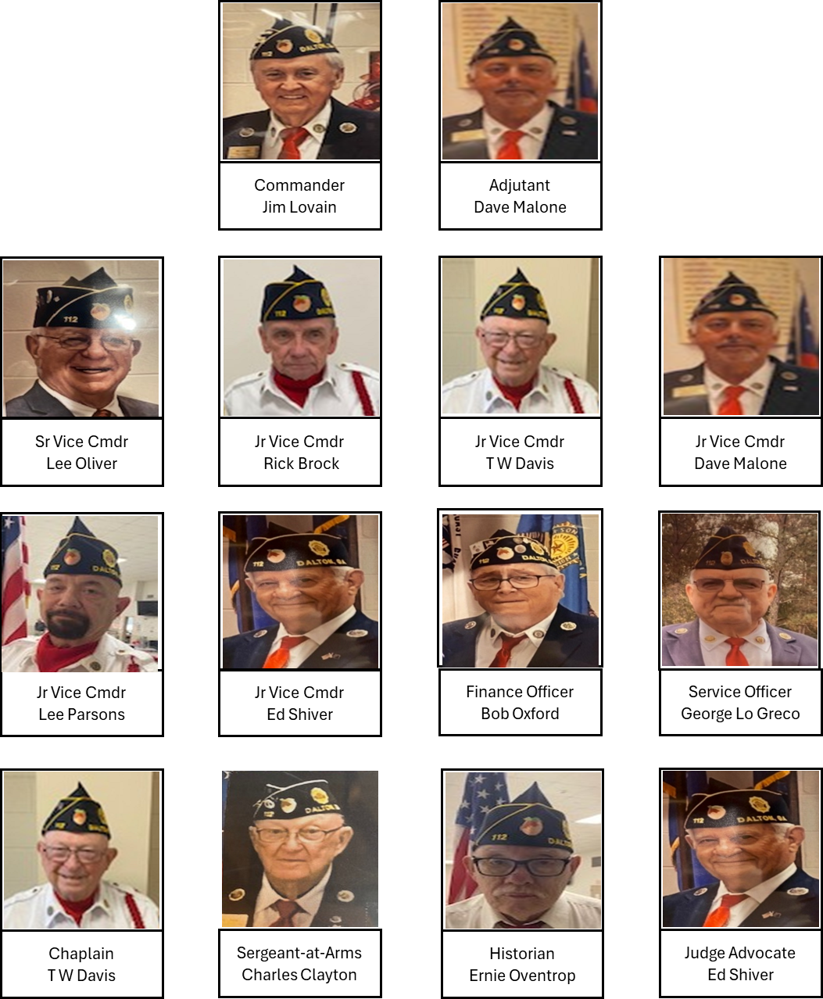

CHAPTER II
ROSTER OF POST CHAIRMAN

COMMITTEE CHAIRMAN

Americanism Committee Rick Brock

Bingo Committee Bob Oxford

Boy’s State Committee Gary Benson

By-Laws Committee Bob Oxford

Finance Committee Bob Oxford

Graves Registration and Memorial Committee T.W. Davis

Investment Committee Jim Lovain

Legislative Committee David Malone

Membership Committee Lee Oliver

Nominating Committee John Czernesk

Sons of the American Legion Committee Anthony Robertson

Veterans Affairs and Rehabilitation Committee George Lo Greco

CHAPTER III
ONE YEAR POST HISTORY

07-04-2024 American Legion Post 112 celebrated Independence Day with its annual picnic, where hamburgers and hotdogs were served to veterans and their families. The Ram Hurst Blues Society provided live entertainment from 6:00 – 8:00 pm and fireworks were enjoyed by all. It was a very good party with great fellowship

07-05-2024 Members of American Legion Post 112’s Honor Guard rendered military funeral honors for Vernon Youell, who faithfully served in the United States Army.

07-06-2024 Members of American Legion Post 112’s Honor Guard rendered military funeral honors for Michael Hill, who faithfully served in the United States Air Force.

07-09-2024 Members of American Legion Post 112’s Honor Guard rendered military funeral honors for James Cline, who faithfully served in the United States Army.

07-10-2024 Members of American Legion Post 112’s Honor Guard rendered military funeral honors for Gerald Molineaux, who faithfully served in the United States Navy.

07-11-2024 Members of American Legion Post 112’s Honor Guard rendered military funeral honors for James Stakely, who faithfully served in the United States Marine Corps.

07-11-2024 American Legion Post 112 Executive Committee convened its regular monthly meeting.

07-12-2024 American Legion Post 112 delivered biscuits to Vets receiving medical care at the VA Clinic in Chattanooga, Tennessee.

07-13-2024 American Legion Post 112 held a Benefit Gospel Concert to raise money to assist the family of seven (7) year old Dash Johnson, who has brain cancer.

07-21-2024 Members of American Legion Post 112’s Honor Guard rendered military funeral honors for Kevin Stanley, who faithfully served in the United States Army.

07-25-2024 American Legion Post 112 convened its regular monthly general membership meeting. Jack Staples, Commander 7th District, Department of Georgia, installed American Legion Post 112’s 2024-2025 officers. Quilts of Valor were presented to Steve Deen, Ed Dewayne, and Grady Shiver

07-25-2024 Members of American Legion Post 112’s Honor Guard rendered military funeral honors for A.J. Lamon, who faithfully served in the United States Army.

08-05-2024 Members of American Legion Post 112’s Honor Guard rendered military funeral honors for Stacie White, who faithfully served in the United States Navy.

08-08-2024 American Legion Post 112 Executive Committee convened its regular monthly meeting.

08-14-2024 Members of American Legion Post 112’s Honor Guard rendered military funeral honors for Earl Thompson, who faithfully served in the United States Army.

08-14-2024 American Legion Post 112 hosted VA Representatives, Kelly Johnson and Elizabeth Humble, who were on-site to assist members with their disability claims

08-16-2024 Members of American Legion Post 112’s Honor Guard rendered military funeral honors for Doug Ivestor, who faithfully served in the United States Navy.

08-17-2024 American Legion Post 112 hosted the American Legion Department of Georgia, District 7 Meeting.

08-22-2024 Members of American Legion Post 112’s Honor Guard rendered military funeral honors for Robert Shipman, who faithfully served in the United States Army.

08-27-2024 Members of American Legion Post 112’s Honor Guard rendered military funeral honors for Mike Riddle, who faithfully served in the United States Navy.

08-29-2024 American Legion Post 112 convened its regular monthly general membership meeting.

09-05-2024 Members of American Legion Post 112’s Honor Guard rendered military funeral honors for Kenneth Eckstein, who faithfully served in the United States Marine Corps.

09-11-2024 American Legion Post 112 delivered biscuits to Vets receiving medical care at the VA Clinic in Chattanooga, Tennessee.

09-12-2024 American Legion Post 112 Executive Committee convened its regular monthly meeting.

09-15-2024 Members of American Legion Post 112’s Honor Guard rendered military funeral honors for Wayne Townsend, who faithfully served in the United States Army.

09-20-2024 Members of American Legion Post 112’s Honor Guard rendered military funeral honors for Larry Joyce, who faithfully served in the United States Army.

09-20-2024 Members of American Legion Post 112’s Honor Guard rendered military funeral honors for Maynard Young, who faithfully served in the United States Army.

09-26-2024 American Legion Post 112 cancelled its regular monthly general membership meeting due to inclement weather.

10-04-2024 Members of American Legion Post 112’s Honor Guard rendered military funeral honors for Jimmie Baker, who faithfully served in the United States Army.

10-05-2024 Members of American Legion Post 112’s Honor Guard rendered military funeral honors for Carrol Davis, who faithfully served in the United States Army.

10-08-2024 Members of American Legion Post 112’s Honor Guard rendered military funeral honors for Doug Brooks, who faithfully served in the United States Navy.

10-10-2024 Members of American Legion Post 112’s Honor Guard rendered military funeral honors for Jacky Hayes, who faithfully served in the United States Navy.

10-10-2024 American Legion Post 112 Executive Committee convened its regular monthly meeting.

10-14-2024 Members of American Legion Post 112’s Honor Guard rendered military funeral honors for Weems White, who faithfully served in the United States Air Force.

10-23-2024 Members of Post 112 served up more than 260 hamburgers and hotdogs to staff and patients at the Chattanooga Outpatient VA Clinic.

10-27-2024 Members of American Legion Post 112’s Honor Guard rendered military funeral honors for William Barnwell, who faithfully served in the United States Army.

10-31-2024 American Legion Post 112 convened its regular monthly general membership meeting. Quilts of Valor were presented to Shannon Bearfield, Charles Clayton, Andrew Hambright, Jon Hiltbrant, Bob Keener, and Charles Ruddell.

11-01-2024 Members of American Legion Post 112’s Honor Guard rendered military funeral honors for Dallas Hall, who faithfully served in the United States Army.

11-09-2024 For nearly 250 years, out courageous and selfless veterans have stood up for the nation’s defense, protecting their countrymen and America’s founding ideas at great personal cost. They have left their loved ones behind, many have served in war zones for months or years and tragically many have suffered serious injuries and lasting wounds, both physical and mental. Today we honor those men and women.

11-14-2024 American Legion Post 112 Executive Committee convened its regular monthly meeting.

11-16-2024 Members of American Legion Post 112’s Honor Guard rendered military funeral honors for Larry Horton, who faithfully served in the United States Army.

11-17-2024 Members of American Legion Post 112’s Honor Guard rendered military funeral honors for James Brumlow, who faithfully served in the United States Air Force.

11-22-2024 Members of American Legion Post 112’s Honor Guard rendered military funeral honors for Floyd Shultz, who faithfully served in the United States Army.

11-28-2024 American Legion Post 112 partnered with Harvest Outreach to provide Thanksgiving Day meals to veterans, homeless and anyone else who wanted a meal. No one was turned away. A total of 981 meals were served.

11-29-2024 Members of American Legion Post 112’s Honor Guard rendered military funeral honors for John Barker, who faithfully served in the United States Air Force.

12-14-2024 American Legion Post 112 hosted a Christmas dinner for veterans and their families. Donations were made, in the amount of $1000.00 each, to the following organizations for their contributions to our community:

● City of Refuge - an organization that works to help meet the basic needs of people in the community, with the goal of equipping them to improve their current situations.

● Daca - an organization that provides temporary relief from deportation.

● Dalton Whitfield Daycare - an organization that provides comprehensive childcare to children of low income and working families.

● DEO Clinic - an organization that provides healthcare to low-income families

● Family Crisis Center - an organization that provides shelter, advocacy, and support to victims of domestic violence in Whitfield, Murray, and Gordon counties.

● Freedom Ranch - an organization that helps individuals reach their highest potential through interaction with horses.

● Friendship House - an organization that provides low-cost daycare services to low-income families.

● Greater Works - an organization that serves homeless and indigent men, women and children that live in our city

● Humane Society - an organization that connects homeless animals with good homes.

12-21-2024 Members of American Legion Post 112’s Honor Guard rendered military funeral honors for Jerry Nelson, who faithfully served in the United States Army.

12-22-2024 Members of American Legion Post 112’s Honor Guard rendered military funeral honors for Ronnie Timms, who faithfully served in the United States Army.

12-30-2024 Members of American Legion Post 112’s Honor Guard rendered military funeral honors for John Burns, who faithfully served in the United States Army.

01-09-2025 American Legion Post 112 Executive Committee convened its regular monthly meeting.

01-21-2025 Members of American Legion Post 112’s Honor Guard rendered military funeral honors for Johnny Green, who faithfully served in the United States Army.

01-29-2025 Members of American Legion Post 112’s Honor Guard rendered military funeral honors for Claudius Morrison, who faithfully served in the United States Army.

01-30-2025 American Legion Post 112 convened its regular monthly general membership meeting.

02-01-2025 Members of American Legion Post 112’s Honor Guard rendered military funeral honors for Ronald Hammrick, who faithfully served in the United States Navy.

02-13-2025 American Legion Post 112 Executive Committee convened its regular monthly meeting.

02-22-2025 Members of American Legion Post 112’s Honor Guard rendered military funeral honors for Richard Albertson, who faithfully served in the United States Army.

02-27-2025 American Legion Post 112 convened its regular monthly general membership meeting.

03-05-2025 Members of American Legion Post 112’s Honor Guard rendered military funeral honors for Shann Hall, who faithfully served in the United States Marine Corps.

03-09-2025 Members of American Legion Post 112’s Honor Guard rendered military funeral honors for Ronald Barber, who faithfully served in the United States Army.

03-13-2025 American Legion Post 112 Executive Committee convened its regular monthly meeting.

03-15-2025 Members of American Legion Post 112’s Honor Guard rendered military funeral honors for William Bishop, who faithfully served in the United States Army.

03-16-2025 Members of American Legion Post 112’s Honor Guard rendered military funeral honors for Kenneth Taylor, who faithfully served in the United States Navy.

03-16-2025 Members of American Legion Post 112’s Honor Guard rendered military funeral honors for Jeffrey Hudson, who faithfully served in the United States Army.

03-29-2025 American Legion Post 112 held a fundraiser for Freedom Ranch today, Saturday, March 29, 2025

04-07-2025 Members of American Legion Post 112’s Honor Guard rendered military funeral honors for James Ross, who faithfully served in the United States Army.

04-10-2025 American Legion Post 112 Executive Committee convened its regular monthly meeting.

04-13-2025 American Legion Post 112 partnered with Freedom Ranch for the 11th Annual Veteran’s Appreciation Day. Our Veterans enjoyed a Barbecue Lunch, Fishing, Horseback Riding, Kayaking, and Canoeing.

04-18-2025 American Legion Post 112 hosted a Flag Retirement Ceremony to dispose of unserviceable American Flags. Members of the Post conducted the traditional ceremony, following the proper protocol for retiring flags that are no longer fit to display. The ceremony successfully retired twenty (20) American flags, ensuring they were treated with the respect they deserve

04-24-2025 American Legion Post 112 convened its regular monthly general membership meeting. Post Officer candidates for the 2025-2026 term were introduced.

04-26-2025 Members of American Legion Post 112’s Honor Guard rendered military funeral honors for Jerry Goodman, who faithfully served in the United States Army.

05-08-2025 American Legion Post 112 Executive Committee convened its regular monthly meeting.

05-14-2025 Members of American Legion Post 112’s Honor Guard rendered military funeral honors for Layfield Rous, who faithfully served in the United States Air Force.

05-20-2025 Members of American Legion Post 112’s Honor Guard rendered military funeral honors for Billy Lee, who faithfully served in the United States Army.

05-23-2025 American Legion Post 112 assisted with the annual Avenue of Flags Ceremony Friday May 23, 2025. The flags are placed on every patriotic holiday throughout the year however, Memorial Day serves a specific and special purpose. Thank you to the men and women who selflessly served our country and paid the ultimate price for our freedom.

05-26-2025 American Legion Post 112 actively participated in the city’s Memorial Day activities. Due to the inclement weather Whitfield County’s Memorial Day Observance was moved to American Legion Post 112. Tribute was paid to the brave men and women from our community who gave their lives in service to the country.

05-27-2-25 Members of American Legion Post 112’s Honor Guard rendered military funeral honors for Randy Pearson, who faithfully served in the United States Air Force.

.05-29-2025 American Legion Post 112 held its 2025-2026 officer elections in lieu of the regular monthly general membership.

06-05-2025 American Legion Post 112 hosted the National Commander James A. LaCoursiere Jr on his tour visiting legion units throughout the United States. These types of visits allow the National Commander to connect with local Posts, understand their needs, and share their vision for the organization.

06-05-2025 Gary Benson and T.W. Davis set up a VA Booth at the Hamilton Medical Center, Dalton, Georgia, to provide an additional point of access for veterans who may have difficulty reaching a traditional VA facility.

06-08-2025 Gary Benson and T.W. Davis took nineteen (19) boys to Valdosta State University to participate in the 2025 Boys State Program. Georgia Boys State is a comprehensive one-week course in state and local government.

06-09-2025 The Whitfield County Sheriff’s Office, Dalton City Police Department, and the American Legion Post 112, partnered for the 2025 Summer Law Cadet Academy. We are excited to engage with our community youth and teach them about public safety and health

06-12-2025 American Legion Post 112 Executive Committee convened its regular monthly meeting.

06-14-2025 American Legion Post 112 hosted a Flag Retirement Ceremony to dispose of unserviceable American Flags. Members of the Post conducted the traditional ceremony, following the proper protocol for retiring flags that are no longer fit to display. The ceremony provided a meaningful opportunity for the community to witness the respectful disposal of worn and faded flags. In attendance were the 2025 Summer Law Cadets and the Boy Scouts and their families. The ceremony successfully retired 32 American flags.

06-17-2025 In keeping with the American Legion’s commitment to community involvement and promoting civic responsibility, Post 112 partnered with local election officials to serve as a polling place. The posts’ facilities were utilized to accommodate voter check-in stations and voting booths.

06-26-2025 American Legion Post 112 held their General Membership Meeting today, June 26, 2025

APPENDIX I
ORGANIZATIONAL CHART

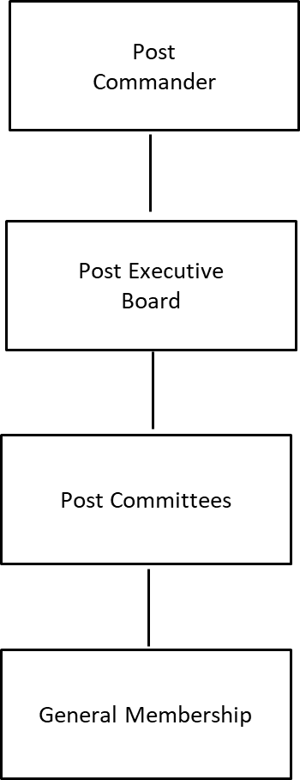

APPENDIX II
PAST COMMANDERS

American Legion Post 112

Gordon Mann 1920–1925 David Pennington 1958
J. H. Steed 1926 Robert L Byers 1959-1961
R. W. Felker 1927 G L Moore 1962-1964
L. A. Weems 1928 Wayne Nations 1965
Clayton Ault 1929 Frank L Means 1966
W. J. Single 1930 Robert L Byers 1967-1968
Claude Miller 1931 Jack Sayre 1969
H. L. Trammel 1932-1933 Robert L. Byers 1970
M. H. Linn 1934 Ben H Millican 1971
H. L. Trammel 1935 Lamar Crow 1972-1973
W. H. Lumpkin 1936 William C Masters 1974-1975
Lyle Weems 1937 Billy A Broom 1976-1977
Sandford Carr 1938 Calvin Huggins 1978
Sam Weed 1939 George P King 1979
R. H. Gregory 1940 Milton Thomas 1980-1984
C. C. Hill 1941 Winfred Deal 1985
Rob Hamilton 1942-1943 Ralph Graves 1986-1988
W. H. Southern 1944-1945 Milton Thomas 1969-1995
E. P. Bright 1946-1947 Cain Vinsant 1996-2003
John McLellan 1948 John Paul Bledsoe 2003-2005
J.T. Looper 1949 Bob Turner 2005-2006
James Steed 1950 Bob Campbell 2006-2007
Dean Smith 1951-1953 John Paul Bledsoe 2007-2009
J L Millsap 1954 Dewey Moss 2009-2015
Joseph Stevens, Jr 1955 Lee Oliver 2015-2020
Tom Miner III 1956-1957 John Wilson 2020-2023
APPENDIX III
ELECTION RESULTS

 | Nominations / Voting Ballot Post 112 Dalton GA
 | Election Date May 29, 2025
 | No. _____
 | Election of Officers for 2025 -2026
 | COMMANDER |  | Vote for one or write in
1 | Jim Lovain | 42
2 | Dewey Moss (Write in) | 1
3
 | Senior Vice Commander |  | Vote for one or write in
1 | Lee Oliver | 42
2 | Gary Benson (Write in) | 1
3
 | Junior Vice Commander |  | Vote for five or write in
1 | Ed Shiver | 38
2 | Dave Malone | 39
3 | Rick Brock | 29
4 | T W Davis | 39
5 | Bob Keener | 31
6 | Lee Parsons | 35
7 | Ron Carter (Write in) | 1
8
 | Finance Officer |  | Vote for one or write in
1 | Bob Oxford | 40
2 |  |  | Nomination Committee
3 |  |  | J Czerneski. G Benson, M Foshee

APPENDIX IV
POST CONSTITUTION

PREAMBLE

For God and Country, we associate ourselves together for the following purpose: to uphold and defend the Constitution of the United States of America; to maintain law and order; to foster and perpetuate a one hundred percent Americanism; to preserve the memories and incidents of our associations in all wars; to inculcate a sense of individual obligation to the community, state, and nation; to combat the autocracy of both the classes and masses; to make right the master of might; to promote peace and good will on earth; to safeguard and transmit to posterity the principles of justice, freedom and democracy; to consecrate and sanctify our comradeship by devotion to mutual helpfulness.

ARTICLE I
NAME

Section 1. The name of the organization shall be American Legion Post 112, American Legion Department of Georgia.

ARTICLE II
OBJECTS

Section 1. The objects and purposes of this Post shall be to promote the principles and policies as set forth in the foregoing preamble, and the National and Department Constitution of the American Legion.

ARTICLE III
NATURE

Section 1. This Post is a civilian veteran’s service organization and membership therein does not affect or increase liability for military or police service.

Section 2. This organization shall be absolutely non-political and shall not be used for the dissemination of partisan principles nor for the promotion of the candidacy of any person seeking office or preferment.

Section 3. Rank does not exist in the American Legion; no member shall be addressed by his or her military or naval title in any meeting of the Post.

Section 4. This organization shall be non-profitable.

ARTICLE IV
MEMBERSHIP

Section 1. Eligibility to membership to the Post shall be as prescribed by the National Constitution of the American Legion.

Section 2. Application for membership shall be made in writing under such regulations as may from time to time be prescribed by the Post Executive Committee. Applicant must be able to furnish a copy of his or her DD-214 and have an Honorable Discharge or under Honorable Conditions Discharge.

Section 3. All applications for membership shall be acted upon at the next Post meeting following such application and after a positive background check has been completed. Judge Advocate shall contact the previous Post of any transferring members to assure there are no negative issues the Post should be aware of. At such meeting the applicant shall be accepted, rejected, or referred to further investigation and consideration. If the majority of members present vote against the acceptance of such application, then such application shall be recorded as rejected. A rejected applicant shall not then be considered until after the expiration of six months from the date of such rejection.

Section 4. Any member of this Post may be expelled or suspended for cause by two thirds majority vote of the membership present at the regular meeting of the post after charges are preferred under oath in writing, and a fair trial has been held upon the member in accordance with procedures prescribed by the National and Department Executive Committees.

Section 5. A member who has been expelled or suspended from the Post for any cause may be reinstated by two thirds majority vote of membership present in the Post meeting and the payment of current dues for the year in which the reinstatement occurs.

Section 6. No person who has been expelled by a Post shall be admitted to membership in another Post without the consent of the expelling Post, except that where such consent has been asked for and denied by each Post he may then appeal to the Department of Georgia Executive Committee for permission to apply for membership to another Post and shall be ineligible for membership until such permission is granted. This process is handled by the Post Judge Advocate.

ARTICLE V
OFFICERS

Section 1. The administrative affairs of Post 112 of the American Legion shall, except as may be otherwise provided by the by-laws, be under the supervision of the Post Executive Committee which shall consist of the elected and appointed officers of the post and immediate past commander.

Section 2. The Officers of the Post shall be a Commander, Senior Vice Commander, five (5) Junior Vice Commanders, Finance Officer, who are elected. Plus, Adjutant, Service Officer, Historian, Chaplain, Sergeant-at-Arms, and Judge Advocate, who are appointed. The Commander, Senior Vice Commander, Five Junior Vice Commanders, and Finance Officer shall be elected by the Membership and shall comprise the voting officers of the Executive Committee. The voting officers of the Post shall be entitled to one vote only, even if they currently hold two positions that normally are entitled to vote. The Commander only votes in the event of a tie. In addition to the aforementioned elected officers, the immediate Past Commander shall have a vote in the affairs of the Executive Committee. The Adjutant, Service Officer, Historian, Chaplain, Sergeant-at-Arms and Judge Advocate shall be appointed by the Commander and will be members of the Executive Committee with voice only and no vote.

Section 3. All officers shall be elected or appointed annually, and they will hold office until successors are duly installed or as otherwise provided. Any officer may be removed for inefficiency or malfeasance by the Executive Committee, two-thirds majority vote of said committee being necessary to affect such removal. Election of officers shall be no earlier than fifteen (15) days and no later than sixty (60) days prior to the Department Convention.

Section 4. Every member of the Post in good standing shall be eligible to hold office in this Post.

Section 5. The duties of Officers are prescribed by the Department of Georgia by-laws and by the Post by-laws.

ARTICLE VI
FINANCE

Section 1. The revenue of the Post shall be derived from annual membership dues and from such other sources as may be provided by vote of the Post Executive Committee.

Section 2. The amount of annual Post dues shall be fixed and determined by the Post Executive Committee.

Section 3. The Post shall pay National, and Department Headquarters annual membership dues for every member of the Post.

ARTICLE VII
CHARTER MEMBERS

Section 1. Members of the Post prior to the issuance of Charter shall be known as Charter Members.

ARTICLE VIII
AMERICAN LEGION AUXILARY

Section 1. The Post recognizes an auxiliary organization to be known as the Auxiliary Unit of American Legion Post 112 Department of Georgia.

Section 2. Membership in the Auxiliary unit shall be as prescribed by the National Constitution and By-Laws of the American Legion Auxiliary.

ARTICLE IX
AMENDMENTS

Section 1. This Constitution is adopted subject to the provisions of the National Constitution of the American Legion and of the Department of Georgia. Any amendments to said National Constitution of the American Legion and the Constitution of the Department of Georgia, which is in conflict with any provisions hereof, shall be regarded as automatically repealing or modifying the provisions of the Constitution to the extent of such conflict.

Section 2. This Constitution may be amended at any regular scheduled post meeting providing that the proposed amendment shall have been submitted in writing and read at the previous regularly scheduled meeting of the post and providing further that written notice shall have been given to all members at least ten (10) days in advance of the date when such amendment is to be voted upon, notifying said members that at such meeting a proposal to amend the constitution is to be voted upon.

ARTICLE X
AUTHENTICATION

Section 1. The Constitution was read at the regularly scheduled meeting held on January 11, 2024, and all members were notified of their proposed adoption at least the (10) days prior to the regularly scheduled meeting held on January 25, 2024. This Constitution was adopted at the regularly scheduled meeting held on January 25, 2024, by at least two-thirds majority and repeals the previous Constitution and amendments thereto.

Signed: ___Jim Lovain___ Commander, American Legion Post 112

APPENDIX V
POST BY-LAWS

ARTICLE I
GENERAL

Section 1. The Post existing under these by-laws is to be known as American Legion Post 112 Department of Georgia.

Section 2. The objects and purposes of Post 112 shall be to promote the principles and policies as set forth in the foregoing preamble and the Post By-Laws stated in this document, National and Department Constitution of the American Legion.

ARTICLE II
MANAGEMENT

Section 1. The government and management of Post 112 is entrusted to the Post Executive Committee as set forth in the Post Constitution.

Section 2. The Executive Committee shall be composed of all currently elected and appointed officers of Post 112. The officers of the Post shall be elected or appointed annually at the last regularly scheduled meeting of the Post prior to the date of the Department Convention and shall take office at the next regularly scheduled meeting following the Department Convention.

Election of officers shall be by written ballot and the candidates must receive a simple majority of the votes of the members present and eligible to vote. In the event there are more than two members nominated for an office and if there is not a majority, the two members receiving the highest totals must have a runoff to determine who is to be elected. The runoff must take place before the next regularly scheduled meeting and before the installation ceremony. In the election of the five (5) Junior Vice Commanders, the five receiving the highest totals shall be considered elected. There will be no nominations from the floor on the night of the election. However, write-in candidates, the night of the election are allowed and will be considered viable and legal candidates for office. Candidates for election must be announced thirty (30) days prior to the election by a committee appointed by the Commander. A space shall be provided on the ballot for write-in candidates. A list of all qualified candidates and the office they seek will be published in the Post 112 newsletter 30 days before the election.

ARTICLE III
POST EXECUTIVE COMMITTEE

Section 1. The Post Executive Committee shall meet for organizational, and such other business as may come before it on the second Thursday of the month at a time determined by the Executive Committee at the Post home after the installation of new officers. Thereafter the Post Executive Committee shall regularly meet at the previously determined time. The Commander shall call a special meeting of the Post Executive Committee upon the written request of three (3) members or more of the Post Executive Committee. Proper notice of not less than ten (10) days must be sent to all members of the Post Executive Committee via the best available method. Five (5) voting members of the Post Executive Committee shall constitute a quorum thereof. Voting during Post Executive Meetings shall be by raising hands when requested. Any item presented for consideration before the Executive Committee that requires an expenditure of $10,000 or more must be referred to the General Meeting for further action after approval by the Executive Committee.

Section 2. The Post Executive Committee is empowered to hire such employees as may be necessary for the operation and maintenance of the Post, shall authorize and approve all necessary expenditures for operations and maintenance, shall require adequate bonds from persons having custody of Post funds, shall hear reports of Post committee chairmen, and generally, shall have charge of and be responsible for the management of the affairs of the Post, approve or disapprove of all appointments of standing committees. Persons authorized to have custody of Post funds shall be Commander, Finance Officer, Adjutant, and Bingo Chairman.

Section 3. The Post Executive Committee shall make recommendations for major repairs, renovations, improvements, and changes of operation to the Post. This type of expenditures or changes in operations will not be made until the minutes of the meeting are read and approved at the next regularly scheduled meeting of the Post. The exception to this provision will be when a necessary repair constitutes an item or situation that would generally be interpreted as an emergency. The Post Commander shall have the authority to approve expenditures deemed to be an emergency.

Section 4. The Post Adjutant shall act as secretary for the Post Executive Committee and will transcribe necessary minutes which will be presented at the next regularly scheduled meeting of the Post. The members of the Post may disapprove of any action under Section 3, Article III hereto by a majority vote of all members present. Votes will be conducted by a show of hands at both Executive Committee meetings and at the monthly General Membership meeting. Minutes approved by the General Meeting are considered final.

ARTICLE IV
DUTIES OF OFFICERS

Section 1 - Duties of the Post Commander: It shall be the duty of the Post Commander to preside at all meetings of the Post, and to have general supervision over the business and affairs of the Post and such officer shall be the Chief Executive Officer of the Post. The Commander shall approve all orders directing the disbursement of funds and shall make an annual report covering the business of the Post for the year and recommendations for the ensuing year, which shall be read at the annual meeting a copy thereof immediately forwarded to the Department Adjutant. The Commander is considered to be an ex officio member of all standing committees of the post. The Commander shall perform such other duties as directed by the post.

Section 2 - Duties of the Senior Vice Commander: The Senior Vice Commander shall assume and discharge the duties of the office of Commander in the absences or temporary disability of the Commander, or when called upon by the Post Commander. In the event of the vacancy of the office of Post Commander, the Senior Vice Commander shall succeed to the office of Post Commander without further elections. The Senior Vice Commander shall be Chairman of Post Membership Committee.

Section 3 - Duties of the Junior Commanders: The Junior Commanders shall perform specific functions respectively assigned to them by the Post Commander and such other duties as are usually incident to their office. In the event of the vacancy of the office of Senior Vice Commander, one of the Junior Vice Commanders shall be selected to succeed to the office of Senior Vice Commander by the Post Executive Committee with the approval of the Commander. This succession shall be determined by length of service in the American Legion. If the most senior Jr. Vice declines to advance to Sr. Vice, then the succession goes down the line by seniority.

Section 4 - Duties of the Post Adjutant. The Post Adjutant shall have charge of and keep a full and correct record of all proceedings of all meetings, keep such records as the National and Department organizations may require, render reports of membership annually or when called upon at a meeting and under direction of the Commander handle correspondence for the Post. The Post Adjutant shall be a member of the Post Membership Committee. In the event the office of Post Adjutant becomes vacant the Post Commander shall appoint a successor to the unexpired term, subject to the approval of the Executive Committee. The duties of the Post Adjutant include the collection of Post dues, the safeguarding of said funds and securely conveying said funds to the Finance Officer for deposit into Post financial accounts.

Section 5 - Duties of the Finance Officer: The Finance Officer of the Post shall establish a checking account requiring two (2) signatures for security purposes. The Finance Officer shall have charge of all finances and see that they are safely deposited in some local bank or banks and shall make his report at both the Regular Post meeting and Post Executive Committee meeting, as to the condition of the finances of the Post, with such recommendations as he may deem expedient or necessary. He shall verify that all checks disbursing the monies of the Post are for valid, approved expenditures. Regular operating expenses may be paid by the Finance Officer as a part of regular duties. Invoices for expenses that are not regular operating expenses may be paid by the Finance Officer, with the agreement of the Commanding Officer, up to a value of $1,000. Funds paid to outside vendors must be accompanied by an invoice and must include a clear reason for the expenditure. Funds distributed to individuals must include a receipt for said expenditure and include the person’s name and a clear reason for the expenditure. If receipts are for items to be used for more than one purpose, it is requested that the receipt be marked to indicate where the item(s) is to be used. Any invoice presented for payment that is not a part of regular operating expenses over $1,000 must be approved by the Executive Committee before payment. Any expense over $10,000 must be presented to the General Monthly Meeting and approved by a majority vote after previously being approved by the Executive Committee. The Finance Officer shall be the Chairman of the Finance Committee.

Section 6 - Duties of the Post Judge Advocate. The Post Judge Advocate shall be the advisor on legal questions and upon all matters involving the interpretation of parliamentary procedures, National and Department of Georgia Constitution, and By-Laws. The Judge Advocate shall be the Chairman of the Legislative Committee.

Section 7 - Duties of the Post Service Officer. The Post Service Officer shall be the principal point of contact for all veterans and widows and orphans of veterans seeking assistance in obtaining veterans benefits. The Service Officer shall make such necessary coordination with, but not limited to, the Georgia Department of Veterans Services and the Veterans Administration medical facilities located within normal commuting distances. The Service Officer shall be the Chairman of the Veterans Affairs and Rehabilitation Committee. The Post shall make a provision for training for the Service Officer if needed.

Section 8 - Duties of the Post Historian. The Post Historian shall preserve the records and archives of the organization and shall publish from time to time such historical data as may be appropriate and transmit the data to the District and Department of Georgia historians. To be appointed as Post Historian, the person considered must be a veteran in good standing.

Section 9 - Duties of the Post Chaplain. The Post Chaplain shall be charged with the spiritual welfare of the Post Comrades and will offer divine but non-sectarian service in the event of dedications, funerals, public functions, etc., adhere to such ceremonial rituals as are recommended by the National or Department Headquarters from time to time. The Chaplain shall be Chairman of the Graves Registration and Memorial Committee.

Section 10 - Duties of the Sergeant-at-Arms. The Sergeant-at-Arms shall preserve order at all Post meetings and shall perform such other duties as may be required from time to time assigned to him by the Post Executive Committee.

Section 11 - Duties of Honor Guard Chairman. The Honor Guard Chairman will be appointed by the Post Commander. Only paid active members (VETERANS) of American Legion Post 112 are eligible to participate in the Honor Guard. The American Legion augments the military honor guard detail as an authorized provider with a chaplain, pallbearers, firing party, bugler, and/or color guard. The Honor Guard will also support community events if possible. Uniforms and uniform accessories for Honor Guard members will be provided by Post 112. The Chairman and Post Finance Officer will assist members with the initial and replacement purchase of uniform items.

ARTICLE V
DELEGATES

Section 1. Delegates and alternates to the Department Convention and/or Conferences shall be nominated by the Post Executive Committee annually at the last regular scheduled meeting of the Post prior to the date of the Department of Georgia Convention and/or Conferences. They shall be elected by a showing of hands at the Post meeting. It shall be decided by the Post Executive Committee what cost will be reimbursable and dollar limits of these expenditures.

ARTICLE VI
POST COMMITTEES

Section 1 - The Post Commander, immediately upon taking office each year, shall appoint the following standing committees and the members of said committees, except as noted in Sections 2,3,5,6,7,9 of Article IV above. Americanism, Bingo, Boys State, By-Laws, Investment Committee, Nominating Committee, Public Relations, Sons of the American Legion, Memorial Day, Veterans Day Parade, Law Cadets, Benevolence, and Honor Guard. Members of the Honor Guard and Honor Guard Committee must be a Veteran in good standing.

Section 2 - Americanism Committee. The Americanism Committee is charged with the inspiration of patriotism and good citizenship by arrangement for proper observation of patriotic occasions, encouragement of patriotic and civic phases of instruction in schools and activities for community and civic betterment.

Section 3 - Bingo Committee. The Bingo Committee is charged with the responsibility of ensuring that the conduct of bingo is in accordance with the laws of the State of Georgia, to include, but not limited to assuring that all Legionnaires or Auxiliary and Sons of the American Legion members that work bingo have appropriate clearance from the State of Georgia, that their dues have been paid, and that appropriate audits are performed in accordance with the laws of the State of Georgia.

Section 4 - Boys State Committee. The Boys State Committee is charged with the responsibility of visiting local schools and delivering the current literature for the upcoming Boys State, explaining all the information pertaining to the event, what each boy is expected to gain from the experience, the Post part in the program. This is normally done through the school counselor, receiving and processing each youth’s application and making arrangements for transportation.

Section 5 - By-Laws Committee. The By-Laws Committee is charged with the responsibility of updating the published By-Laws within three (3) years of the published date of the immediate previously published By-Laws. Recommendations for updates must be solicited from both the present Executive Committee and from the General Membership. Recommendations for amendments to Post By-Laws shall be recorded by the Chairman of the By-Laws committee for inclusion at the next update.

Section 6 - Investment Committee. The Investment Committee is charged with overseeing monetary funds deposited into non-bank investment products. The Investment Committee is charged with ensuring that these non-FDIC insured products are monitored on a regular basis to ensure that the funds belonging to the Post are as safe as possible and are making positive progress given the financial climate that exists at that time. The Chairman of the Investment Committee is charged with giving a status update at the monthly Executive Committee meeting and quarterly to the General Membership meeting. The Chairman of the Investment Committee is appointed by the Post Commander annually, with approval of the Executive Committee, and is approved by a vote of the Executive Committee. Additional members of the Investment Committee are recommended to the Executive Committee by the Chairman and the Commander for their approval.

Section 7 - Sons of the American Legion Committee. This Committee shall have supervision over the operations of the Post’s Squadron of the Sons of the American Legion.

Section 8. - Nominating Committee. The Commander shall be charged with appointing a Nominating Committee at the third (3rd) Post meeting before the Department Convention. The Nominating Committee shall make necessary recommendations at the second (2nd) Post meeting before the Department Convention. This procedure does not prevent the right of nomination from the floor from any member in good standing prior to actual voting. The Nomination Committee shall ensure that all nominees are present to accept or reject the nomination.

ARTICLE VII
RESOLUTIONS

Section 1. All resolutions of state or national scope presented to this Post by a member or reported to the Post by a committee shall merely embody the opinion of this Post on the subject and a copy of the same shall be forwarded to the Department Headquarters for Approval, before any publicity or action taken other than mere passage by the Post is taken.

ARTICLE VIII
MEETINGS

Section 1. All regular meetings of the Post shall be held on the last Thursday of each month, starting at a time determined by the membership in a majority vote of those members present. All meetings will be held at the Post home. Voting conducted during Post 112 General Meetings will be by raising of hands.

Section 2. The Post Commander or a majority of the Executive Committee shall have the power to call a special meeting of the Post at any time.

Section 3. Twenty-five (25) paid members of the Post shall constitute a quorum at the monthly Post meeting.

Section 4. All Post members whose mailing address or email address is known to the Post shall be notified in writing at least ten (10) days in advance of a special called meeting. This called meeting shall also be advertised on the Post social media outlets and, time permitting, in the monthly newsletter.

ARTICLE IX
NOTICES

Section 1. Every member shall furnish to the Post either their mailing address or email address for the purpose of receiving the newsletter and/or special informational notifications.

Section 2. The Post Commander shall see that notice of the annual election of officers is given at least two (2) weeks prior to said election by any and all means readily available.

ARTICLE X
RULES OF ORDER

Section 1. All proceedings of this Post shall be conducted under and pursuant to the latest edition of Robert’s Rules of Order, except as herein otherwise provided.

ARTICLE XI
AUTHENTICATION

Section 1. These By-Laws were read at the regularly scheduled Post meeting held January 11, 2024, all members were notified of their proposed adoption at least ten (10) days prior to the regularly scheduled Post meeting held on January 25, 2024. These By-Laws were adopted at the regularly scheduled Post meeting held on January 25, 2024, by at least two-thirds of the members present and voting and repeals previous By-Laws.

Signed: ___Jim Lovain___ Commander, American Legion Post 112

American Legion Post 112
Executive Meeting
07/11/2024

Call to Order: The meeting was called to order at 5:30 pm. The Chaplain gave an opening prayer/invocation. With the colors in place the flag was honored and the Pledge of Allegiance recited.

Roll Call: Jr Vice Commanders Dewey Moss, Don Gray, Ed Shiver, Sgt-at-Arms Junior Hammontree, and Historian Janet Duncan were absent.

Minutes from the last meeting: June 13, 2024, minutes were read and approved by a show of hands.

Finance Report: The Finance Report was given & approved by a show of hands. The Finance Officer also gave an update on Bingo Operations.

OLD BUSINESS

- Electronic Sign – Still needs repair. We are waiting on parts. The Post Commander and Finance Officer have been trained.

NEW BUSINESS

- The installation of 2024-2025 Post Officers will be held on July 25, 2024.

- Building Maintenance: Jr Vice Commander Lee Parsons said he will help with maintenance unless problems are beyond his capability.

- A motion was made to pay a fee of $150.00 to have the tank pressure washed and another $850.000 to have the building pressure washed. After discussion the motion was approved by a show of hands.

- The A/C Unit on the roof needs work to ensure maintenance technicians are safe while making repairs. Quotes will be obtained for a welder to make repairs.

- The Auxiliary Room needs a return duct installed to help with circulation and A/C unit sweating. The Commander will get quotes.

- SAL: The Finance Officer proposed SAL checking accounts be closed and merged with the Posts’ accounts to save CPA costs and allow the SAL to operate like the Post committees. A motion was made to do so, but there was not a second, therefore, the motion failed to pass.

- Military Seals: A motion was made to purchase Military Department seals to be displayed in the legion hall. Purchase will be approximately $1.000.00. After discussion, the motion was approved by a show of hands. The Adjutant will place the order.

- Preamble Sign: Sr Vice Commander Lee Oliver is having the new Preamble Sign framed.

- Honor Guard: A motion was made to purchase “Bucket hats” for the honor guard to help protect against the heat. The motion was approved by a show of hands. The finance officer said he will check to see if they are available to order.

- Space Force Flags are needed for the legion hall and honor guard. Adjutant will work with the finance officer to order.

- District Meeting will be held August 17, 2024, at Post 112. SAL at 9:00 am and regular membership at 10:00 am.

- Benefit fund raiser for Anthony and Vicky Robertson’s grandson on July 13, 2024, from 2:00 – 6:00 pm.

Meeting Adjournment: The Chaplain gave a closing prayer. With the colors in place, the flag was honored. The meeting adjourned at 6:30 pm.

American Legion Post 112
Executive Meeting
08/08/2024

Call to Order: The meeting was called to order at 5:30 pm. The Chaplain gave an opening prayer/invocation. With the colors in place the flag was honored and the Pledge of Allegiance recited.

Roll Call: Jr Vice Commander Rick Brock was absent.

Minutes from the last meeting: July 11, 2024, minutes were distributed, and a motion was made not to read the minutes but to approve as written. Motion was approved by a show of hands.

Finance Report: The Finance Report was given and approved by a show of hands. The Finance Officer also gave an update on Bingo Operations and announced the By-Laws are approved and are going to be printed.

OLD BUSINESS – No Old Business

NEW BUSINESS

- Building Maintenance - There is a leak in the Commander’s office. After discussion, a motion was made to turn this over to the insurance company for repairs. The motion was approved by a show of hands.

- Parking spaces need to be re-striped. Topic tabled until quotes are obtained.

- The Auxiliary Room needs a return duct installed to help with circulation and A/C unit sweating.

- A fence is needed around the tank. Topic tabled until quotes are obtained.

- Bingo – Two more monitors are needed to allow all players to see numbers being called. After discussion a motion was made to have two more monitors installed. Motion was approved by a show of hands.

- Budget – A separate meeting will be scheduled for the annual budget.

- District Meeting will be held August 17, 2024, at Poast 112. SAL at 9:00 am and regular membership at 10:00 am.

- The Chamber of Commerce will hold a Business Expo on September 12, 2024, an opportune recruitment event. Motion was made to support the Expo and approved by a show of hands.

- Flags needing disposal will be properly disposed of on a weekly basis.

Meeting Adjournment: The Chaplain gave a closing prayer. With the colors in place, the flag was honored. The meeting adjourned at 6:30 pm.

American Legion Post 112
Executive Meeting
09/12/2024

Call to Order: The meeting was called to order at 5:30 pm. The Chaplain gave an opening prayer/invocation. With the colors in place, the flag was honored and the Pledge of Allegiance recited.

Roll Call: Jr Vice Commander Ed Shiver was absent.

Minutes from the last meeting: August 8, 2024, minutes were distributed, and a motion was made to not read the minutes, but to approve as written. Motion was approved by a show of hands.

Finance Report: The Finance report was given & approved by a show of hands. The Finance Officer reminded everyone that account balances should not be briefed to the open public during General Membership and Executive Meetings.

OLD BUSINESS – There was no Old Business.

NEW BUSINESS

- Bingo: Two more monitors have been purchased…awaiting installation.

- Budget: Several adjustments were made to the upcoming annual budget expenditure. After discussion, a motion was made, and the new budget was approved by a show of hands.

- Veteran of the Year. The Commander appointed Lee Oliver to chair a committee to select the Veteran of the Year.

- Harrison Parker resigned his position as Chaplain of Post 112.

Meeting Adjournment: T.W. Davis gave a closing prayer. With the colors in place, the flag was honored. The meeting adjourned at 7:00 pm.

American Legion Post 112
Executive Meeting
10/10/2024

Call to Order: The meeting was called to order at 5:30 pm. The Chaplain gave an opening prayer/invocation. With the colors in place, the flag was honored and the Pledge of Allegiance recited.

Roll Call: Jr Vice Commander Rick Brock and Service Officer George Lo Greco were absent.

Minutes from the last meeting: September 12, 2024, minutes were distributed, and a motion was made to not read the minutes, but to approve as written. Motion was approved by a show of hands.

Finance Report: The Finance report was given & approved by a show of hands.

OLD BUSINESS

- Fence around Tank: One quote has been received. A motion was made and approved to proceed with having the fence installed.

- Parking Lot Striping: One quote has been received. Tabled until two more quotes are received.

NEW BUSINESS

- VA Clinic Cookout: Volunteers are needed for the VA Clinic Cookout on October 23, 2024.

- Floors: The floors need to be stripped and waxed. The amount of $1,800.00 was approved by a show of hands.

- Veterans Day Parade: This year’s parade will be held on November 9, 2024.

- Veteran of the Year: The Veteran of the Year will ride in the parade and attend the Elks Lodge luncheon on November 10, 2024.

- Christmas Party: This year’s Christmas Party will be held on December 14, 2024.

Meeting Adjournment: The Chaplain gave a closing prayer. With the colors in place, the flag was honored. The meeting adjourned at 7:30 pm.

American Legion Post 112
Executive Meeting
11/14/2024

Call to Order: The meeting was called to order at 5:30 pm. The Chaplain gave an opening prayer/invocation. With the colors in place, the flag was honored and the Pledge of Allegiance recited.

Roll Call: All officers were present.

Minutes from the last meeting: October 10, 2024, minutes were distributed, and a motion was made to not read the minutes, but to approve as written. Motion was approved by a show of hands.

Finance Report: Finance report was given & approved by a show of hands.

OLD BUSINESS

- Parking Lot Striping: We have obtained 3 quotes. A motion was made and approved for a cost of $850.00 to continue with this project.

- Veteran of the Year: This year’s Veteran of the Year will be Charles Clayton.

NEW BUSINESS

- Applicants for Kitchen: Three applicants were interviewed to lease and manage the kitchen for Bingo and other post functions as requested. After the interviews all applicants were dismissed. After discussion a motion was made and approved by a show of hands to award the position to Marie Erwin.

- American Tower: A request was made to adjust the current contract/lease agreement. After reviewing and discussing the proposal, a motion was made and approved to maintain the current rent, a 3% annual escalation will continue, a non-compete clause added and terms of 5 years each with a final expiration date of September 28, 2089.

- Donations: A motion was made and approved to donate $1,000.00 each to 10 separate charitable organizations. (City of Refuge, Dalton/Whitfield Daycare, Reboot Program, Doc-up, Humane Society, Greater Works, Friendship House, Deo Clinic, Northwest Georgia Crisis Center, and Freedom Ranch).

- The district meeting will be held in Cartersville on November 16, 2024.

Meeting Adjournment: The Chaplain gave a closing prayer. With the colors in place, the flag was honored. The meeting adjourned at 7:30 pm.

American Legion Post 112
Executive Meeting
01/09/2025

Call to Order: The meeting was called to order at 5:30 pm. The Chaplain gave an opening prayer/invocation. With the colors in place, the flag was honored and the Pledge of Allegiance recited.

Roll Call: Jr Vice Commander/Judge Advocate Ed Shiver was absent.

Minutes from the last meeting: : November 14, 2024, minutes were distributed, and a motion was made to not read the minutes, but to approve as written. Motion was approved by a show of hands.
.
Finance Report: The Finance reports for November and December 2024 were given & both were approved by a show of hands.

OLD BUSINESS

- American Tower: Lease agreement is still being reviewed prior to final signatures.

- Parking Lot Striping: Contract has been awarded. Waiting for better weather prior to completion.

NEW BUSINESS

- 2024-2025 Post History Report: Historian Ernie Oventrop gave a presentation of the recommended format for the Annual Post History Report.

- By-Laws: The Commander prefaced the By-Laws review by reminding everyone to follow Roberts Rules to ensure no interruptions while someone has the floor, and to get his approval prior to addressing the committee to allow a more expeditious review. The Constitution and By-Laws were reviewed, and several recommendations were discussed. The Executive Committee is ensuring the Post and National Policy, and verbiage alignment. The Commander asked the Executive Board to review the By-Laws for further updates as we will continue review/updates during the next Executive Meeting.

- Dues: Two changes concerning current dues were discussed with motions made, voted on, and approved by a show of hands.

First, our current dues will be increased from $35.00 to $40.00 due to an increase in the Department dues.

Second, Effective immediately, dues for new members age 65 or older will be paid by the Post. On July 1, 2025, all Post members age 65 or older, the annual membership renewal for 2026 and beyond will be paid by the post.

- The National Commander will be in Canton January 16, 2025.

Meeting Adjournment: The Chaplain gave a closing prayer. With the colors in place, the flag was honored. The meeting adjourned at 7:30 pm.

American Legion Post 112
Executive Meeting
02/13/2025

Call to Order: The meeting was called to order at 5:30 pm. The Chaplain gave an opening prayer/invocation. With the colors in place, the flag was honored and the Pledge of Allegiance recited.

Roll Call: Sgt-at-Arms Charles Clayton and Historian Ernie Oventrop were absent.

Minutes from the last meeting: January 10, 2025, minutes were distributed and approved by a show of hands.

Finance Report: The Finance Report was not given. The Finance Officer’s computer crashed.

OLD BUSINESS

- American Tower: Lease agreement is being reviewed by an attorney. A motion was made and approved by a show of hands to have Travis Henry of Burns, Henry, & Kirksey Law Firm to represent the Post and renegotiate the lease agreement.

- Parking Lot Striping: Complete.

- Dues: The Commander reminded everyone that dues will increase for $35.00 to $40.00 due to an increase in the Department dues. Membership is being notified through meetings and the newsletter. July 1, 2025, for all Post members the age of 65 or older, the annual membership renewal for 2026 and beyond will be paid by the post. We need all members to verify their birthday and update their address, phone numbers and email addresses.

NEW BUSINESS

- Computer Program: A motion was made to upgrade the Finance Officer’s computer and purchase Quicken Books to maintain our accounting program more efficiently. A motion was made and approved by a show of hands.

- SAL: SAL Commander Anthony Robertson gave an update and explained the SAL operations.

- Helping Veterans and other community organizations: Sr Vice Commander Lee Oliver is seeking ways to assist organizations such as Veterans, AJROTC, and Scouting programs in the local community. Please contact him if you have any ideas.

- District 7 Meeting. The District 7 meeting will be held February 15, 2025, in Lindale, Georgia.

Meeting Adjournment: The Chaplain gave a closing prayer. With the colors in place, the flag was honored. The meeting adjourned at 6:40 pm.

American Legion Post 112
Executive Meeting
03/13/2025

Call to Order: The meeting was called to order at 5:30 pm. The Chaplain gave an opening prayer/invocation. With the colors in place, the flag was honored and the Pledge of Allegiance recited.

Roll Call: Service Officer George Lo Greco and Finance Officer Bob Oxford were absent.

Minutes from the last meeting: February 13, 2025, minutes were distributed and approved by a show of hands.

Finance Report: Finance was not given.

OLD BUSINESS

- Air Conditioner: The air conditioner on the roof is unsafe to maintain. A motion was made and approved by a show of hands to get quotes to have the air conditioner replaced with a new unit on ground level. Jr Vice Ed Shiver is going to get the quotes and report back to the Executive Committee.

- Helping Veterans and other community organizations: A motion was made to support Scouting within the Northwest, GA area, with a donation of $10,000. The donation will be divided out to financially support scouts that cannot afford to attend camp or pay annual dues, rebuilding lean-tos, and repairing the COPE (obstacle course) to meet safety standards, and helping finish building a restroom facility at the Handi-Craft Lodge at Camp Sydney Dew. Box Oxford will oversee the distribution of the donation. After discussion, the motion was approved by show of hands.

NEW BUSINESS

- SAL: SAL Commander Anthony Robertson will be checking how Post 112 can assist the Homeless Vets in our area.

- Election: With the election of new officers approaching, the Commander asked Jon Czerneski to chair the election committee.

Meeting Adjournment: The Chaplain gave a closing prayer. With the colors in place, the flag was honored. The meeting adjourned at 6:30 pm.

American Legion Post 112
Executive Meeting
04/10/2025

Call to Order: The meeting was called to order at 5:30 pm. The Chaplain gave an opening prayer/invocation. With the colors in place, the flag was honored and the Pledge of Allegiance recited.

Roll Call: All officers were present.

Minutes from the last meeting: March 13, 2025, minutes were distributed and approved by a show of hands.

Finance Report: The Finance reports for January, February, and March were given and approved by a show of hands.

OLD BUSINESS

1 Air Conditioner: Two companies gave quotes for replacing the rooftop unit. The quote of $29,450.00 by Dalton Heating and Air was discussed and a motion was made and approved to award the contract to Dalton Heating and Air. This action will now be brought before the General Membership for their final approval.

NEW BUSINESS

- Election: With the election of new officers approaching, candidates will be introduced and allowed to speak at the General Membership Meeting on April 24, 2025. The election will be on May 29, from 4:00 – 7:00 pm

- Fireworks: The City of Dalton wishes to use our Parking Area for the July 4th celebration. A motion was made and approved to only charge $500 flat rate for the use.

- Freedom Ranch Veterans Appreciation Day: Will be held April 13, 2025, beginning at 1:00pm

- The Golden Gaiter Event and Picnic: Will be held May 16, 2025, beginning at 4:00 pm

Meeting Adjournment: The Chaplain gave a closing prayer. With the colors in place, the flag was honored. The meeting adjourned at 6:30 pm.

American Legion Post 112
Executive Meeting
05/08/2025

Call to Order: The meeting was called to order at 5:30 pm. The Chaplain gave an opening prayer/invocation. With the colors in place, the flag was honored and the Pledge of Allegiance recited.

Roll Call: Commander Jim Lovain and Service Officer George Lo Greco were absent.

Minutes from the last meeting: April 10, 2025, minutes were distributed and approved by a show of hands.

Finance Report: The Finance report was given and approved by a show of hands.

OLD BUSINESS – There was no Old Business

NEW BUSINESS

- Consolidate Post Report: The annual Consolidated Post Report was reviewed and completed.

- Bingo Computers: A motion was made to upgrade the current bingo computers at a cost of $1,00.00 per month, with a caveat to rent more in the future if needed. After discussion, the motion was approved by a show of hands.

- Checks: After discussion with the bank, the Finance Officer stated that the bank doesn’t want checks made out to the Post to get CASH for replenishing Bingo cash requirements. A motion was made to allow checks to be made out to “CASH” with the requirement of ensuring the check stubs were accurately annotated. After discussion the motion was approved by show of hands.

- Audit: The Executive Committee hasn’t seen or heard any results from the audit conducted 1 year ago. The committee also sees a conflict of interest being a Post Jr Vice Commander at the time, was part of the audit. Two motions were made toward the audit and future audits: The fist motion made is to nullify and not accept any results due to the timespan and the conflict of interest. The second motion is to hire a certified accounting firm to conduct any future audits concerning the finance of the Post. After lengthy discussion, both motions were unanimously approved by show of hands.

- District Meeting: Will be held in Calhoun May 17, 2025, at 10:00 am.

- Law Cader Program: June 9-14, 2025, 30 kids are enrolled

- Chaplain TW Davis is looking for two drivers to assist in transportation to Boy’s State, June 8, 2025, leaving at 0600.

- John Palmer will be the new Service Officer and will be going to Atlanta for training soon

Meeting Adjournment: The Chaplain gave a closing prayer. With the colors in place, the flag was honored. The meeting adjourned at 6:55 pm.
American Legion Post 112
Executive Meeting
06/12/2025

Call to Order: The meeting was called to order at 5:30 pm. George Lo Greco gave an opening prayer/invocation. With the colors in place, the flag was honored and the Pledge of Allegiance recited.

Roll Call: Junior Vice Commanders T.W. Davis, Dave Malone, and Lee Parsons were absent.

Minutes from the last meeting: Minutes of May 8, 2025, meeting were read and approved by a show of hands.

Finance Report: The Finance Report was presented by Bob Oxford. It was noted that May had five (5) Fridays, therefore extra money was taken in from Bingo. It was also noted that May averaged 121 players per week with average sales of $42.80 per person.

OLD BUSINESS.

- The Finance Officer continues to receive request for reimbursement that do not comply with current rules, specifically, the By-Laws state in Article 4, Section 5 “Funds distributed to individuals must include a receipt for said expenditure and include the person’s name and a clear reason for the expenditure.” Failure to comply could result in nonpayment.

NEW BUSINESS.

- Election. There was much discussion surrounding the recent election held in May 2025. Following discussion, Lee Oliver made a motion that we have six (6) Junior Vice Commanders for the year 2025-2026. Box Oxford seconded the motion. The motion was passed unanimously. Further it was agreed that we need a written procedure establishing rules for conducting elections. Ernie Oventrop will write a procedure and present it for review at the next Executive Committee Meeting.

- Rusted doors. There are four (4) rusted doors that are difficult to open and close. Box Oxford made a motion that these doors be replaced. Lee Oliver seconded the motion. The motion was passed unanimously.

- Toilets. There are five (5) toilets that need to be replaced. Lee Oliver made a motion that they be replaced. Bob Oxford seconded the motion. The motion was passed unanimously.

- Painting. Lee Oliver stated there are rumors about painting the interior of the American Legion. Jim Lovain responded by saying these are not rumors that he is currently getting quotes. Lee Oliver made a motion that we authorize up to $10,000 for the project. Box Oxford seconded the motion. The motion was passed unanimously.

- Wheelchairs. There are three (3) wheelchairs in the back room. The question was raised “what do we do with them”. Suggestions include repair, sell or keep. No decision was reached regarding the wheelchairs.

- State Convention. The State Convention will be held in Duluth June 26, 27, & 28th. Jim Lovain and Lee Oliver will be attending. Anyone else that is interested in attending is welcome.

- Law Cadet Graduation. Law Cadet Graduation is scheduled for Saturday, June 14, 2025. There will be a Flag Retirement Ceremony, followed by a Graduation Ceremony. Afterwards everyone will be served hamburgers and hot dogs. These activities will be held at American Legion Post 112.

Meeting Adjournment: George Lo Greco gave a closing prayer. With the colors in place, the flag was honored. The meeting adjourned at 6:38 pm.

American Legion Post 112
General Membership Meeting
07/25/2024

Call to Order: The meeting was called to order at 6:00 pm. The Chaplain gave an opening prayer/invocation. With the colors in place, the flag was honored and the Pledge of Allegiance recited.

POW/MIA: The Sgt-at-Arms placed the POW/MIA Flag on the empty chair, and we held a moment of silence.

Preamble: Members recited the preamble.

Roll Call: Jr Vice Commanders Dewey Moss and Janet Duncan were absent.

Minutes from the last meeting: June 27, 2024, General Membership Meeting minutes were read and approved by a show of hands.

Finance Report: The Finance Report was given and approved by a show of hands.

OLD BUSINESS – There was no Old Business.

NEW BUSINESS

- Installation of Officers: Jack Staples led the ceremony and installed Post 112’s new officers.

- Dues: The Commander and Adjutant discussed the error made at National Headquarters with renewal letters. Dues increased from $25.00 to $35.00.

- Quilts of Valor: Janice Wilmot presented Quilts of Valor to Steve Dean, Ed Dewayne, and Grady Shiver.

Birthdays: We celebrated birthdays for 2 members.

Raffle: Two names were drawn but the members were not present.

Meeting Adjournment: The Chaplain gave a closing prayer. With the colors in place, the flag was honored. The meeting adjourned at 6:45 pm and a meal was served.

American Legion Post 112
General Membership Meeting
08/29/2024

Call to Order: The meeting was called to order at 6:00 pm. The Chaplain gave an opening prayer/invocation. With the colors in place, the flag was honored and the Pledge of Allegiance recited.

POW/MIA: The Sgt-at-Arms placed the POW/MIA Flag on the empty chair, and we held a moment of silence.

Preamble: Members recited the preamble.

Roll Call: Jr Vice Commanders Ed Shiver & T W Davis were absent.

Minutes of the last meeting: July 25, 2024, General Membership Meeting minutes were read and approved by a show of hands. Dewey Moss requested the Executive Committee Minutes be read and approved but was reminded the latest “approved” Executive Minutes are posted and the minutes would not be read and approved by the General Membership.

Finance Report: The Finance Report was given and approved by a show of hands.

OLD BUSINESS- There was no Old Business.

NEW BUSINESS

- Investment Committee: Dewey Moss gave an update on the current investments. He also wants to be on the account and said he will not continue as chairman unless he is.

- Boys State: Gary Benson gave an update and introduced one student that spoke of the experience and thanked everyone for their support.

- By-Laws: A member made a motion to make a change to the by-laws limiting individuals to holding only one position. He was reminded that by-laws issues should be brought before the by-law committee for review and consideration. It was also mentioned that each person holding a position has only one vote per the by-laws.

- Guest Speaker: Andrew Parker, Dalton City Administrator, gave a status update of local community projects both completed and in progress.

Birthdays: We celebrated birthdays for 2 members.

Raffle: Two names were drawn but the members were not present.

Meeting Adjournment: The Chaplain gave a closing prayer. With colors in place, the flag was honored. The meeting adjourned at 6:45 pm and a meal was served.

American Legion Post 112
General Membership Meeting
09/26/2024



MEETING CANCELLED DUE TO INCLEMENT WEATHER

American Legion Post 112
General Membership Meeting
10/31/2024

Call to Order: The meeting was called to order at 6:00 pm. T.W. Davis gave an opening prayer/invocation. With the colors in place, the flag was honored and the Pledge of Allegiance recited.

POW/MIA: The Sgt-at-Arms placed the POW/MIA Flag on the empty chair, and we held a moment of silence.

Preamble: Members recited the preamble.

Roll Call: Finance Officer Bob Oxford was absent.

Minutes from the last meeting: There was no meeting in the month of September due to inclement weather. August 29. 2024, General Membership Meeting minutes were read and approved by a show of hands

Finance Report: The Finance Report was not given, but printed copies were made available to the membership.

OLD BUSINESS – There was no Old Business.

NEW BUSINESS

- Guest Speaker: Jack Staples, 7th District Commander made the following announcements:

● The Department will increase membership dues by $5.00 next year.

● District Meeting in Cartersville on November 17, 2024.

- Quilts of Valor: Quilts of Valor were presented to Shannon Bearfield, Charles Clayton, Andres Hambright, Jon Hiltbrant, Bob Keener, and Charles Ruddell.

- New Members: Two new members were voted in and welcomed to the post by a show of hands.

Birthdays: We celebrated birthdays with 5 members.

Raffle: Four names were drawn but the members were not present.

Meeting Adjournment: T.W. Davis gave a closing prayer. With the colors in place, the flag was honored. The meeting adjourned at 6:45 pm and a meal was served.

American Legion Post 112
General Membership Meeting
November 2024

NO MEETING



American Legion Post 112
General Membership Meeting
December 2024

NO MEETING



American Legion Post 112
General Membership Meeting
01/30/2025

Call to Order: The meeting was called to order at 6:00 pm. The Chaplain gave an opening prayer/invocation. With the colors in place, the flag was honored and the Pledge of Allegiance recited.

POW/MIA: The Sgt-at-Arms placed the POW/MIA Flag on the empty chair, and we held a moment of silence.

Preamble: Members recited the preamble.

Roll Call: All officers were present.

Minutes from the last meeting: October 31, 2024, General Membership Meeting minutes were read and approved by a show of hands.

Finance Report: Finance Reports for November & December 2024 were given and approved by a show of hands.

OLD BUSINESS – There was no Old Business.

NEW BUSINESS

- Guest Speakers:

Michael Schwartz, Dept Sr Vice Commander announced he is running for the Department Commander. He also spoke on the importance of membership and how the American Legion is the “Voice of veterans and their Families”. He stressed the importance of renewing membership before January 31st to keep from losing continuous years and insurance. He also stated how impressed he is with the number of members in attendance.

Jack Staples, District Commander announced February 15, 2025, is the District Meeting.

- Dues: Current dues will increase to $40.00 for 2026, due to the Department raising their dues.

- New Members: Three new members were introduced and voted in.

Birthdays: We celebrated birthdays with 15 members.

Raffle: Six names were drawn but only one member was present.

Meeting Adjournment: The Chaplain gave a closing prayer. With the colors in place, the flag was honored. The meeting adjourned at 6:45 pm and a meal was served.

American Legion Post 112
General Membership Meeting
02/27/2025

Call to Order: The meeting was called to order at 6:00 pm. The Chaplain gave an opening prayer/invocation. With the colors in place, the flag was honored and the Pledge of Allegiance recited.

POW/MIA: The Sgt-at-Arms placed the POW/MIA Flag on the empty chair, and we held a moment of silence.

Preamble: Members recited the preamble.

Roll Call: All officers were present.

Minutes from the last meeting: January 30, 2025, General Membership Meeting minutes were read and approved by a show of hands

Finance Report: The Finance Report was not given. The Finance Officer’s computer crashed.

OLD BUSINESS

- Dues: The Adjutant reminded members that dues will increase to $40.00 for 2026, due to the increase in Department dues.

NEW BUSINESS

- Dues: Dues for “New” members over the age of 65 will be paid by the Post. Beginning July 1, 2025, dues for all members age 65 and older will be paid by the Post. Please update your birthday, email and phone numbers with the Adjutant.

Birthdays: We celebrated birthdays with 1 member.

Raffle: Five names were drawn but only one member was present.

Meeting Adjournment: The Chaplain gave a closing prayer. With the colors in place, the flag was honored. The meeting adjourned at 6:35 pm and a meal was served.

American Legion Post 112
General Membership Meeting
03/27/2025

Call to Order: The meeting was called to order at 6:00 pm. The Chaplain gave an opening prayer/invocation. With the colors in place, the flag was honored and the Pledge of Allegiance recited.

POW/MIA: The Sgt-at-Arms placed the POW/MIA Flag on the empty chair, and we held a moment of silence.

Preamble: Members recited the preamble.

Roll Call: All officers were present.

Minutes from the last meeting: February 27, 2025, General Membership Meeting minutes were read and approved by a show of hands

Finance Report: The Finance Report was not given. The Finance Officer’s computer has been repaired, but finance reports for January, February, and March need to be presented to the Executive Committee for approval prior to membership approval.

OLD BUSINESS

- Dues: Members were reminded to ensure their information (birthday, address, email, etc.) is up to date with the Adjutant.

NEW BUSINESS

- Election Committee: John Czernesk will chair the election committee along with Mark Foshee and Gary Benson. John asked that anyone interested in running for office contact him to be placed on the ballot. Candidates will be introduced during April’s membership meeting, the election will be held on May 29, 2025, from 4:00 – 7:00 pm, and the newly elected officers will be installed in June.

- Guest Speakers:

Sheriff Darren Pierce gave an update and list of accomplishments of his administration thus far for 2025 and answered questions from our members.

A representative with Caption Call gave a briefing on Captioning phones for hearing loss.

Michael Ridley, who works with the homeless, said there are homeless vets that need help with tents, clothes, food, and water.

- Freedom Ranch Veterans Appreciation Day: Will be held Sunday, April 13, 2025

- Law Cadet Program: Will be held from June 9-14, 2025

Birthdays: We celebrated birthdays with 1 member.

Raffle: Two names were drawn but members with not present.

Meeting Adjournment: The Chaplain gave a closing prayer. With the colors in place, the flag was honored. The meeting adjourned at 7:05 pm and a meal was served.

American Legion Post 112
General Membership Meeting
04/24/2025

Call to Order: The meeting was called to order at 6:00 pm. The Chaplain gave an opening prayer/invocation. With the colors in place, the flag was honored and the Pledge of Allegiance recited.

POW/MIA: The Sgt-at-Arms placed the POW/MIA Flag on the empty chair, and we held a moment of silence.

Preamble: Members recited the preamble.

Roll Call: Service Officer George Lo Greco was absent.

Minutes from the last meeting: March 27, 2025, General Membership Meeting minutes were read and approved by a show of hands

Finance Report: The Finance Report was read and approved by a show of hands.

OLD BUSINESS – There was no Old Business

NEW BUSINESS

- The A/C Unit on the roof needs to be replaced. General Membership was briefed on the cost General Membership approved replacing the unit.

- John Czerneski asked if there were any more members wishing to run for an officer position and announced the ballot would be closed after tonight’s meeting. Candidates were introduced and allowed to address the membership. The Commander announced that our next meeting on May 29, 2024, will be for the election of new officers. The voting will begin at 4:00 pm and close at 7:00 pm. A meal will be provided.

- A prayer request was made for Jack Reddix.

- The Commander read a “Thank You” note from the family of Terry Ross, for the Honor Guard performing military honors.

Birthdays: We celebrated birthdays with 3 members.

Raffle: Larry Addis won the raffle.

Meeting Adjournment: The Chaplain gave a closing prayer. With the colors in place, the flag was honored. The meeting adjourned at 6:45 pm and a meal was served.

American Legion Post 112
General Membership Meeting
05/29/2025

NO MEETING



ELECTION NIGHT
2025-2026 POST OFFICERS

American Legion Post 112
General Membership Meeting
06/29/2024

Call to Order: The meeting was called to order at 6:00 pm. The Chaplain gave an opening prayer/invocation. With the colors in place, the flag was honored and the Pledge of Allegiance recited.

POW/MIA: The Sgt-at-Arms placed the POW/MIA Flag on the empty chair, and we held a moment of silence.

Preamble: Members recited the preamble.

Roll Call: All officers were present.

Minutes from the last meeting: April 24, 2025, General Membership Meeting minutes were read and approved by a show of hands

Finance Report: The Finance Report was read and approved by a show of hands.

OLD BUSINESS

- The Adjutant reminded members to verify birthdays and Post 112 will be paying the membership renewal for members 65 and older.

- The Air Conditioning Unit on the roof has been replaced and another unit has a bad heat exchanger and is being replaced.

NEW BUSINESS

- Gas Lines: Several gas lines have leaks and are being repaired/replaced.

- Toilets: All toilets throughout the building will be replaced due to failures that have led to high water bills.

- Paint: Membership Hall will receive a new coat of paint.

- Election: Due to the tie between Rick Brock and Bob Keener, the Executive Committee voted to have six Junior Vice Commanders for the year 2025-2026.

- Fourth of July Cookout: Will be held July 4, 2025, at 6:00 pm.

Birthdays: We celebrated birthdays with 3 members.

Raffle: There was no raffle this month.

Meeting Adjournment: The Chaplain gave a closing prayer. With the colors in place, the flag was honored. The meeting adjourned at 6:35 pm and a meal was served.

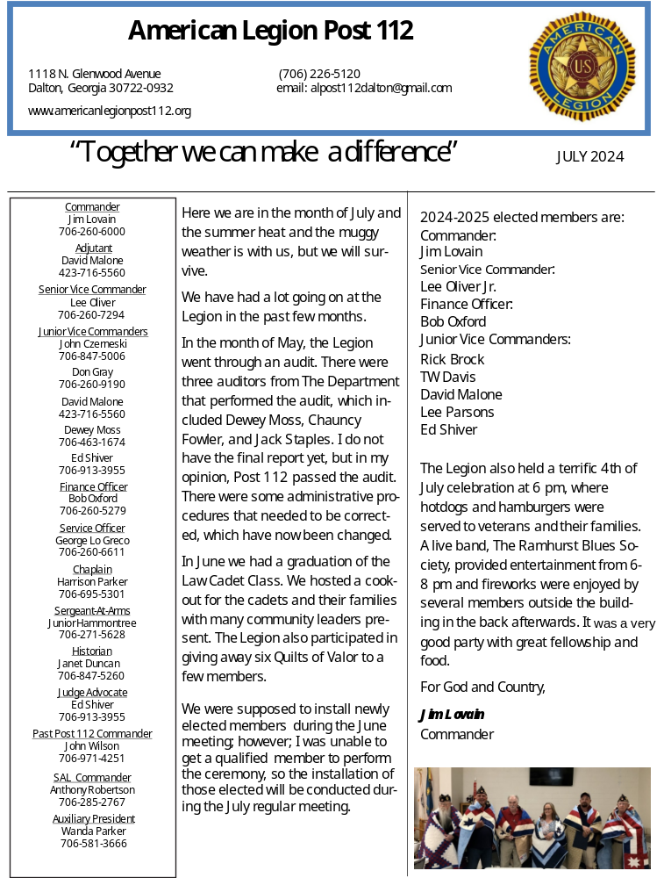

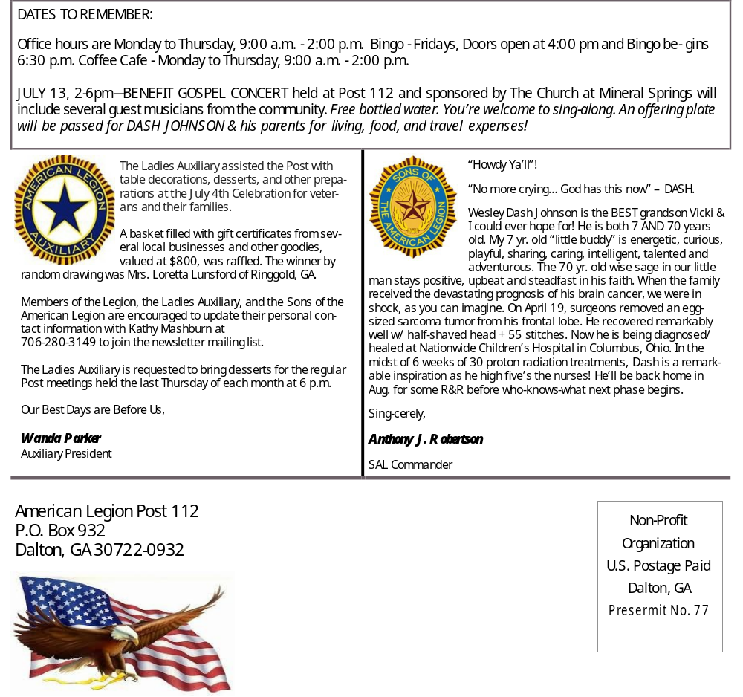

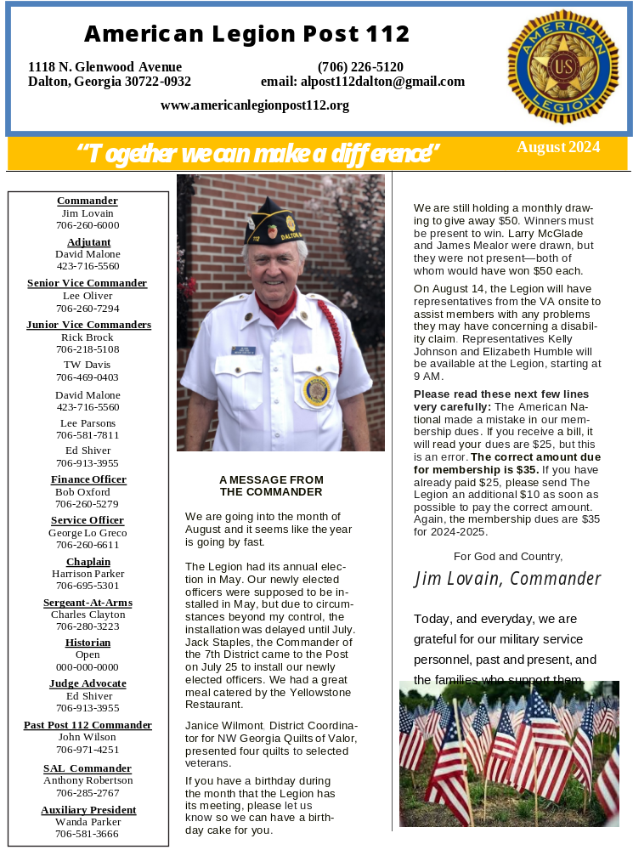

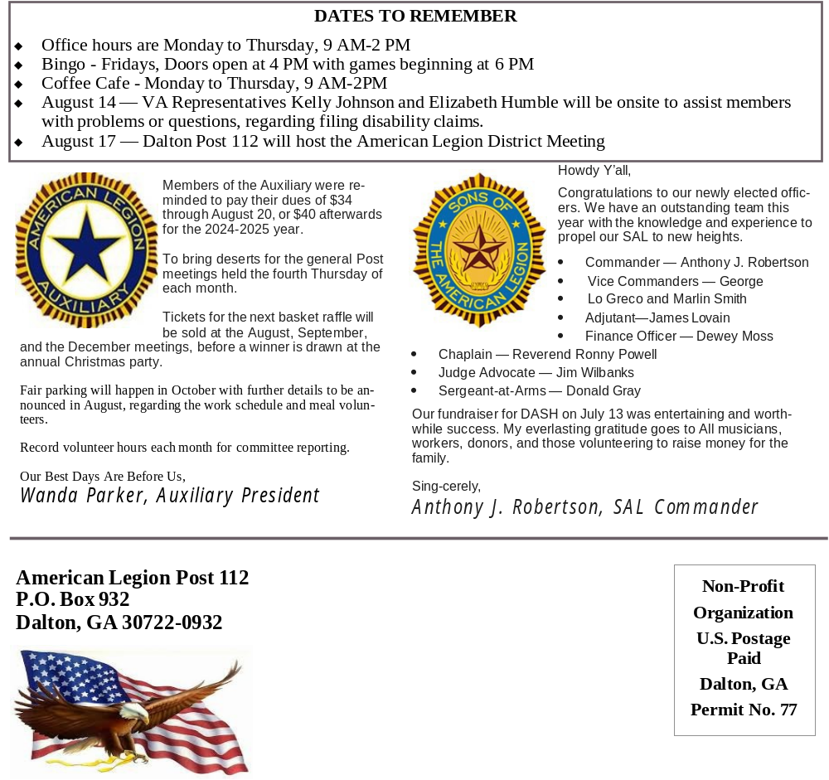

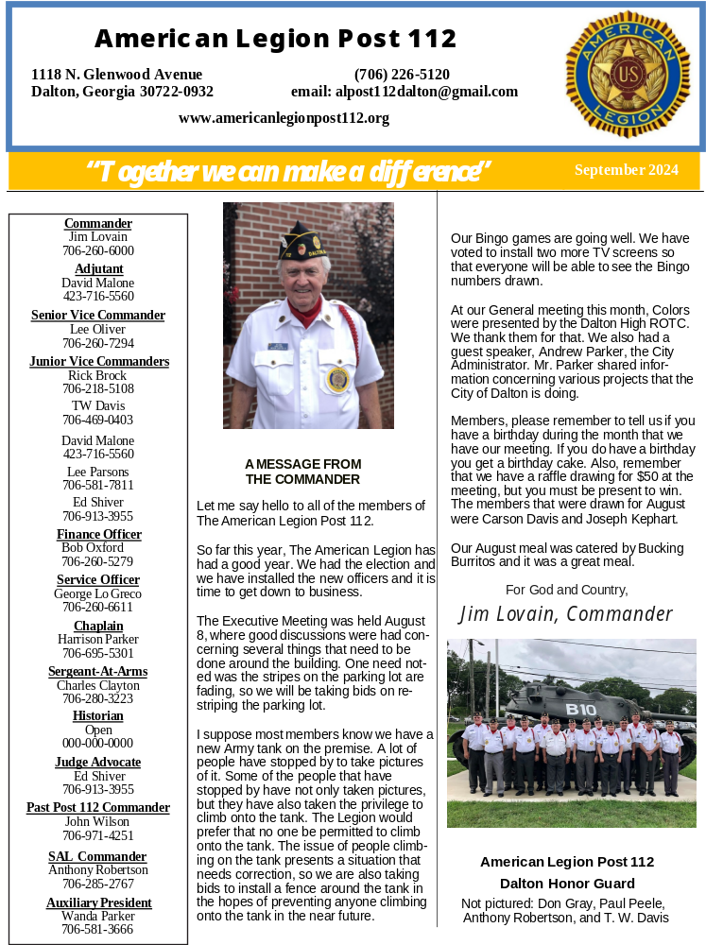

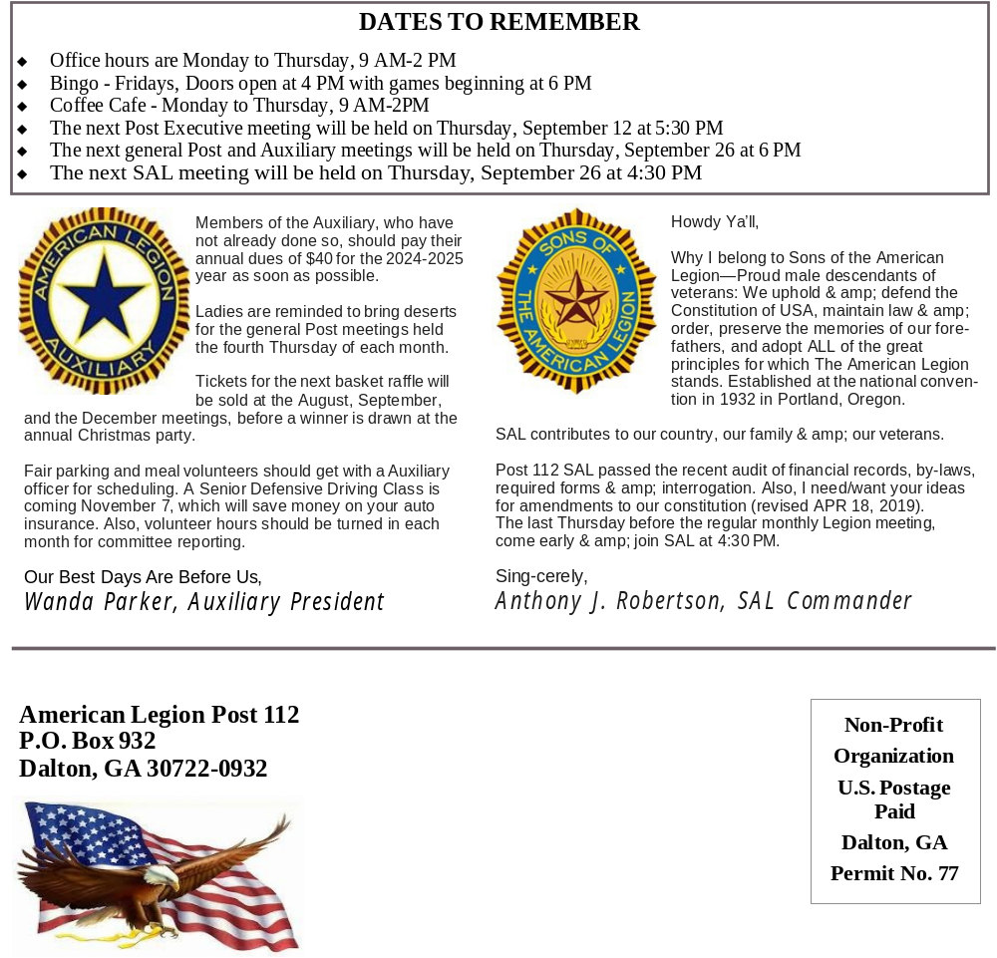

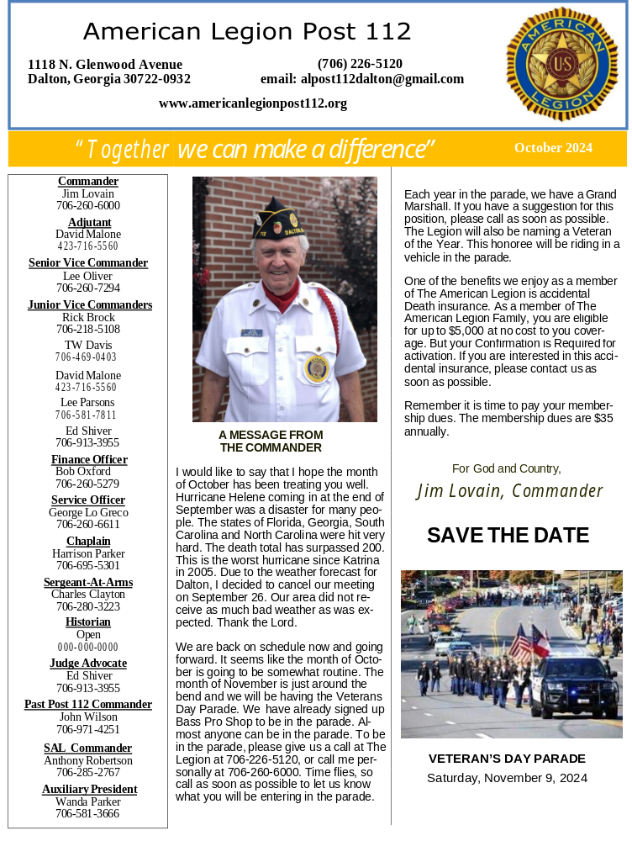

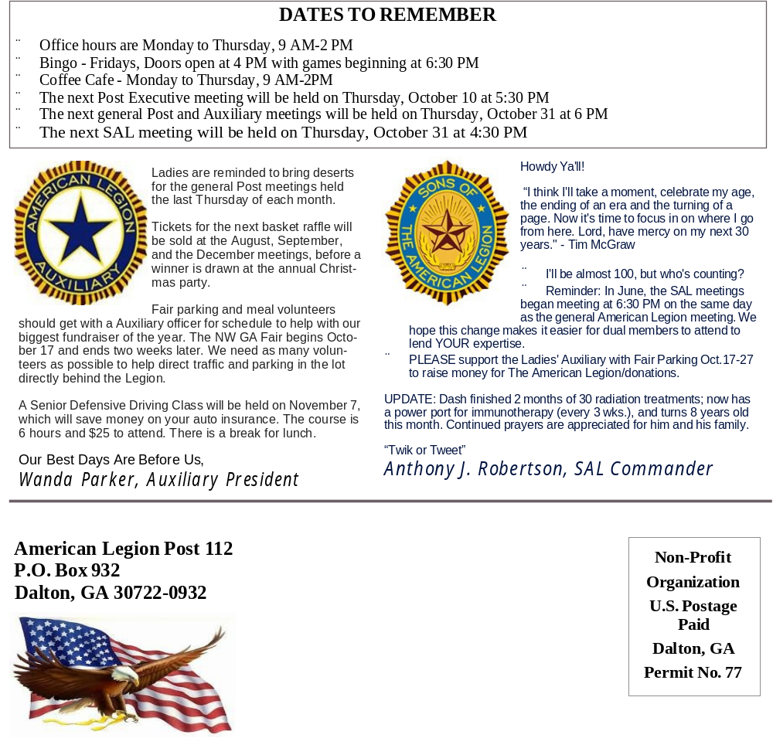

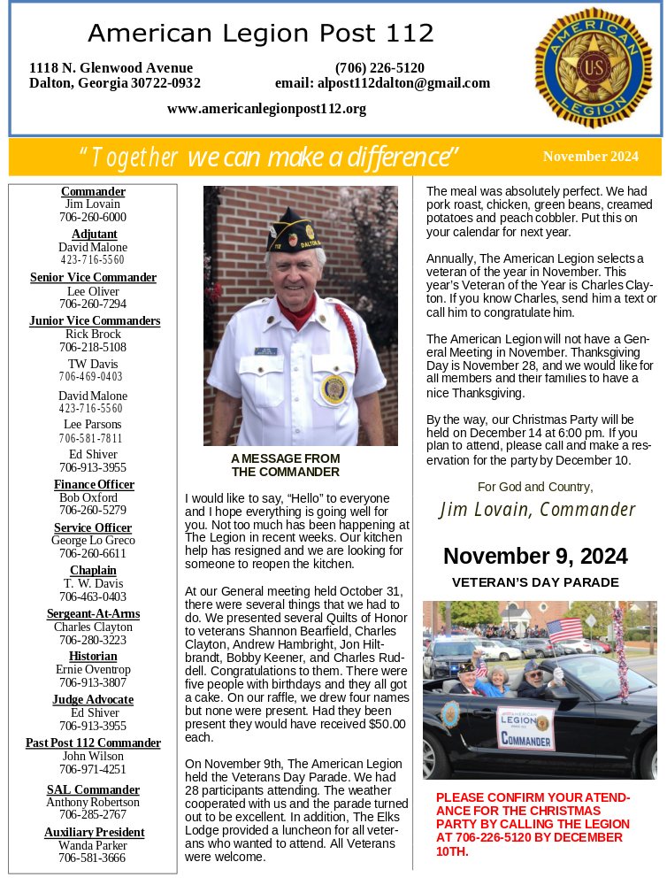

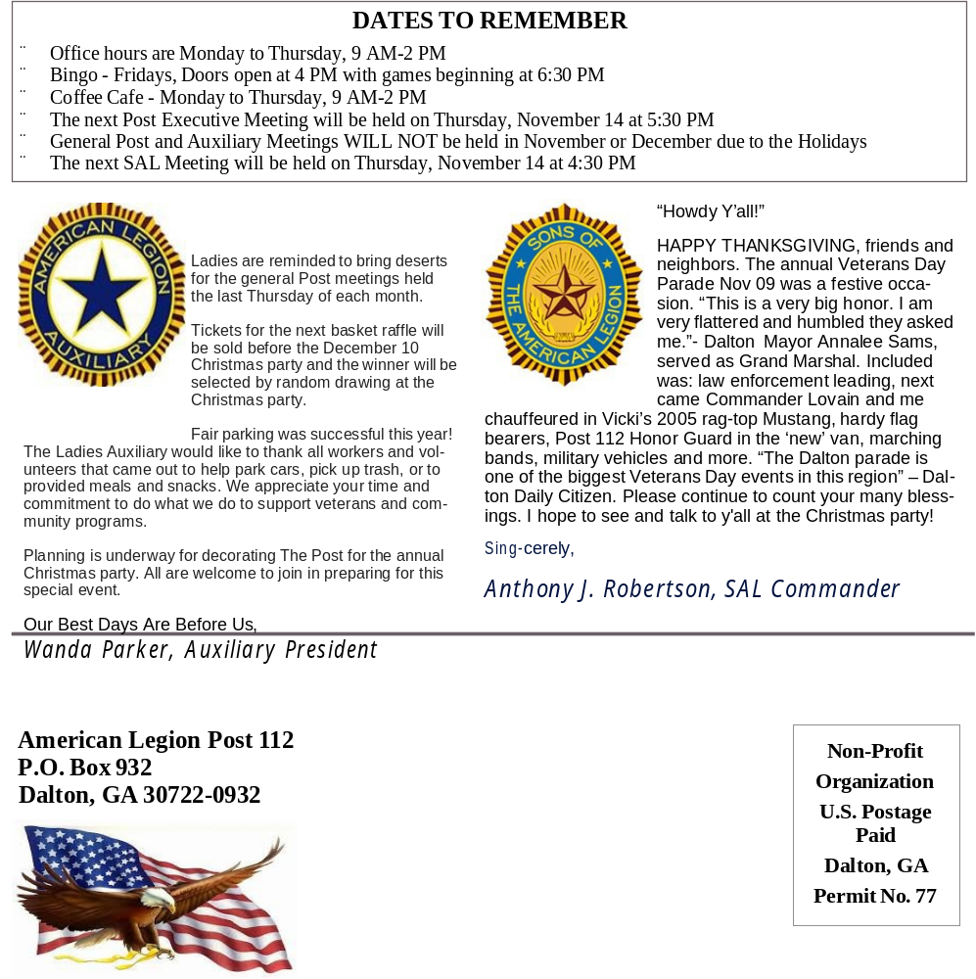

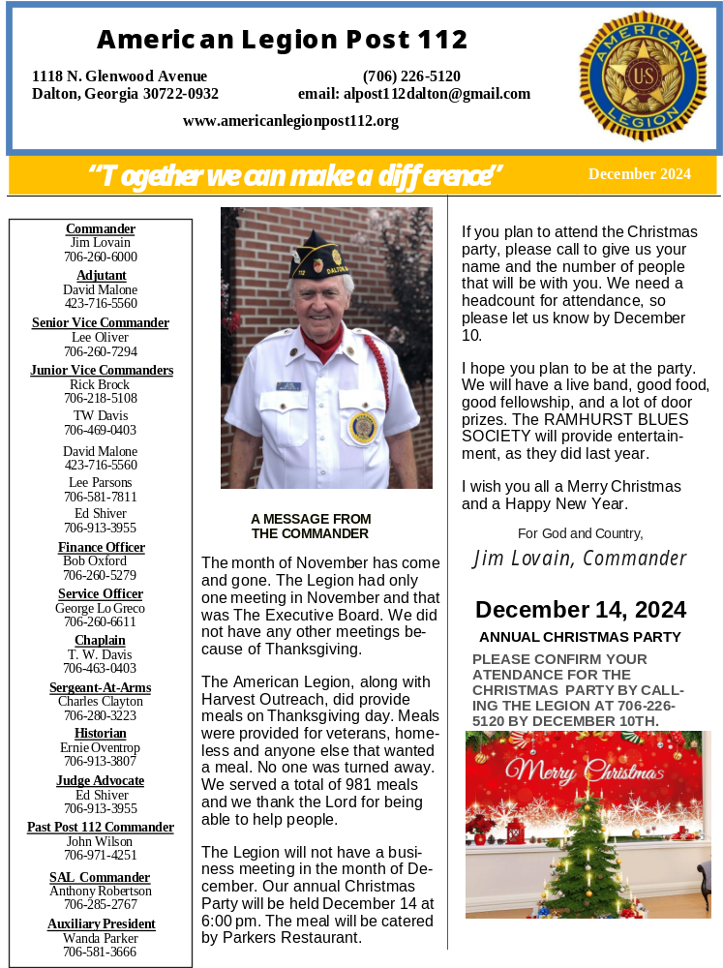

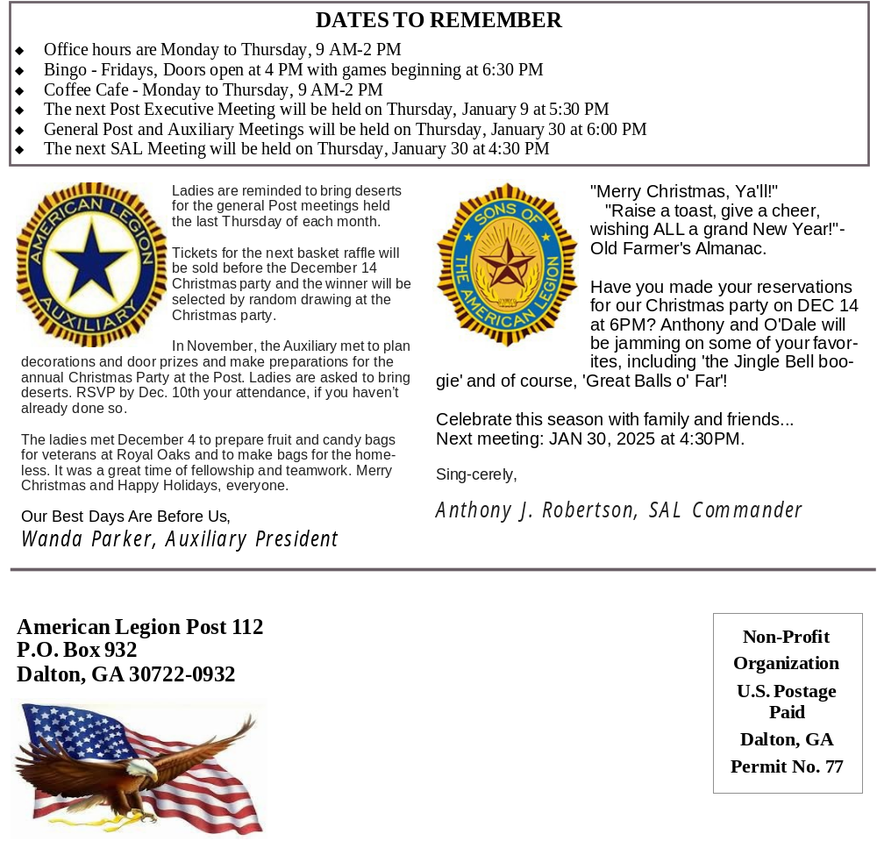

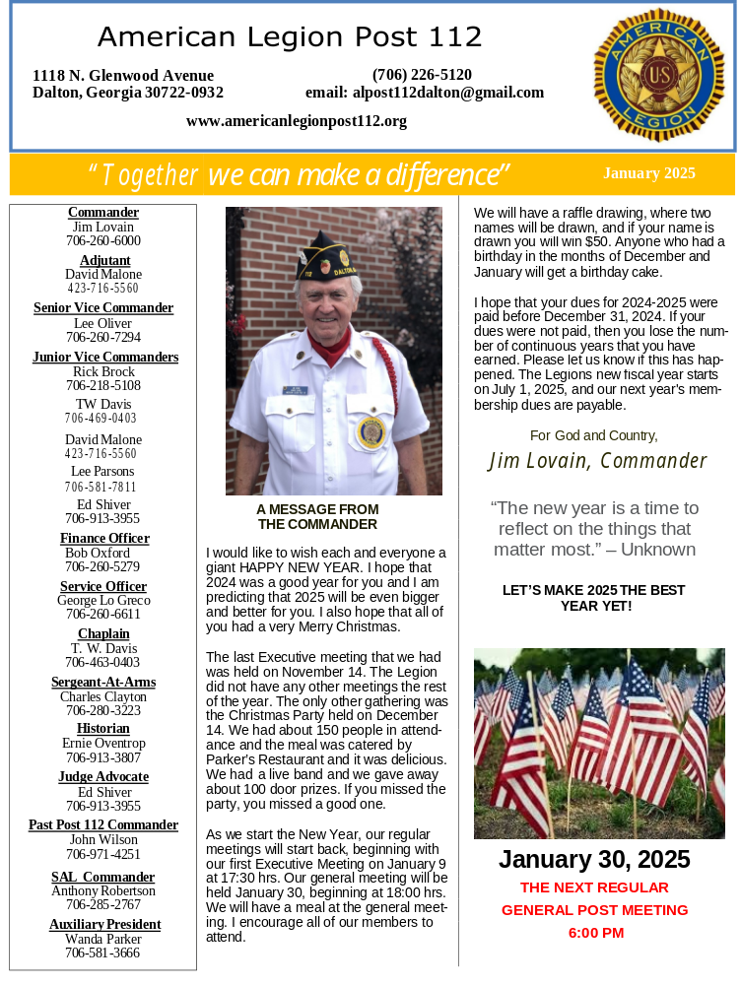

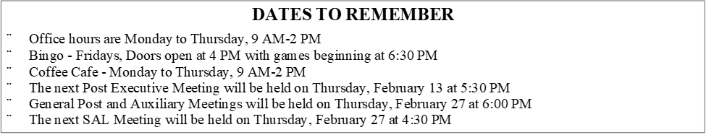
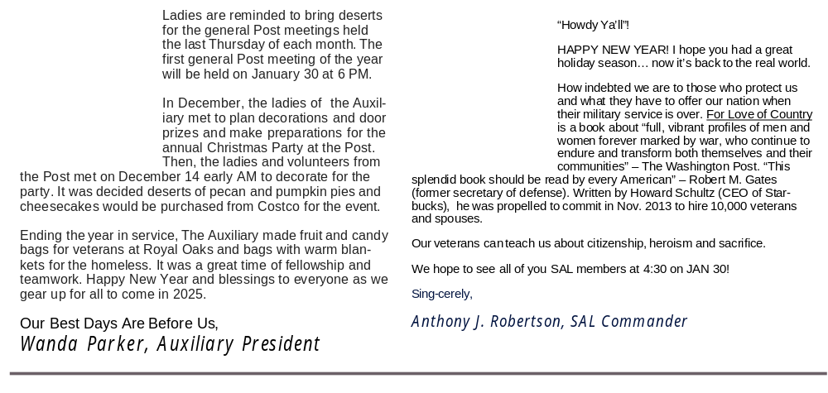

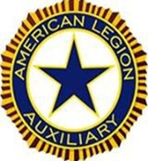

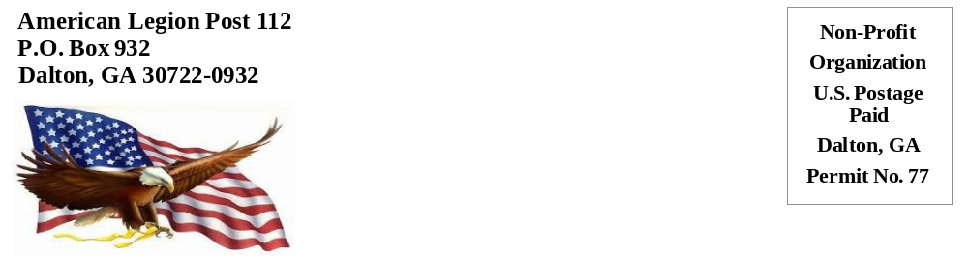

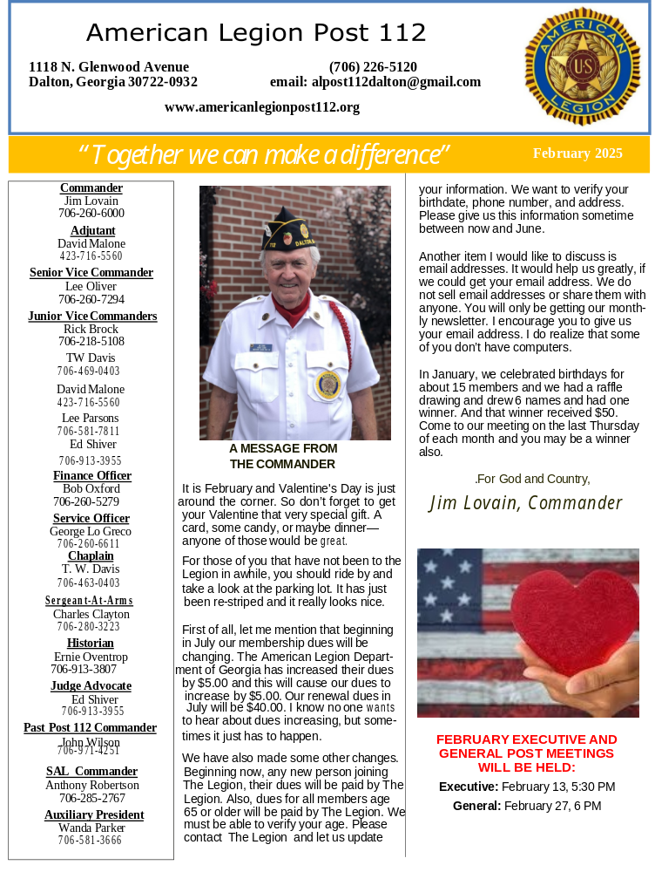

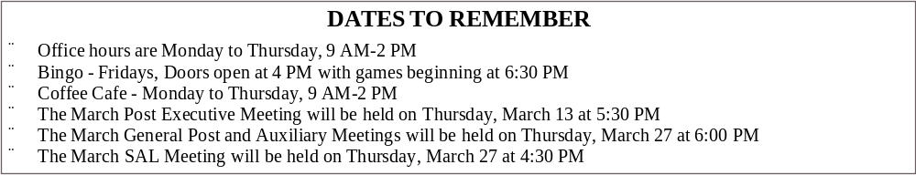
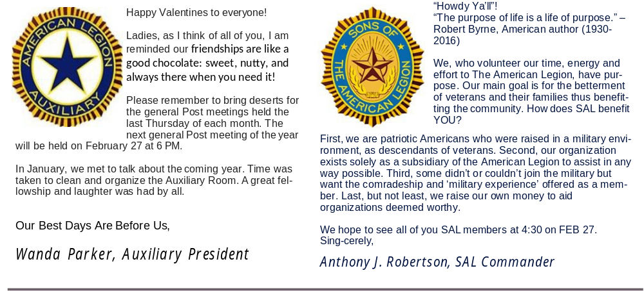
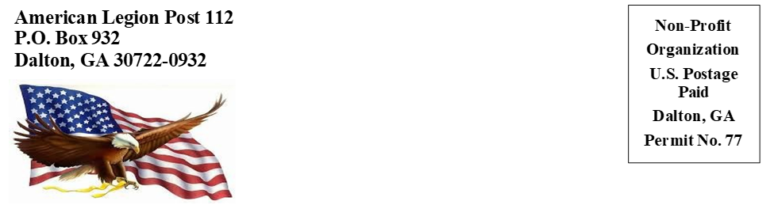

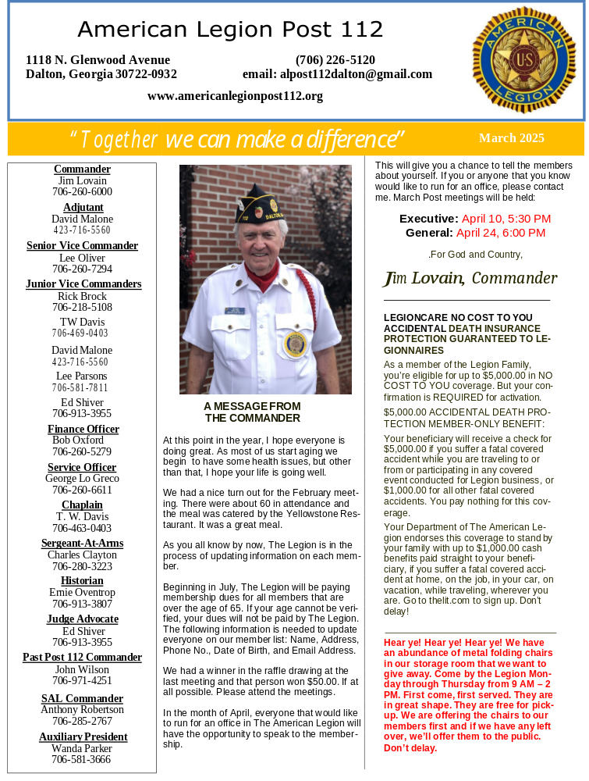

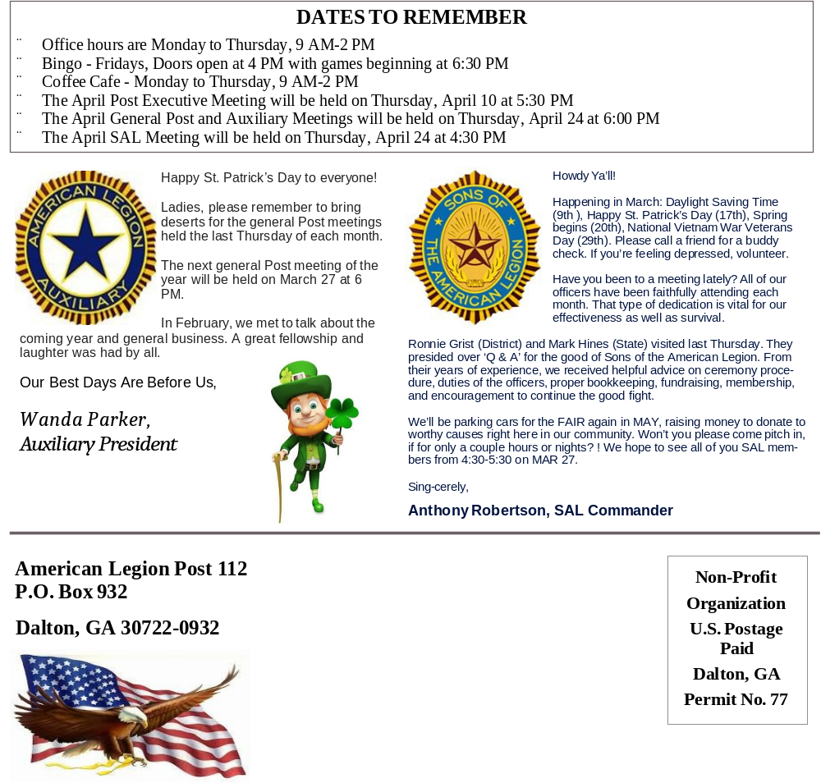

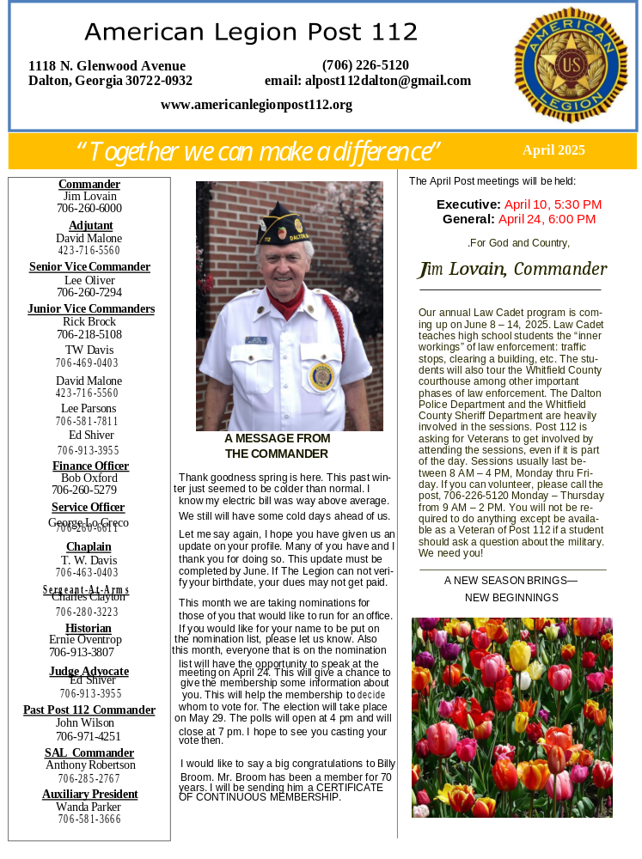

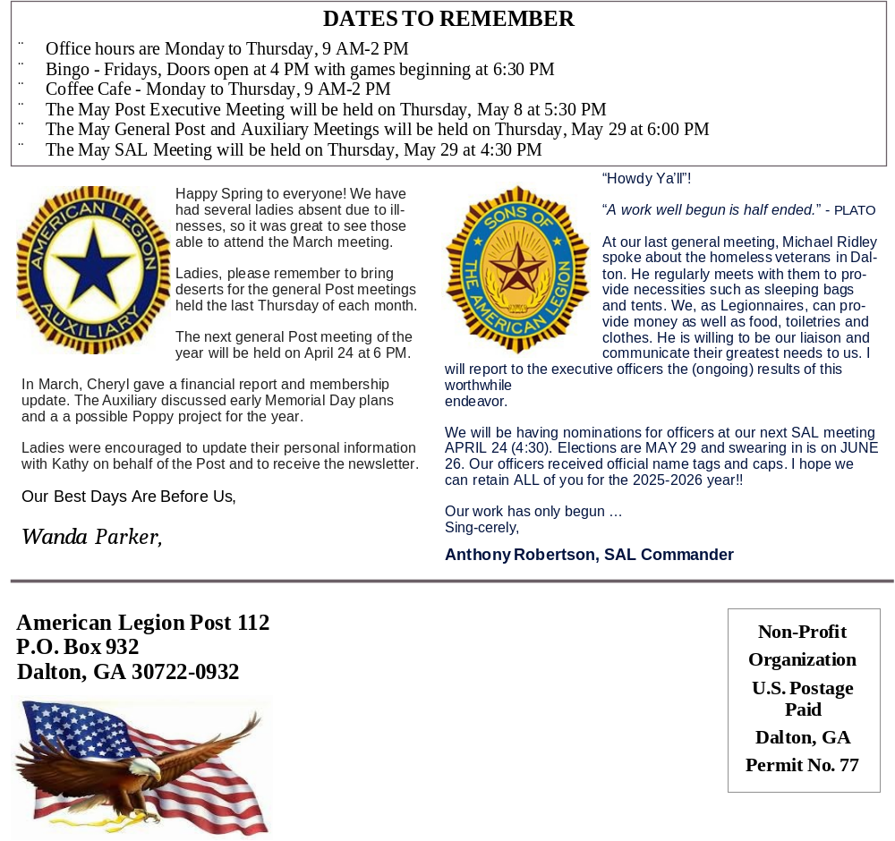

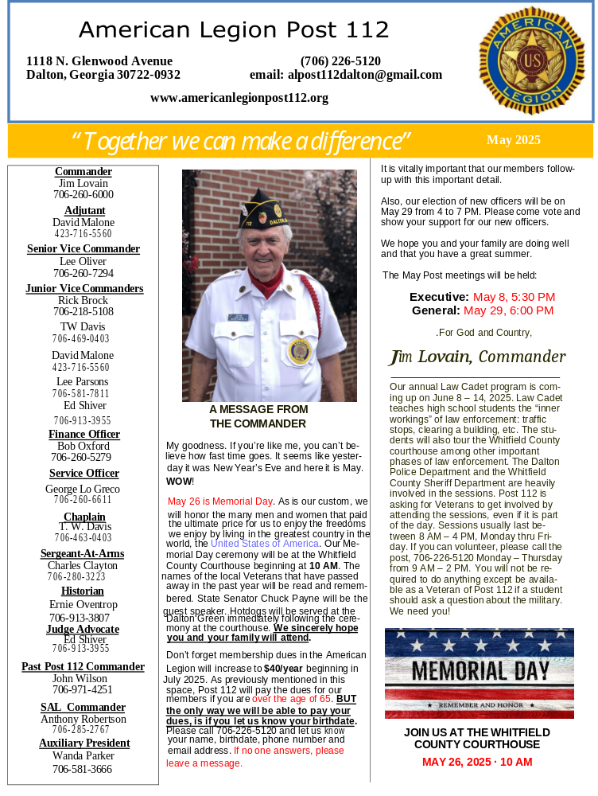

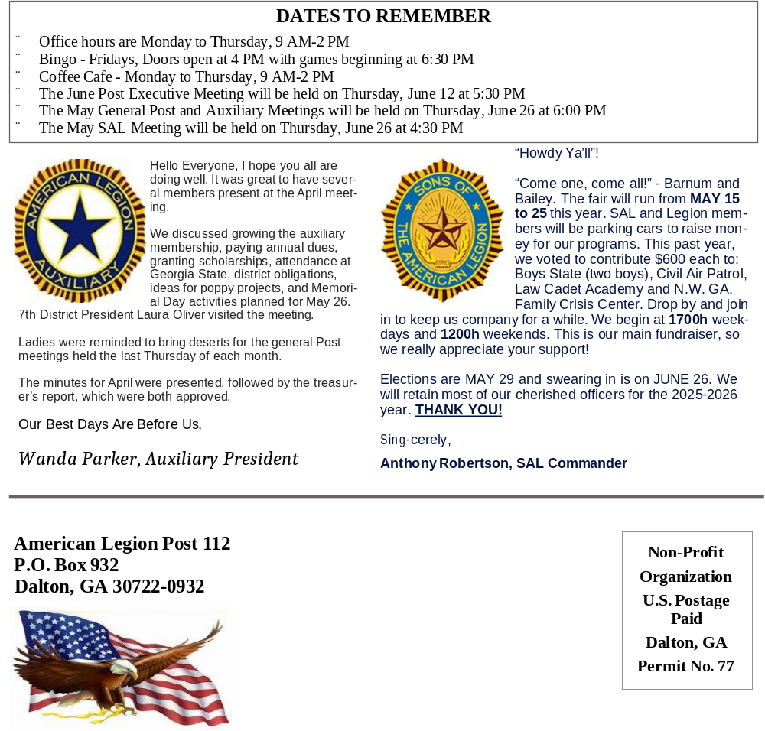

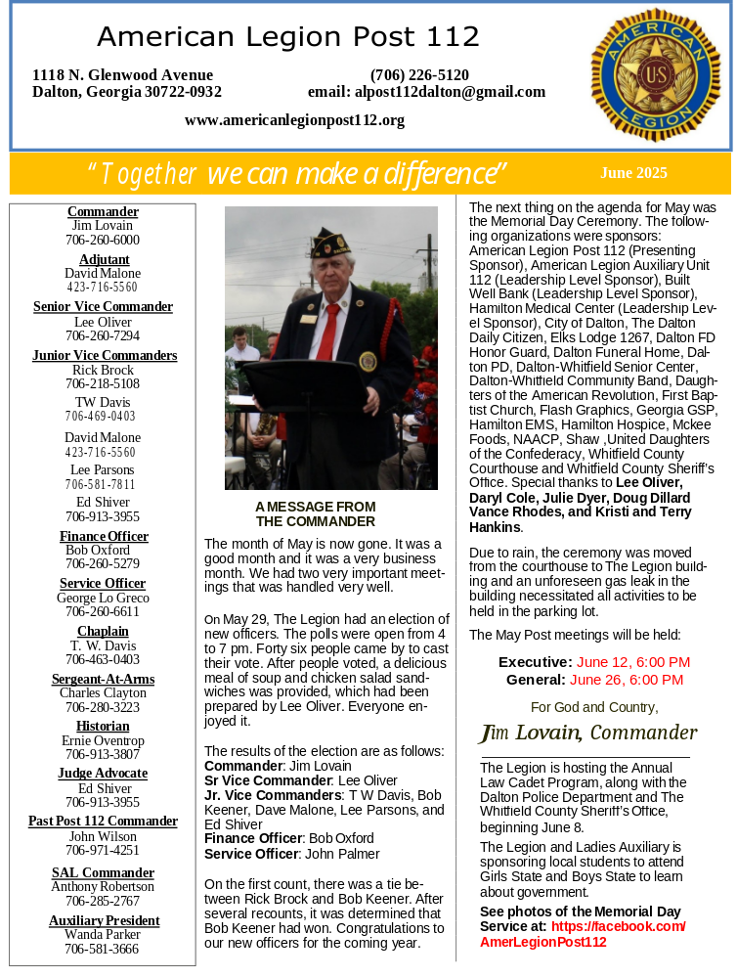

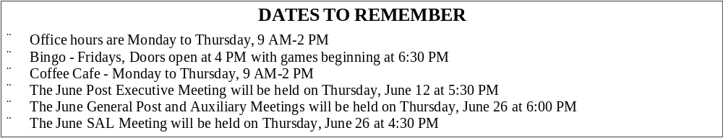

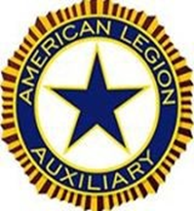
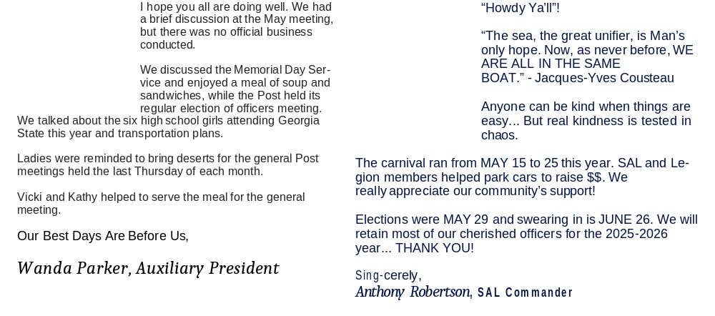

INDEX
TOPIC | PAGE
By-Laws | 23-29
Constitution | 19-22
Election Results | 18
Executive Committee Meetings | 30-42
General Membership Meetings | 43-55
Introduction | 3
Newsletters | 56-79
One Year Post History | 8-15
Organizational Chart | 16
Past Commanders | 17
Preamble | 4
Preample Explanation | 5
Post Chairman | 7
Post Officers | 6
Table of Contents | 2

