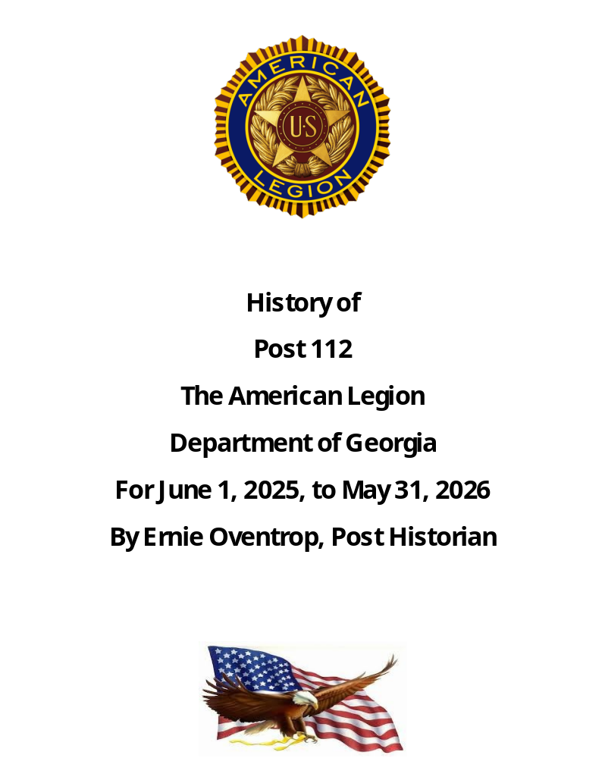

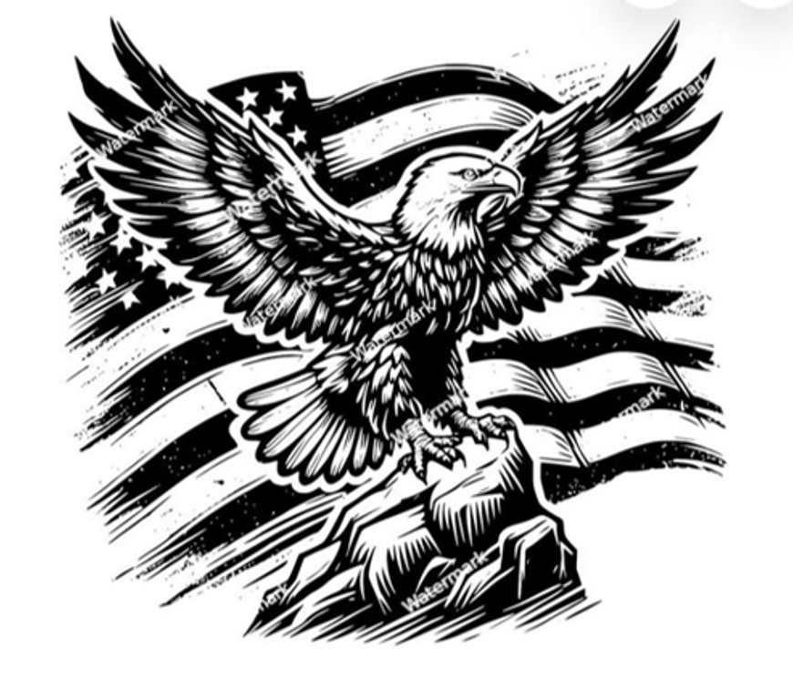

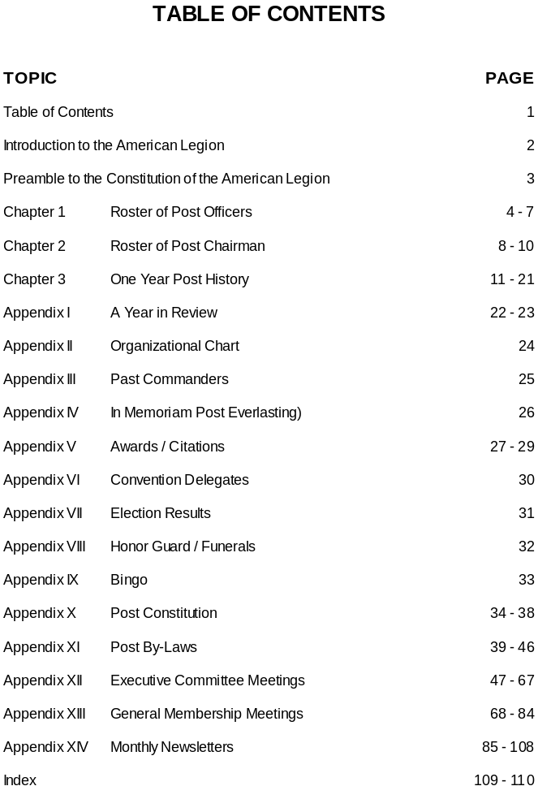
“Introduction to the American Legion”
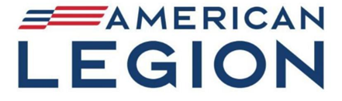

A group of 20 officers who served in the American Expeditionary Forces (AEF) in France during World War I is credited with founding the Legion. AEF Headquarters asked the officers to suggest ideas on how to improve troop morale. One officer, Lt. Col. Theodore Roosevelt Jr. proposed an organization of veterans. In February 1919, the group formed a temporary committee and selected several hundred officers who had the confidence and respect of the whole Army. About 1,000 officers and enlisted men attended the Paris Caucus in March 1919.
They adopted a temporary constitution and the name The American Legion. The group also elected an executive committee to complete the organization’s work. It considered each soldier of the AEF a member of the Legion. The executive committee named a committee to organize veterans at home in the United States.
In May 1919, the Legion held a second organizing caucus in St. Louis. It completed the constitution and made plans for a permanent organization, setting up temporary headquarters in New York City and beginning its relief, employment, and Americanism programs. Congress granted the Legion a national charter in September 1919. The first national convention convened in Minneapolis on Nov. 10-12, 1919, adopting a permanent constitution and electing officers to head the organization. Delegates also voted to locate the Legion’s national headquarters in Indianapolis, Indiana.
The Legion continues to support the four pillars of service and advocacy upon which it was founded: Veterans Affairs & Rehabilitation, National Security, Americanism, and Children & Youth.

Preamble to the Constitution of
The American legion

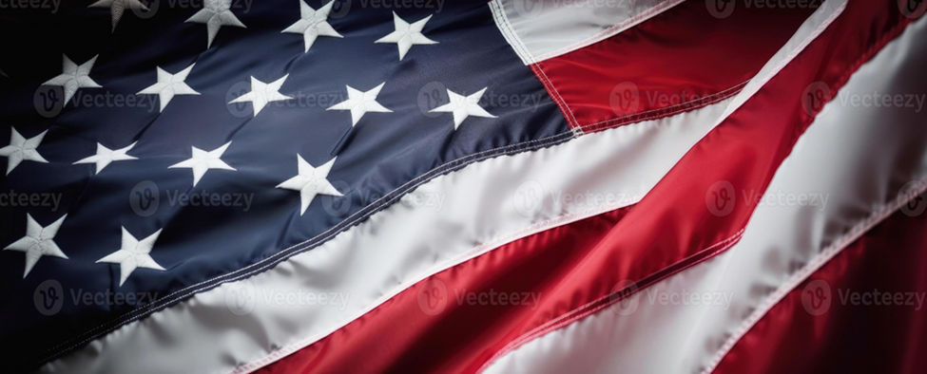

For God and Country, we associate ourselves together for the following purposes:

To uphold and defend the Constitution of the United States of America:

To maintain law and order:

To foster and perpetuate a one hundred percent Americanism:

To preserve the memories and incidents of our associations in all wars:

To inculcate a sense of individual obligation to the community, state, and nation:

To combat the autocracy of both the classes and the masses:

To make right the master of might:

To promote peace and goodwill on earth:

To safeguard and transmit to posterity the principles of justice, freedom, and democracy:

To consecrate and sanctify our comradeship by our devotion to mutual helpfulness:

CHAPTER I
ROSTER OF POST OFFICERS
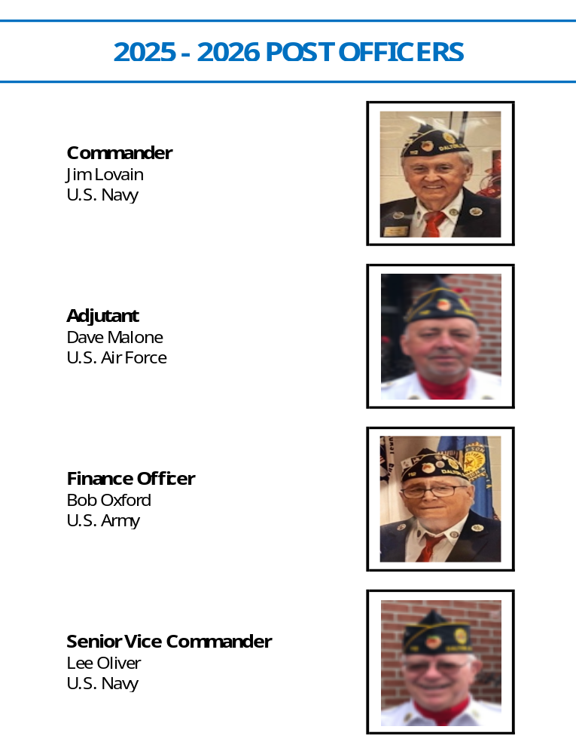
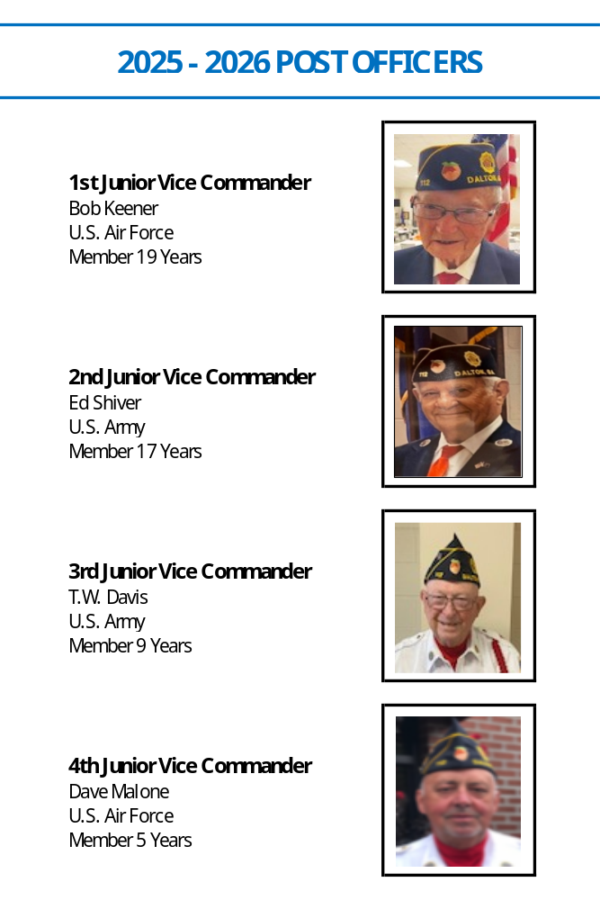
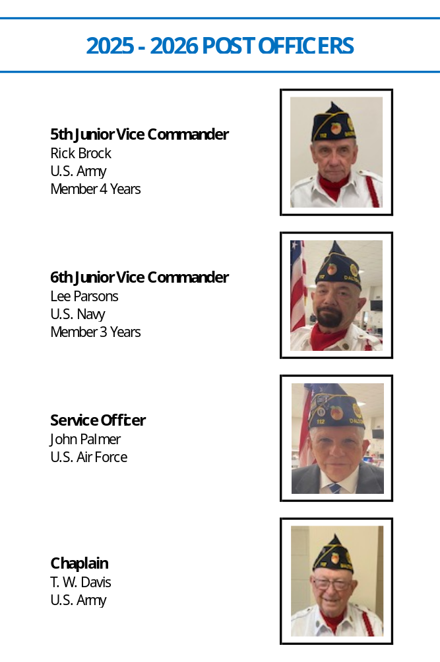
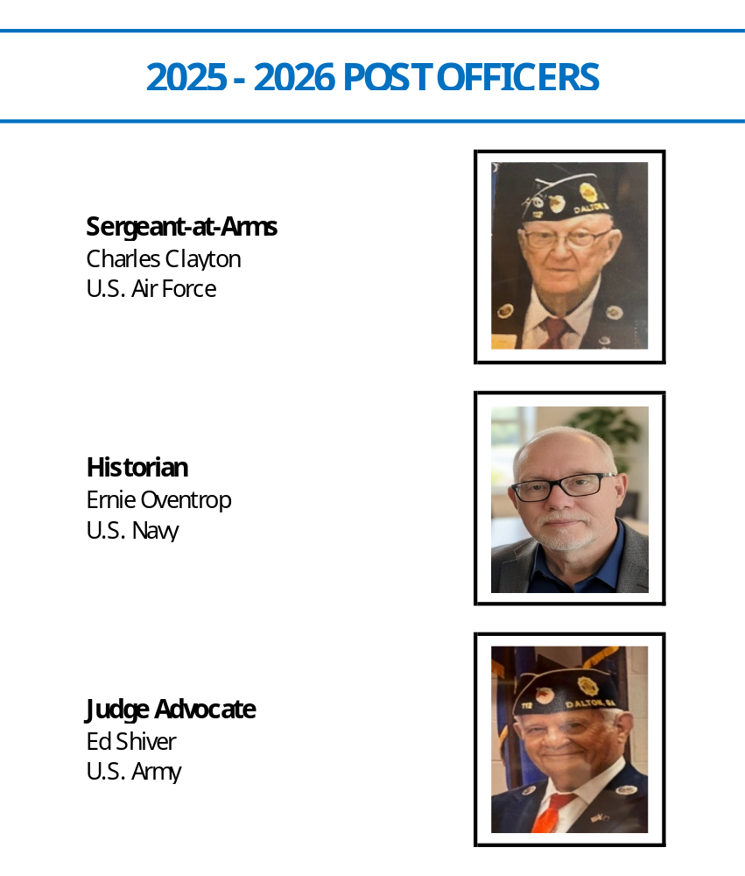

CHAPTER II
ROSTER OF POST CHAIRMAN
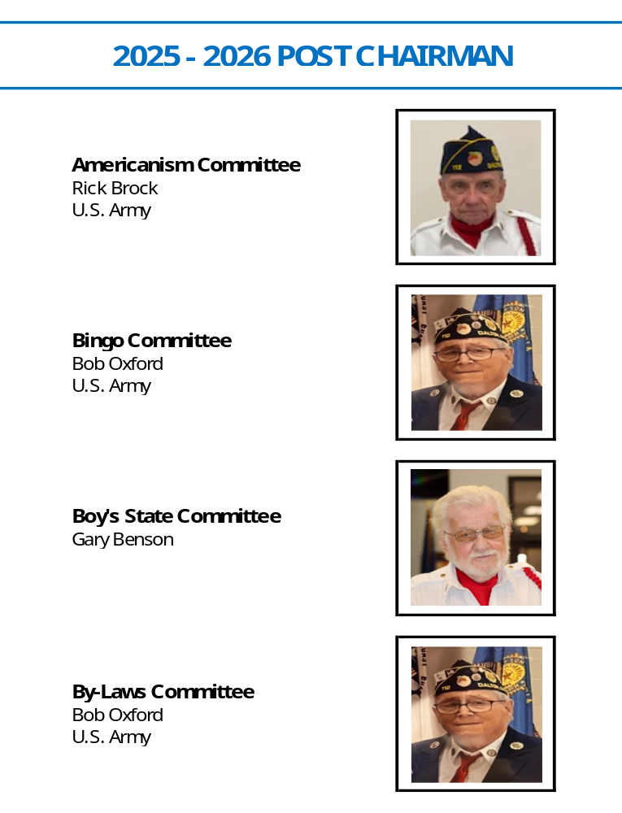
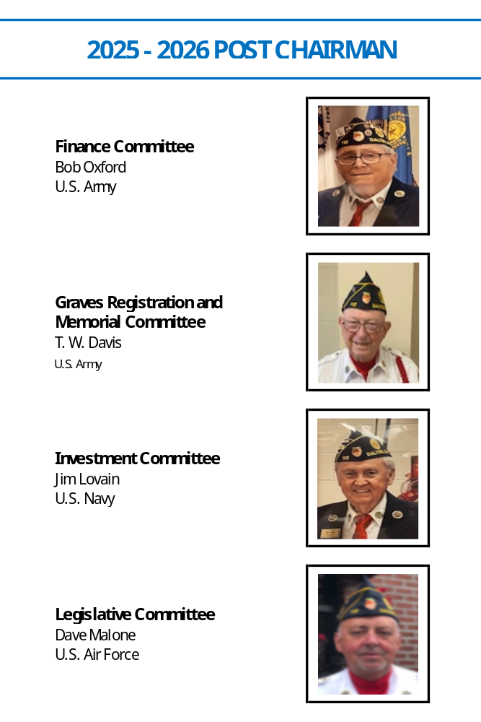
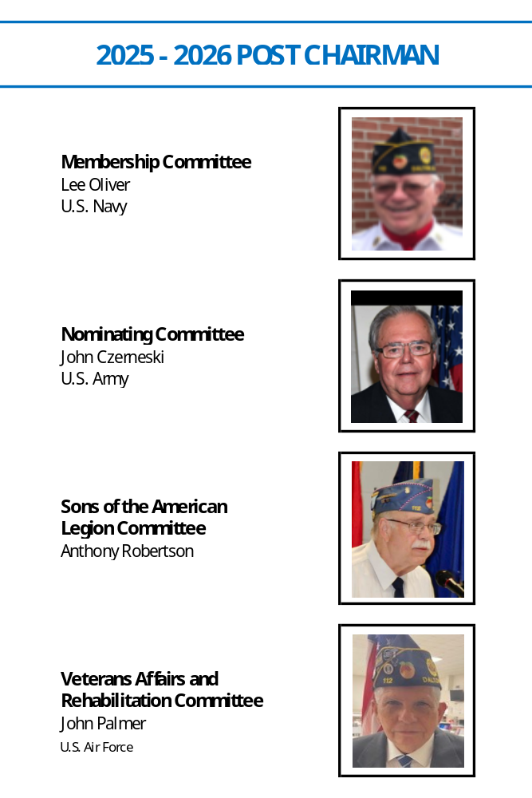
CHAPTER III
ONE-YEAR POST HISTORY

06-05-2025 National Commander Visit - American Legion Post 112 was deeply honored to host the National Commander James A. LaCoursiere Jr, during his tour visiting legion units throughout the United States.

06-05-2025 Veteran’s Booth – Post 112 set up a Booth at the Hamilton Medical Center, Dalton, Georgia, to provide an additional point of access for veterans who may have difficulty reaching a traditional VA facility.

06-06-2025 Bingo Night

.06-08-2025 Boys State - Post 112 sponsored 19 High School students from the Dalton Whitfield County School District to attend the annual American Legion Boy’s State Program at Valdosta State University.

06-09-2025 Law Cadet Summer Camp - Post 112, Whitfield County Sheriff’s Office, and the Dalton City Police Department, partnered for the 2025 Summer Law Cadet Academy, a weeklong program to educate young people interested in law enforcement careers.

06-12-2025 Executive Committee Meeting - (See pages 47-48 for details).

06-13-2025 Bingo Night

06-14-2025 Flag Day - A solemn and dignified flag retirement ceremony was conducted by members of Post 112. The ceremony provided a meaningful opportunity for the community to witness the respectful disposal of worn and faded flags. 32 flags were retired.

06-17-2025 Special Election Day - Post 112 partnered with local election officials to serve as a polling place.

06-17-2025 Veteran’s Appreciation Day - Post 112 partnered with Freedom Ranch for their 11th Annual Veteran’s Appreciation Day.

06-20-2025 Bingo Night

06-26-2025 General Membership Meeting - (See pages 68-69 for details).

06-27-2025 Department Convention – Commander Jim Lovain and Sr. Vice Commander Lee Oliver represented Post 112 at the Department of Georgia Convention in Duluth, GA.

06-27-2025 Bingo Night

07-03-2025 Avenue of Flags - Post 112 assisted in putting out flags at the Whitfield County Courthouse for the Independence Day Celebration.

07-04-2025 Independence Day - Post 112 celebrated Independence Day with its annual picnic, where hamburgers and hot dogs were served to veterans and their families.

07-07-2025 Avenue of Flags - Post 112 assisted in taking up flags at the Whitfield County Courthouse.

07-10-2025 Executive Committee Meeting – Cancelled (Building Renovations)

07-10-2025 Flag Retirement – 30 flags were retired on this date.

07-18-2025 Bingo Night

07-23-2025 Funeral / Honor Guard – Jennifer Tanner, U.S. Navy

.07-25-2025 Bingo Night.
07-28-2025 Funeral / Honor Guard – Jerry Miller, U.S. Army

07-31-2025 General Membership Meeting - (See pages 70 for details).

08-01-2025 Bingo Night

08-06-2025 Funeral / Honor Guard – Terry Cowan, U.S. Army

08-08-2025 Funeral / Honor Guard – William Stewart, U.S. Army

08-08-2025 Bingo Night

08-14-2025 Funeral / Honor Guard – Gary Crider, U.S. Army

08-14-2025 Executive Committee Meeting - (See pages 50-51 for details).

08-15-2025 Bingo Night

08-19-2025 Flag Retirement – 24 flags were retired on this date.

08-21-2025 Funeral / Honor Guard – William Young, U.S. Army

08-22-2025 Bingo Night

08-28-2025 General Membership Meeting - (See pages 71 for details).

08-29-2025 Funeral / Honor Guard – Larry Whitaker, U.S. Army

08-29-2025 Bingo Night

09-05-2025 Bingo Night

09-10-2025 Flag Retirement – 33 flags were retired on this date.

09-11-2025 Executive Committee Meeting - (See pages 52-53 for details).

09-12-2025 Bingo Night

09-15-2025 Funeral / Honor Guard – Larry Paul Fauscett, U.S. Army

09-15-2025 Funeral / Honor Guard – Steve Wilson, U.S. Army

09-19-2025 Funeral / Honor Guard – Gordon Parks, U.S. Army

09-19-2025 Bingo Night

09-24-2025 VA Clinic Cookout - Members of American Legion Post 112, the Ladies Auxiliary, and the Sons of the American Legion (SAL) held a cookout for veterans at the VA Medical Center in Chattanooga, Tennessee.

09-25-2025 General Membership Meeting - (See pages 72-73 for details).

09-26-2025 Bingo Night

09-30-2025 Funeral / Honor Guard – Luther King, U.S. Army

10-02-2025 Funeral / Honor Guard – Howard Hamilton, U.S. Army

10-02-2025 Funeral / Honor Guard – Clifford Cunningham, U.S. Marine Corps

10-03-2025 Bingo Night

10-07-2025 Funeral / Honor Guard – George Blackwell, U.S. Army

10-08-2025 Funeral / Honor Guard – Robert White, U.S. Air Force

10-09-2025 Executive Committee Meeting - (See pages 54-55 for details).

10-10-2025 Funeral / Honor Guard – Sandy Gene Parson, U.S. Army

10-10-2025 Bingo Night

10-17-2025 Bingo Night

10-21-2025 Funeral / Honor Guard - Silas Mason, U.S. Army

10-22-2025 Funeral / Honor Guard – Frank Brock, U.S. Air Force

10-23-2025 First Responders Appreciation - Post 112 hosted its annual First Responders Appreciation luncheon and banquet to honor the dedication and service of local Police, Firefighters, and Emergency Services personnel.

10-24-2025 Bingo Night

10-25-2025 Funeral / Honor Guard – William Manly, U.S. Air Force

10-31-2025 Bingo Night

11-02-2025 Flag Retirement – 38 flags were retired on this date.

11-04-2025 Election Day - Post 112 partnered with local election officials to serve as a polling place.

11-07-2025 Avenue of Flags - Members of American Legion Post 112 assisted in putting out flags at the Whitfield County Courthouse for the Veteran’s Day Celebration.

11-07-2025 Bingo Night

11-08-2025 Veteran’s Day Parade - In a powerful display of community solidarity and patriotic pride, Post 112 played a significant role in the city’s annual Veteran’s Day Parade. Legionnaires and members of the Legion Family marched in a vibrant procession to honor our nation’s heroes. The event, which drew hundreds of spectators, underscored the community’s deep-rooted respect for those who have served. Post 112 proudly recognized Lewis Headrick as its Veteran of the Year. This honor was bestowed in recognition of his exceptional dedication to the American Legion.

11-10-2025 Flag Appreciation - Members of American Legion Post 112 conducted a flag appreciation and history class at the Royal Oaks Assisted Living Facility in Dalton, Georgia. The program aimed to educate residents on the proper respect and history of the U.S. flag, a core tenet of the Legion’s mission. The class included a presentation on the evolution of the American flag, the meaning of its symbol, and the proper customs and courtesies outlined in the U.S. Flag Code. Post members demonstrated the correct procedure for folding the flag into the traditional triangular shape of a cocked hat and explained the significance of each fold. A special thanks goes out to Lee Oliver, Gary Benson, and Fred Denbleyker for dedicating their time to this important event.

11-11-2025 Northwest Elementary School’s Veteran’s Day Celebration - A special thanks to David Malone, Lee Oliver, Lee Parsons, and Anthony Robertson for their dignified presentation of colors at Northwest Elementary School’s Veteran’s Day Celebration.

11-12-2025 Avenue of Flags - Members of American Legion Post 112 assisted in taking up flags at the Whitfield County Courthouse.

11-13-2025 Executive Committee Meeting - (See page 56 for details).

11-14-2025 Funeral / Honor Guard – Jackie Deaton, U.S. Army

11-14-2025 Bingo Night

11-15-2025 District 7 Meeting - Hosted DOG District 7 quarterly meeting.

11-21-2025 Bingo Night

11-25-2025 Funeral / Honor Guard – Larry Wheeler, U.S. Army

11-27-2025 Thanksgiving Day - Post 112 continued its long-standing tradition of hosting a free Thanksgiving dinner open to the Post members, their families, and the local community. A total of 1,129 meals were served.

11-28-2025 Bingo Night

12-02-2025 Special Bingo Night – Post 112, in conjunction with the Down-Home Christmas Organization, organized a special bingo night to raise funds for the local community’s needy families. All proceeds were used to purchase and distribute food to families in need during the holiday season.

12-05-2025 Bingo Night

12-09-2024 Whitfield County Senior Center - American Legion Post 112 was invited to perform a POW/MIA Recognition Ceremony at the Whitfield County Senior Center’s annual “A Veteran’s Christmas” celebration. The centerpiece of the ceremony was the traditional Missing Man Table meticulously set up by Gary Benson and explained by Post Commander Jim Lovain. The ceremony was deeply moving, strengthening our resolve to support families and advocate for full accountability, reflecting the Legion’s core mission to honor and remember.

12-12-2025 Funeral / Honor Guard – Jerry Taylor, U.S. Navy

12-12-2025 Bingo Night

12-13-2025 Christmas Dinner – Post 112 continued its tradition of hosting an annual Veterans Christmas dinner. Over 60 veterans and their family members attended the festive event.

12-18-2025 Funeral / Honor Guard – Roy Pangle, U.S. Army

12-19-2025 Funeral / Honor Guard – Bill Riverman, U.S. Air Force

12-19-2025 Bingo Night

12-20-2025 Funeral / Honor Guard – John Vicker, U.S. Army

01-07-2026 Funeral / Honor Guard – Jerome Elliot, U.S. Army

01-07-2026 Funeral / Honor Guard – Fred Morgan, U.S. Army

01-08-2026 Flag Retirement – 32 flags were retired on this date.

01-08-2026 Executive Committee Meeting - (See pages 58-59 for details).

01-09-2026 Bingo Night

01-14-2026 Funeral / Honor Guard – James Rogers, U.S. Army

01-15-2026 Funeral / Honor Guard – Ronald Underwood, U.S. Army

01-16-2026 Bingo Night

01-23-2026 Bingo Night

01-23-2026 Funeral / Honor Guard – Jason Reed, U.S. Army

01-23-2026 Funeral / Honor Guard – James Barron, U.S. Army

01-29-2026 General Membership Meeting - (See page 77 for details).

01-30-2026 Bingo Night

02-05-2026 Funeral / Honor Guard – Clyde Marley, U.S. Army

02-06-2026 Bingo Night

02-07-2026 Oratorical Contest - Post 112 proudly hosted District 7’s annual American Legion High School Oratorical Scholarship Contest. This year’s event featured student speakers from local high schools, delivering prepared orations on the U.S. Constitution, followed by an assigned topic presentation.

02-12-2026 Executive Committee Meeting - (See pages 60-61 for details).

02-13-2026 Bingo Night

02-14-2026 Townhall Meeting. Americal Legion Post 112 hosted a Candidate Forum for the Georgia Congressional District 14 Special Election.

02-14-2026 Funeral / Honor Guard – Larry Plumley, U.S. Army

02-18-2026 Flag Retirement – 41 flags were retired on this date.

02-19-2026 League of Women Voters – Post 112 provided transportation for 13 students from local High Schools to the state capital where they experienced Democracy in action.

02-20-2026 Funeral / Honor Guard – Cliff Hudgens, U.S. Army

02-20-2026 Bingo Night

02-26-2026 General Membership Meeting - (See pages 78-79 for details).

02-27-2026 Bingo Night

03-02-2026 Funeral / Honor Guard – William Archie, U.S. Army

03-03-2026 Funeral / Honor Guard - Herman O’Neal, U.S. Army

03-06-2026 Bingo Night

03-08-2026 Funeral / Honor Guard – Delbert Stancill, U.S. Army

03-09-2026 Veterans Resource Fair – Post 112 hosted a Veterans Resource Fair today.

03-10-2026 Georgia’s 14th Congressional District Special Election - Post 112 partnered with local election officials to serve as a polling place.

03-11-2026 Flag Retirement – 7 flags were retired on this date.

03-12-2026 Executive Committee Meeting - (See pages 62-63 for details).

03-13-2026 Bingo Night

03-20-2026 Bingo Night

03-25-2026 Funeral / Honor Guard – Harris Thomason, U.S. Army

03-26-2026 General Membership Meeting - (See pages 80-81 for details).

03-27-2026 Funeral / Honor Guard – Fred Mason, U.S. Navy

03-27-2026 Bingo Night

03/29/2026 American Legion Birthday - Today we celebrate the American Legion’s 107th Birthday.

03-31-2026 Funeral / Honor Guard – Steven Jeffers, U.S. Air Force

04-02-2026 Vet to Vet Event – The Georgia Vet to Vet Organization, offered free, confidential peer support for veterans in Dalton and nearby areas. Volunteers help with benefits, disability claims, healthcare, outreach, and resource connections.

04-03-2026 Funeral / Honor Guard – Ira Padgett, U.S. Air Force

04-03-2026 Bingo Night

04-04-2026 Funeral / Honor Guard – Charles DeFore, U.S. Navy

04-07-2026 Georgia’s 14th Congressional District Run Off Election - Post 112 partnered with local election officials to serve as a polling place.

04-09-2026 Funeral / Honor Guard – Eddie Stainton, U.S. Army

04-09-2026 Executive Committee Meeting - (See pages 64-65 for details).

04-10-2026 Bingo Night

04-12-2026 Veteran’s Appreciation Day - Post 112 partnered with Freedom Ranch for the 12th Annual Veteran’s Appreciation Day.

04-15-2026 Funeral / Honor Guard – Odis Stinnett, U.S. Army

04-16-2026 Funeral / Honor Guard – James Echols, U.S. Air Force

04-17-2026 Bingo Night

04-21-2026 Funeral / Honor Guard – Ellis Payne, U.S. Army

04-24-2026 Bingo Night

04-30-2026 General Membership Meeting - (See pages 82-83 for details).

05-01-2026 Bingo Night

05-02-2026 Membership Drive – Led by Membership Chairman Lee Oliver, Post 112 held a membership drive at Food City on 1308 W Walnut Avenue to connect with local veterans. The event added seven new members and six prospective members. Eight Legionnaires staffed tables and handed out brochures promoting American Legion benefits.

05-05-2026 Flag Retirement – 58 flags were retired on this date.

05-06-2026 Vet to Vet Event – Post 112 hosted the Georgia Vet to Vet Organization, offering free, confidential peer support for veterans in Dalton and nearby areas. Veteran volunteers help with benefits, disability claims, healthcare, outreach, and resource connections.

05-07-2026 Funeral / Honor Guard – Max Baker, U.S. Army

05-08-2026 Funeral / Honor Guard – Samuel Chastain, U.S. Army

05-08-2026 Bingo Night

05-12-2026 Funeral / Honor Guard – Glenn Flood, U.S. Army

05-14-2026 Executive Committee Meeting - (See pages 66-67 for details).

05-15-2026 Bingo Night

05-16-2026 Gator Walk – Post 112 presented colors at Heritage Park Gator Walk.

05-16-2026 District 7 Meeting - On this date, Commander Jim Lovain, Sr Vice Commander Lee Oliver, and Dewey Moss represented Post 112 at the DOG District 7 meeting in Lindale, Georgia.

05-19-2026 Primary Election Day - Post 112 partnered with local election officials to serve as a polling place.

05-19-2026 Funeral / Honor Guard – William Stewart, U.S. Army

05-22-2026 Funeral / Honor Guard – Curtis Mathis, U.S. Marine Corps

05-22-2026 Avenue of Flags - American Legion Post 112 assisted with the annual Avenue of Flags Ceremony Friday May 22, 2026. The flags are placed on every patriotic holiday throughout the year however, Memorial Day serves a specific and special purpose. Thank you to the men and women who selflessly served our country and paid the ultimate price for our freedom.

05-22-2026 Bingo Night

05-24-2026 Spring Fair Parking Fundraiser - This year’s annual spring fair parking project was once again a major success for Post 112. Over the course of the ten-day county fair, members volunteered to direct vehicles, collect parking fees, and ensure a safe and welcoming experience for visitors. Funds raised will support our veterans’ assistance programs and community outreach efforts. We extend our gratitude to every member who gave their time in support of this fundraiser.

05-25-2026 Memorial Day Celebration – Post 112 hosted the City of Dalton’s annual Memorial Day Tribute. The event, which drew a large crowd, commenced at 10:00 with a welcome address by Post Commander Jim Lovain. The program featured a guest speaker, Senator Chuck Payne, a wreath laying, a 21-gun salute by the Honor Guard, and a rendering of Taps. The Post subsequently hosted a community luncheon at the Legion Hall, reinforcing our commitment to honoring our fallen heroes and connecting with local families.

05-27-2026 Avenue of Flags - Members of American Legion Post 112 assisted in taking up flags at the Whitfield County Courthouse for Veteran’s Day Celebration.

05-28-2026 Geneal Membership Meeting – Election Night for Fiscal Year 2026-2027 Post Officers (See page 84 for details).

05-29-2026 Bingo Night

APPENDIX I
COMMANDER’S YEAR IN REVIEW

1. Veteran’s Affairs & Rehabilitation

● Service Officer helped 23 veterans successfully navigate and secure VA disability claims and healthcare benefits.

● Post 112 and the Sons of the American legion (SAL) held a cookout for veterans at the VA Medical Center in Chattanooga, Tennessee, serving more than 200 meals.

● Donated $12,000 to local organizations supporting veterans and the broader community.

● Provided Military Honors at 51 funerals.

2. Children & Youth

● Donated $10,000 to the Boy Scouts of America for Camp Sidney Dew Renovations.

● Provided 1,129 free Thanksgiving meals to members of the community.

3. Americanism

● Hosted the City of Dalton’s 2025 4th of July Celebration.

● Organized Dalton, Georgia’s 2025 Veteran’s Day Parade.

● Sponsored 4 local high school students in the American Legion High School Oratorical Scholarship Program.

● Sponsored 19 high school students to attend Boys State.

● Hosted the City of Dalton’s 2026 Memorial Day Tribute.

● Retired 295 worn American flags with dignity.

● Our weekly Bingo program continued to be a cornerstone of our community outreach and fundraising efforts this year. Hosted every Friday evening, the program drew an average weekly attendance of 100 players. These funds directly support our Post’s local programs, provide emergency financial assistance to area veterans and fund our annual Thanksgiving Community Meal.

4. National Security

● Partnered with the Whitfield County Sheriff’s office and the Dalton City Police Department for the 2025 Summer Law Cadet Academy

● Hosted a First Responders Appreciation luncheon and banquet on Thursday, October 23, 2025, honoring local police, firefighters, and emergency service personnel.

Post Operations & Membership

● Hall Renovations: Completed the following projects – Replaced air conditioning units, awnings, plumbing replacing 5 toilets, and painted the membership hall.

Looking Ahead

● As we close out this highly successful term, I want to thank our volunteers, executive committee, and community partners. Next year, our focus will be on recruiting younger veterans. We look forward to your continued support in the coming year.

For God and Country,

Jim Lovain

Jim Lovain
Commander, Post 112

APPENDIX II
ORGANIZATIONAL CHART
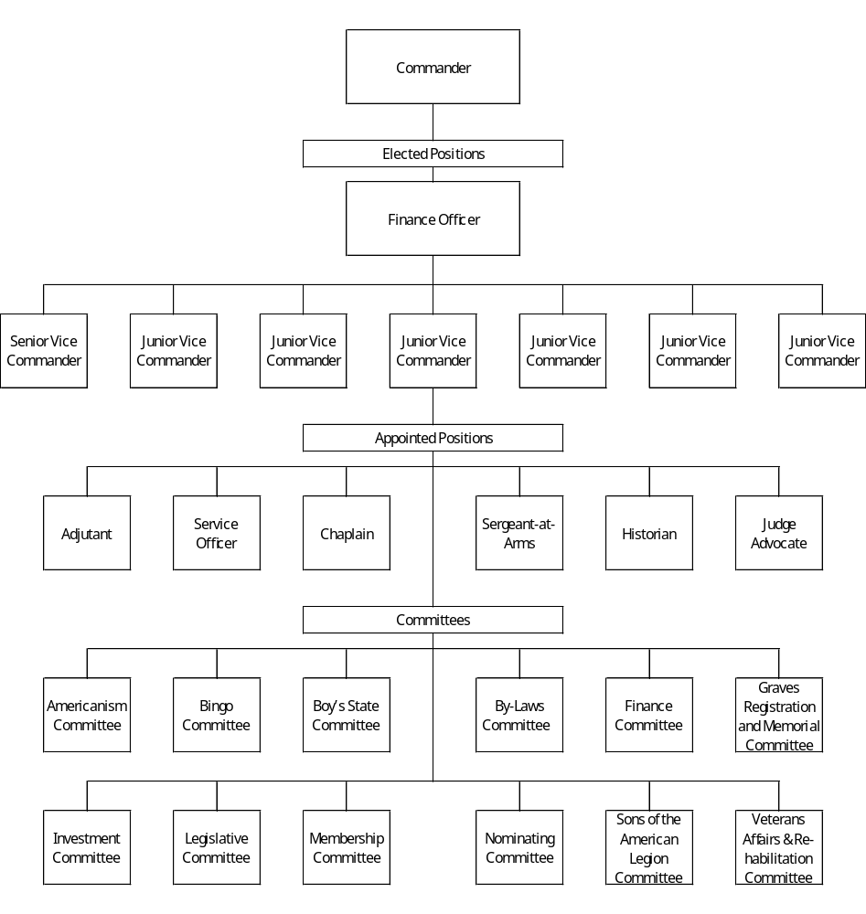

APPENDIX III
PAST COMMANDERS

Gordon Mann 1920–1925 David Pennington 1958
J. H. Steed 1926 Robert L Byers 1959-1961
R. W. Felker 1927 G L Moore 1962-1964
L. A. Weems 1928 Wayne Nations 1965
Clayton Ault 1929 Frank L Means 1966
W. J. Single 1930 Robert L Byers 1967-1968
Claude Miller 1931 Jack Sayre 1969
H. L. Trammel 1932-1933 Robert L. Byers 1970
M. H. Linn 1934 Ben H Millican 1971
H. L. Trammel 1935 Lamar Crow 1972-1973
W. H. Lumpkin 1936 William C Masters 1974-1975
Lyle Weems 1937 Billy A Broom 1976-1977
Sandford Carr 1938 Calvin Huggins 1978
Sam Weed 1939 George P King 1979
R. H. Gregory 1940 Milton Thomas 1980-1984
C. C. Hill 1941 Winfred Deal 1985
Rob Hamilton 1942-1943 Ralph Graves 1986-1988
W. H. Southern 1944-1945 Milton Thomas 1989-1995
E. P. Bright 1946-1947 Cain Vinsant 1996-2003
John McLellan 1948 John Paul Bledsoe 2003-2005
J.T. Looper 1949 Bob Turner 2005-2006
James Steed 1950 Bob Campbell 2006-2007
Dean Smith 1951-1953 John Paul Bledsoe 2007-2009
J L Millsap 1954 Dewey Moss 2009-2015
Joseph Stevens, Jr 1955 Lee Oliver 2015-2020
Tom Miner III 1956-1957 John Wilson 2020-2023

APPENDIX IV
IN MEMORIAM (POST EVERLASTING)

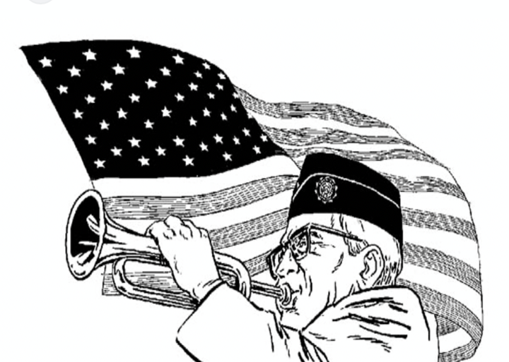
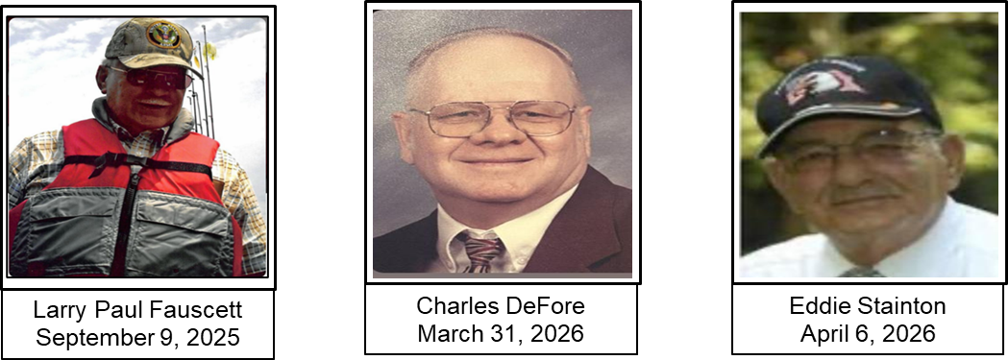

APPENDIX V
AWARDS / CITATIONS


2024 – 2025 Post History Award

It is with great pride and gratitude that Post 112 announces its recent recognition for outstanding chronicle keeping. Out Post was awarded First Place / Best Narrative in the Department of Georgia Post History Contest.

This comprehensive report, compiled by Post Historian Ernie Oventrop, documents our Post’s journey from July 1, 2024, to June 30, 2025. It captures the dedication of our Legionnaires, our Boys State sponsorships, Scout Unit support, and our ongoing commitment to the Dalton, GA community.

This achievement would not have been possible without the continued participation, and volunteer efforts of every member in our American Legion Family. By recording these milestones, our Post preserves a lasting, award winning legacy of veterans strengthening America.




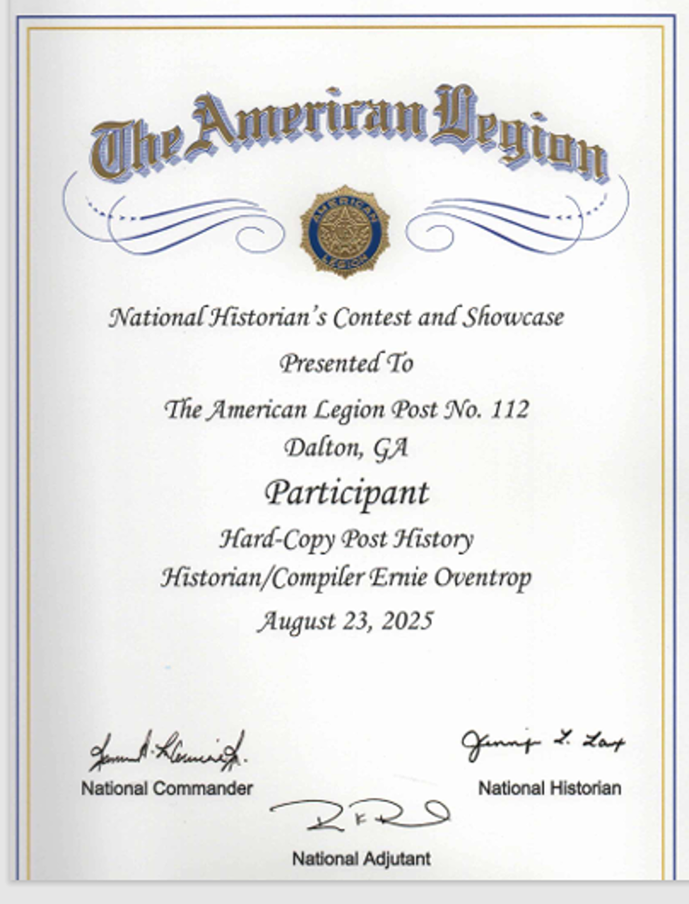

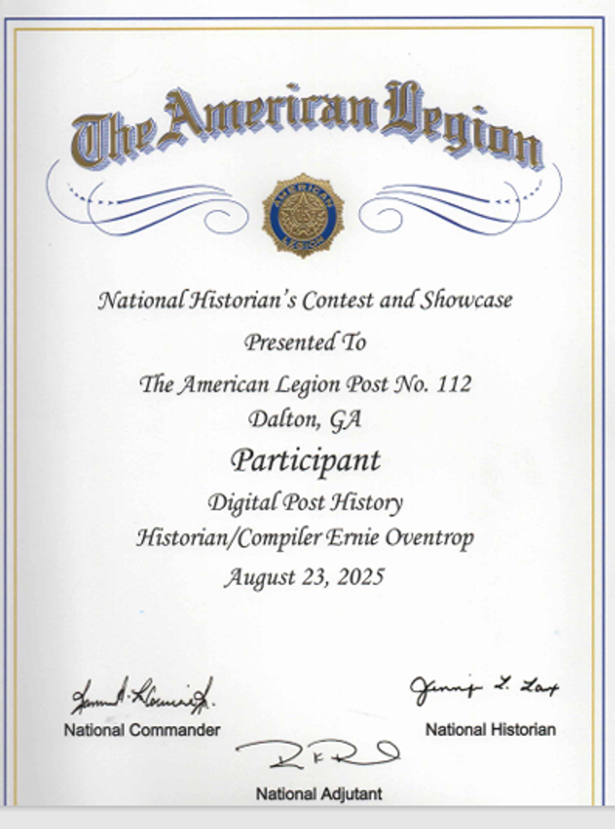

APPENDIX VI
CONVENTION DELEGATES

The following Legionnaires were duly elected to represent Post 112 at the Department of Georgia’s 106th Annual Convention in Duluth, Georgia from June 27 through June 29, 2025:

Delegates:

● Jim Lovain (Post Commander)

● Lee Oliver (Sr. Vice Commander)

The following Legionnaires were duly elected to represent Post 112 at the Department of Georgia Mid-Winter Convention in Duluth, Georgia from January 30 through February 2, 2026:
Delegates:

● Jim Lovain (Post Commander)

● Lee Oliver (Sr. Vice Commander)

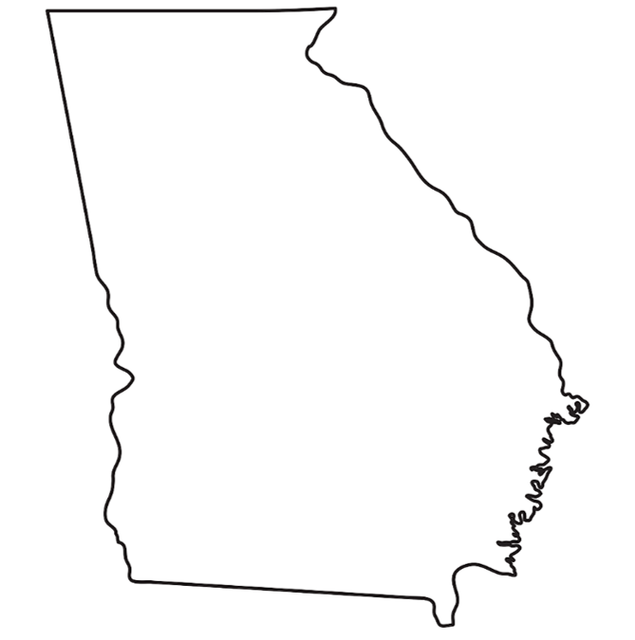

.

APPENDIX VII
ELECTION RESULTS

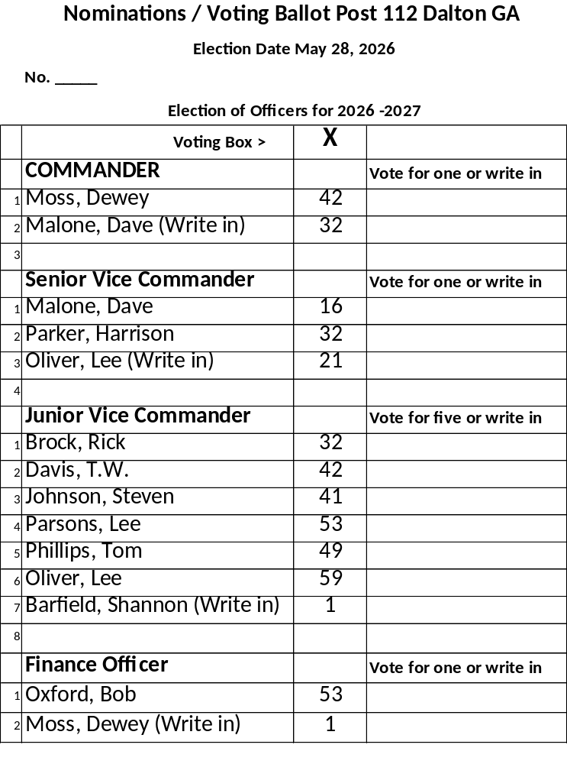

APPENDIX VIII
HONOR GUARD / FUNERALS

Over the past twelve months, the Post Honor Guard has remained one of our most visible and dedicated groups, serving the community with solemn pride. The guard provided full military funeral honors for 51 local veterans, including the traditional three-volley rifle salute, Taps, and ceremonial flag folding for the next of kin.

The Post extends its condolences to the families of the following veterans and expresses its gratitude for their service.

Jennifer Tanner, U.S. Navy Ronald Underwood, U.S. Army
Jerry Miller, U.S. Army Jason Reed, U.S. Army
Terry Cowan, U.S. Army James Barron, U.S. Army
William Stewart, U.S. Army Clyde Marley, U.S. Army
Gary Crider, U.S. Army Larry Plumley, U.S. Army
William Young, U.S. Army Cliff Hudgens, U.S. Army
Larry Whitaker, U.S. Army William Archie, U.S. Army
Larry Fauscett, U.S. Army Herman O’Neal, U.S. Army
Steve Wilson, U.S. Army Delbert Stencill, U.S. Army
Gordon Parks, U.S. Army Harris Thomason, U.S. Army
Luther King, U.S. Army Fred Masters, U.S. Navy
Howard Hamilton, U.S. Army Steven Jeffers, U.S. Air Force
Clifford Cunningham, U.S. Marine Corps Ira Padgett, U.S. Air Force
George Blackwell, U.S. Army Charles DeFore, U.S. Navy
Robert White, U.S. Air Force Eddie Stainton, U.S. Army
Sandy Parsons, U.S. Army Odis Stinnett, U.S. Army
Silas Mason, U.S. Army James Echols, U.S. Air Force
Frank Brock, U.S. Air Force Ellis Payne, U.S. Army
William Manly, U.S. Air Force Max Baker, U.S. Army
Jackie Deaton, U.S. Army Samuel Chastain, U.S. Army
Larry Wheeler, U.S. Army Glenn Flood, U.S. Army
ROY Pangle, U.S. Army William Stewart, U.S. Army
Bill Riverman, U.S. Air Force Curtis Mathis, U.S. Marine Corps
John Vicker, U.S. Army
Jerome Elliot, U.S. Army
Fred Morgan, U.S. Army
James Rogers, U.S. Army

APPENDIX IX


Our weekly Post Bingo program remained the cornerstone of our community outreach and fundraising efforts this past year. Managed by Post 112 volunteers, these sessions attracted an average of 100 players per week. The revenue generated directly subsidized our veteran’s assistance programs, providing emergency relief grants, and transportation to VA clinic appointments. Beyond fundraising, the weekly bingo nights serve as a social hub for the local Dalton, Georgia community.



APPENDIX X
POST CONSTITUTION

PREAMBLE

For God and Country, we associate ourselves together for the following purpose: to uphold and defend the Constitution of the United States of America; to maintain law and order; to foster and perpetuate a one hundred percent Americanism; to preserve the memories and incidents of our associations in all wars; to inculcate a sense of individual obligation to the community, state, and nation; to combat the autocracy of both the classes and masses; to make right the master of might; to promote peace and good will on earth; to safeguard and transmit to posterity the principles of justice, freedom and democracy; to consecrate and sanctify our comradeship by devotion to mutual helpfulness.

ARTICLE I
NAME

Section 1. The name of the organization shall be American Legion Post 112, American Legion Department of Georgia.

ARTICLE II
OBJECTS

Section 1. The objects and purposes of this Post shall be to promote the principles and policies as set forth in the foregoing preamble, and the National and Department Constitution of the American Legion.

ARTICLE III
NATURE

Section 1. This Post is a civilian veteran’s service organization, and membership therein does not affect or increase liability for military or police service.

Section 2. This organization shall be absolutely non-political and shall not be used for the dissemination of partisan principles nor for the promotion of the candidacy of any person seeking office or preferment.

Section 3. Rank does not exist in the American Legion; no member shall be addressed by his or her military or naval title in any meeting of the Post.

Section 4. This organization shall be non-profit.

ARTICLE IV
MEMBERSHIP

Section 1. Eligibility to membership to the Post shall be as prescribed by the National Constitution of the American Legion.

Section 2. Application for membership shall be made in writing under such regulations as may from time to time be prescribed by the Post Executive Committee. Applicant must be able to furnish a copy of his or her DD-214 and have an Honorable Discharge or under Honorable Conditions Discharge.

Section 3. All applications for membership shall be acted upon at the next Post meeting following such application and after a positive background check has been completed. Judge Advocate shall contact the previous Post of any transferring members to assure there are no negative issues the Post should be aware of. At such meeting the applicant shall be accepted, rejected, or referred to further investigation and consideration. If the majority of members present vote against the acceptance of such application, then such application shall be recorded as rejected. A rejected applicant shall not then be considered until after the expiration of six months from the date of such rejection.

Section 4. Any member of this Post may be expelled or suspended for cause by two thirds majority vote of the membership present at the regular meeting of the post after charges are preferred under oath in writing, and a fair trial has been held upon the member in accordance with procedures prescribed by the National and Department Executive Committees.

Section 5. A member who has been expelled or suspended from the Post for any cause may be reinstated by two thirds majority vote of membership present in the Post meeting and the payment of current dues for the year in which the reinstatement occurs.

Section 6. No person who has been expelled by a Post shall be admitted to membership in another Post without the consent of the expelling Post, except that where such consent has been asked for and denied by each Post he may then appeal to the Department of Georgia Executive Committee for permission to apply for membership to another Post and shall be ineligible for membership until such permission is granted. This process is handled by the Post Judge Advocate.

ARTICLE V
OFFICERS

Section 1. The administrative affairs of Post 112 of the American Legion shall, except as may be otherwise provided by the by-laws, be under the supervision of the Post Executive Committee which shall consist of the elected and appointed officers of the post and immediate past commander.

Section 2. The Officers of the Post shall be a Commander, Senior Vice Commander, five (5) Junior Vice Commanders, Finance Officer, who are elected. Plus, Adjutant, Service Officer, Historian, Chaplain, Sergeant-at-Arms, and Judge Advocate, who are appointed. The Commander, Senior Vice Commander, Five Junior Vice Commanders, and Finance Officer shall be elected by the Membership and shall comprise the voting officers of the Executive Committee. The voting officers of the Post shall be entitled to one vote only, even if they currently hold two positions that normally are entitled to vote. The Commander only votes in the event of a tie. In addition to the aforementioned elected officers, the immediate Past Commander shall have a vote in the affairs of the Executive Committee. The Adjutant, Service Officer, Historian, Chaplain, Sergeant-at-Arms and Judge Advocate shall be appointed by the Commander and will be members of the Executive Committee with voice only and no vote.

Section 3. All officers shall be elected or appointed annually, and they will hold office until successors are duly installed or as otherwise provided. Any officer may be removed for inefficiency or malfeasance by the Executive Committee, two-thirds majority vote of said committee being necessary to affect such removal. Election of officers shall be no earlier than fifteen (15) days and no later than sixty (60) days prior to the Department Convention.

Section 4. Every member of the Post in good standing shall be eligible to hold office in this Post.

Section 5. The duties of Officers are prescribed by the Department of Georgia by-laws and by the Post by-laws.

ARTICLE VI
FINANCE

Section 1. The revenue of the Post shall be derived from annual membership dues and from such other sources as may be provided by vote of the Post Executive Committee.

Section 2. The amount of annual Post dues shall be fixed and determined by the Post Executive Committee.

Section 3. The Post shall pay National and Department Headquarters annual membership dues for every member of the Post.

ARTICLE VII
CHARTER MEMBERS

Section 1. Members of the Post prior to the issuance of Charter shall be known as Charter Members.

ARTICLE VIII
AMERICAN LEGION AUXILARY

Section 1. The Post recognizes an auxiliary organization to be known as the Auxiliary Unit of American Legion Post 112 Department of Georgia.

Section 2. Membership in the Auxiliary unit shall be as prescribed by the National Constitution and By-Laws of the American Legion Auxiliary.

ARTICLE IX
AMENDMENTS

Section 1. This Constitution is adopted subject to the provisions of the National Constitution of the American Legion and of the Department of Georgia. Any amendments to said National Constitution of the American Legion and the Constitution of the Department of Georgia, which is in conflict with any provisions hereof, shall be regarded as automatically repealing or modifying the provisions of the Constitution to the extent of such conflict.

Section 2. This Constitution may be amended at any regular scheduled post meeting providing that the proposed amendment shall have been submitted in writing and read at the previous regularly scheduled meeting of the post and providing further that written notice shall have been given to all members at least ten (10) days in advance of the date when such amendment is to be voted upon, notifying said members that at such meeting a proposal to amend the constitution is to be voted upon.

ARTICLE X
AUTHENTICATION

Section 1. The Constitution was read at the regularly scheduled meeting held on January 11, 2024, and all members were notified of their proposed adoption at least the (10) days prior to the regularly scheduled meeting held on January 25, 2024. This Constitution was adopted at the regularly scheduled meeting held on January 25, 2024, by at least two-thirds majority and repeals the previous Constitution and amendments thereto.

Signed: ___Jim Lovain___ Commander, American Legion Post 112

APPENDIX XI
POST BY-LAWS

ARTICLE I
GENERAL

Section 1. The Post existing under these by-laws is to be known as American Legion Post 112 Department of Georgia.

Section 2. The objects and purposes of Post 112 shall be to promote the principles and policies as set forth in the foregoing preamble and the Post By-Laws stated in this document, National and Department Constitution of the American Legion.

ARTICLE II
MANAGEMENT

Section 1. The government and management of Post 112 is entrusted to the Post Executive Committee as set forth in the Post Constitution.

Section 2. The Executive Committee shall be composed of all currently elected and appointed officers of Post 112. The officers of the Post shall be elected or appointed annually at the last regularly scheduled meeting of the Post prior to the date of the Department Convention and shall take office at the next regularly scheduled meeting following the Department Convention.

Election of officers shall be by written ballot, and the candidates must receive a simple majority of the votes of the members present and eligible to vote. In the event there are more than two members nominated for an office and if there is not a majority, the two members receiving the highest totals must have a runoff to determine who is to be elected. The runoff must take place before the next regularly scheduled meeting and before the installation ceremony. In the election of the five (5) Junior Vice Commanders, the five receiving the highest totals shall be considered elected. There will be no nominations from the floor on the night of the election. However, write-in candidates, the night of the election are allowed and will be considered viable and legal candidates for office. Candidates for election must be announced thirty (30) days prior to the election by a committee appointed by the Commander. A space shall be provided on the ballot for write-in candidates. A list of all qualified candidates and the office they seek will be published in the Post 112 newsletter 30 days before the election.

ARTICLE III
POST EXECUTIVE COMMITTEE

Section 1. The Post Executive Committee shall meet for organizational, and such other business as may come before it on the second Thursday of the month at a time determined by the Executive Committee at the Post home after the installation of new officers. Thereafter the Post Executive Committee shall regularly meet at the previously determined time. The Commander shall call a special meeting of the Post Executive Committee upon the written request of three (3) members or more of the Post Executive Committee. Proper notice of not less than ten (10) days must be sent to all members of the Post Executive Committee via the best available method. Five (5) voting members of the Post Executive Committee shall constitute a quorum thereof. Voting during Post Executive Meetings shall be by raising hands when requested. Any item presented for consideration before the Executive Committee that requires an expenditure of $10,000 or more must be referred to the General Meeting for further action after approval by the Executive Committee.

Section 2. The Post Executive Committee is empowered to hire such employees as may be necessary for the operation and maintenance of the Post, shall authorize and approve all necessary expenditures for operations and maintenance, shall require adequate bonds from persons having custody of Post funds, shall hear reports of Post committee chairmen, and generally, shall have charge of and be responsible for the management of the affairs of the Post, approve or disapprove of all appointments of standing committees. Persons authorized to have custody of Post funds shall be Commander, Finance Officer, Adjutant, and Bingo Chairman.

Section 3. The Post Executive Committee shall make recommendations for major repairs, renovations, improvements, and changes of operation to the Post. This type of expenditures or changes in operations will not be made until the minutes of the meeting are read and approved at the next regularly scheduled meeting of the Post. The exception to this provision will be when a necessary repair constitutes an item or situation that would generally be interpreted as an emergency. The Post Commander shall have the authority to approve expenditures deemed to be an emergency.

Section 4. The Post Adjutant shall act as secretary for the Post Executive Committee and will transcribe necessary minutes which will be presented at the next regularly scheduled meeting of the Post. The members of the Post may disapprove of any action under Section 3, Article III hereto by a majority vote of all members present. Votes will be conducted by a show of hands at both Executive Committee meetings and at the monthly General Membership meeting. Minutes approved by the General Meeting are considered final.

ARTICLE IV
DUTIES OF OFFICERS

Section 1 - Duties of the Post Commander: It shall be the duty of the Post Commander to preside at all meetings of the Post, and to have general supervision over the business and affairs of the Post and such officer shall be the Chief Executive Officer of the Post. The Commander shall approve all orders directing the disbursement of funds and shall make an annual report covering the business of the Post for the year and recommendations for the ensuing year, which shall be read at the annual meeting a copy thereof immediately forwarded to the Department Adjutant. The Commander is considered to be an ex officio member of all standing committees of the post. The Commander shall perform such other duties as directed by the post.

Section 2 - Duties of the Senior Vice Commander: The Senior Vice Commander shall assume and discharge the duties of the office of Commander in the absences or temporary disability of the Commander, or when called upon by the Post Commander. In the event of the vacancy of the office of Post Commander, the Senior Vice Commander shall succeed to the office of Post Commander without further elections. The Senior Vice Commander shall be Chairman of Post Membership Committee.

Section 3 - Duties of the Junior Commanders: The Junior Commanders shall perform specific functions respectively assigned to them by the Post Commander and such other duties as are usually incident to their office. In the event of the vacancy of the office of Senior Vice Commander, one of the Junior Vice Commanders shall be selected to succeed to the office of Senior Vice Commander by the Post Executive Committee with the approval of the Commander. This succession shall be determined by length of service in the American Legion. If the most senior Jr. Vice declines to advance to Sr. Vice, then the succession goes down the line by seniority.

Section 4 - Duties of the Post Adjutant. The Post Adjutant shall have charge of and keep a full and correct record of all proceedings of all meetings, keep such records as the National and Department organizations may require, render reports of membership annually or when called upon at a meeting and under direction of the Commander handle correspondence for the Post. The Post Adjutant shall be a member of the Post Membership Committee. In the event the office of Post Adjutant becomes vacant the Post Commander shall appoint a successor to the unexpired term, subject to the approval of the Executive Committee. The duties of the Post Adjutant include the collection of Post dues, the safeguarding of said funds and securely conveying said funds to the Finance Officer for deposit into Post financial accounts.

Section 5 - Duties of the Finance Officer: The Finance Officer of the Post shall establish a checking account requiring two (2) signatures for security purposes. The Finance Officer shall have charge of all finances and see that they are safely deposited in some local bank or banks and shall make his report at both the Regular Post meeting and Post Executive Committee meeting, as to the condition of the finances of the Post, with such recommendations as he may deem expedient or necessary. He shall verify that all checks disbursing the monies of the Post are for valid, approved expenditures. Regular operating expenses may be paid by the Finance Officer as a part of regular duties. Invoices for expenses that are not regular operating expenses may be paid by the Finance Officer, with the agreement of the Commanding Officer, up to a value of $1,000. Funds paid to outside vendors must be accompanied by an invoice and must include a clear reason for the expenditure. Funds distributed to individuals must include a receipt for said expenditure and include the person’s name and a clear reason for the expenditure. If receipts are for items to be used for more than one purpose, it is requested that the receipt be marked to indicate where the item(s) is to be used. Any invoice presented for payment that is not a part of regular operating expenses over $1,000 must be approved by the Executive Committee before payment. Any expense over $10,000 must be presented to the General Monthly Meeting and approved by a majority vote after previously being approved by the Executive Committee. The Finance Officer shall be the Chairman of the Finance Committee.

Section 6 - Duties of the Post Judge Advocate. The Post Judge Advocate shall be the advisor on legal questions and upon all matters involving the interpretation of parliamentary procedures, National and Department of Georgia Constitution, and By-Laws. The Judge Advocate shall be the Chairman of the Legislative Committee.

Section 7 - Duties of the Post Service Officer. The Post Service Officer shall be the principal point of contact for all veterans and widows and orphans of veterans seeking assistance in obtaining veterans benefits. The Service Officer shall make such necessary coordination with, but not limited to, the Georgia Department of Veterans Services and the Veterans Administration medical facilities located within normal commuting distances. The Service Officer shall be the Chairman of the Veterans Affairs and Rehabilitation Committee. The Post shall make a provision for training for the Service Officer if needed.

Section 8 - Duties of the Post Historian. The Post Historian shall preserve the records and archives of the organization and shall publish from time to time such historical data as may be appropriate and transmit the data to the District and Department of Georgia historians. To be appointed as Post Historian, the person considered must be a veteran in good standing.

Section 9 - Duties of the Post Chaplain. The Post Chaplain shall be charged with the spiritual welfare of the Post Comrades and will offer divine but non-sectarian service in the event of dedications, funerals, public functions, etc., adhere to such ceremonial rituals as are recommended by the National or Department Headquarters from time to time. The Chaplain shall be Chairman of the Graves Registration and Memorial Committee.

Section 10 - Duties of the Sergeant-at-Arms. The Sergeant-at-Arms shall preserve order at all Post meetings and shall perform such other duties as may be required from time to time assigned to him by the Post Executive Committee.

Section 11 - Duties of Honor Guard Chairman. The Honor Guard Chairman will be appointed by the Post Commander. Only paid active members (VETERANS) of American Legion Post 112 are eligible to participate in the Honor Guard. The American Legion augments the military honor guard detail as an authorized provider with a chaplain, pallbearers, firing party, bugler, and/or color guard. The Honor Guard will also support community events if possible. Uniforms and uniform accessories for Honor Guard members will be provided by Post 112. The Chairman and Post Finance Officer will assist members with the initial and replacement purchase of uniform items.

ARTICLE V
DELEGATES

Section 1. Delegates and alternates to the Department Convention and/or Conferences shall be nominated by the Post Executive Committee annually at the last regular scheduled meeting of the Post prior to the date of the Department of Georgia Convention and/or Conferences. They shall be elected by a showing of hands at the Post meeting. It shall be decided by the Post Executive Committee what cost will be reimbursable and dollar limits of these expenditures.

ARTICLE VI
POST COMMITTEES

Section 1 - The Post Commander, immediately upon taking office each year, shall appoint the following standing committees and the members of said committees, except as noted in Sections 2,3,5,6,7,9 of Article IV above. Americanism, Bingo, Boys State, By-Laws, Investment Committee, Nominating Committee, Public Relations, Sons of the American Legion, Memorial Day, Veterans Day Parade, Law Cadets, Benevolence, and Honor Guard. Members of the Honor Guard and Honor Guard Committee must be a Veteran in good standing.

Section 2 - Americanism Committee. The Americanism Committee is charged with the inspiration of patriotism and good citizenship by arrangement for proper observation of patriotic occasions, encouragement of patriotic and civic phases of instruction in schools and activities for community and civic betterment.

Section 3 - Bingo Committee. The Bingo Committee is charged with the responsibility of ensuring that the conduct of bingo is in accordance with the laws of the State of Georgia, to include, but not limited to assuring that all Legionnaires or Auxiliary and Sons of the American Legion members that work bingo have appropriate clearance from the State of Georgia, that their dues have been paid, and that appropriate audits are performed in accordance with the laws of the State of Georgia.

Section 4 - Boys State Committee. The Boys State Committee is charged with the responsibility of visiting local schools and delivering the current literature for the upcoming Boys State, explaining all the information pertaining to the event, what each boy is expected to gain from the experience, the Post part in the program. This is normally done through the school counselor, receiving and processing each youth’s application and making arrangements for transportation.

Section 5 - By-Laws Committee. The By-Laws Committee is charged with the responsibility of updating the published By-Laws within three (3) years of the published date of the immediate previously published By-Laws. Recommendations for updates must be solicited from both the present Executive Committee and from the General Membership. Recommendations for amendments to Post By-Laws shall be recorded by the Chairman of the By-Laws committee for inclusion at the next update.

Section 6 - Investment Committee. The Investment Committee is charged with overseeing monetary funds deposited into non-bank investment products. The Investment Committee is charged with ensuring that these non-FDIC insured products are monitored on a regular basis to ensure that the funds belonging to the Post are as safe as possible and are making positive progress given the financial climate that exists at that time. The Chairman of the Investment Committee is charged with giving a status update at the monthly Executive Committee meeting and quarterly to the General Membership meeting. The Chairman of the Investment Committee is appointed by the Post Commander annually, with approval of the Executive Committee, and is approved by a vote of the Executive Committee. Additional members of the Investment Committee are recommended to the Executive Committee by the Chairman and the Commander for their approval.

Section 7 - Sons of the American Legion Committee. This Committee shall have supervision over the operations of the Post’s Squadron of the Sons of the American Legion.

Section 8. - Nominating Committee. The Commander shall be charged with appointing a Nominating Committee at the third (3rd) Post meeting before the Department Convention. The Nominating Committee shall make necessary recommendations at the second (2nd) Post meeting before the Department Convention. This procedure does not prevent the right of nomination from the floor from any member in good standing prior to actual voting. The Nomination Committee shall ensure that all nominees are present to accept or reject the nomination.

ARTICLE VII
RESOLUTIONS

Section 1. All resolutions of state or national scope presented to this Post by a member or reported to the Post by a committee shall merely embody the opinion of this Post on the subject and a copy of the same shall be forwarded to the Department Headquarters for Approval, before any publicity or action taken other than mere passage by the Post is taken.

ARTICLE VIII
MEETINGS

Section 1. All regular meetings of the Post shall be held on the last Thursday of each month, starting at a time determined by the membership in a majority vote of those members present. All meetings will be held at the Post home. Voting conducted during Post 112 General Meetings will be by raising of hands.

Section 2. The Post Commander or a majority of the Executive Committee shall have the power to call a special meeting of the Post at any time.

Section 3. Twenty-five (25) paid members of the Post shall constitute a quorum at the monthly Post meeting.

Section 4. All Post members whose mailing address or email address is known to the Post shall be notified in writing at least ten (10) days in advance of a special called meeting. This meeting shall also be advertised on the Post social media outlets and, time permitting, in the monthly newsletter.

ARTICLE IX
NOTICES

Section 1. Every member shall furnish to the Post either their mailing address or email address for the purpose of receiving the newsletter and/or special informational notifications.

Section 2. The Post Commander shall see that notice of the annual election of officers is given at least two (2) weeks prior to said election by any, and all means readily available.

ARTICLE X
RULES OF ORDER

Section 1. All proceedings of this Post shall be conducted under and pursuant to the latest edition of Robert’s Rules of Order, except as herein otherwise provided.

ARTICLE XI
AUTHENTICATION

Section 1. These By-Laws were read at the regularly scheduled Post meeting held January 11, 2024; all members were notified of their proposed adoption at least ten (10) days prior to the regularly scheduled Post meeting held on January 25, 2024. These By-Laws were adopted at the regularly scheduled Post meeting held on January 25, 2024, by at least two-thirds of the members present and voting and repeals previous By-Laws.

Signed: ___Jim Lovain___ Commander, American Legion Post 112

APPENDIX XII
EXECUTIVE COMMITTEE MEETINGS

American Legion Post 112
Executive Committee Meeting
06/12/2025

Call to Order: The meeting was called to order at 5:37 pm. George Lo Greco gave an opening prayer/invocation. With the colors in place, the flag was honored, and the Pledge of Allegiance was recited.

Roll Call: Junior Vice Commanders T.W. Davis, Dave Malone, and Lee Parsons were absent.

Minutes from last meeting: Minutes of May 8, 2025, meeting were read and approved by a show of hands.

Finance Report: The Finance Report was presented by Bob Oxford. It was noted that May had five (5) Fridays, therefore extra money was taken in from Bingo. It was also noted that May averaged 121 players per week with average sales of $42.80 per person.

OLD BUSINESS.

- The Finance Officer continues to receive request for reimbursement that do not comply with current rules, specifically, the By-Laws state in Article 4, Section 5 “Funds distributed to individuals must include a receipt for said expenditure and include the person’s name and a clear reason for the expenditure.” Failure to comply could result in nonpayment.

NEW BUSINESS.

- Election. There was much discussion surrounding the recent election held in May 2025. Following discussion, Lee Oliver made a motion that we have six (6) Junior Vice Commanders for the year 2025-2026. Box Oxford seconded the motion. The motion was passed unanimously. Further it was agreed that we need a written procedure establishing rules for conducting elections. Ernie Oventrop will write a procedure and present it for review at the next Executive Committee Meeting.

- Rusted doors. There are four (4) rusted doors that are difficult to open and close. Box Oxford made a motion that these doors be replaced. Lee Oliver seconded the motion. The motion was passed unanimously.

- Toilets. There are five (5) toilets that need to be replaced. Lee Oliver made a motion that they be replaced. Bob Oxford seconded the motion. The motion was passed unanimously.

- Painting. Lee Oliver stated there are rumors about painting the interior of the American Legion. Jim Lovain responded by saying these are not rumors that he is currently getting quotes. Lee Oliver made a motion that we authorize up to $10,000 for the project. Box Oxford seconded the motion. The motion was passed unanimously.

- Wheelchairs. There are three (3) wheelchairs in the back room. The question was raised “what do we do with them”. Suggestions include repair, sell or keep. No decision was reached regarding the wheelchairs.

- State Convention. The State Convention will be held in Duluth June 26, 27, & 28th. Jim Lovain and Lee Oliver will be attending. Anyone else that is interested in attending is welcome.

- Law Cadet Graduation. Law Cadet Graduation is scheduled for Saturday, June 14, 2025. There will be a Flag Retirement Ceremony, followed by a Graduation Ceremony. Afterwards everyone will be served hamburgers and hot dogs. These activities will be held at American Legion Post 112.

Meeting Adjournment: George Lo Greco gave a closing prayer. With the colors in place, the flag was honored. The meeting adjourned at 6:38 pm.

American Legion Post 112
Executive Committee Meeting
07/10/2025




American Legion Post 112
Executive Committee Meeting
08/14/2025

Call to Order: The meeting was called to order at 5:30 pm. The Chaplain gave an opening prayer/invocation. With the colors in place, the flag was honored, and the Pledge of Allegiance was recited.

Roll Call: Sgt-at-Arms Charles Clayton was absent.

Minutes from last meeting: Minutes of May 8, 2025, meeting was distributed and approved by a show of hands.

Finance Report: Finance Reports for June and July were given. A motion was made and after discussion the finance reports were approved by a show of hands.

OLD BUSINESS.

- Membership Hall has been painted, toilets have been replaced, and the roof is being checked/repaired for leaks. Metal door replacement is still in process.

- The Historian developed an SOP for election procedures and asked everyone to review for discussion at the next Executive Meeting.

NEW BUSINESS.

- Budget. An update was given on our investments. We need to diversify, and this issue was tabled until the next Executive Meeting.

- By-Laws. Hall Rental and Convention Delegates were discussed.

- Hall Rental. The Hall Rental Contract needs to be followed to enforce stipulations such as use of alcohol, security deposits, cost for members vs non-members and refunds. This issue was tabled until the contract is edited and presented at the next Executive Committee Meeting.

- Convention Delegates. A reminder that Convention Delegates need to be nominated and approved by the Executive Committee as specified in our By-Laws.

- Chairs. A motion was made to purchase 250 chairs for the membership hall at an approximate cost of $7,500. After discussion, the motion was approved by a show of hands.

- Stage. The stage area needs to be modified to and move the Bingo table and computers up front and more centered. This will allow the corner platform to be removed and will open more space. After discussion the issue was tabled and will be brought before General Membership for ideas and recommendations for contactors.

- Appreciation Day. Senior Vice Commander Lee Oliver is planning an Appreciation Day for First Responders. Tentative date is October 23, 2025, during General Membership Meeting. A motion was made to proceed with the plans and after discussion the motion was approved by a show of hands.

- The District Meeting is on 08/26/3035 in Cedartown.

- Post 112 will host the District Meeting on November 15, 2025.

Meeting Adjournment: The Chaplain gave a closing prayer. With the colors in place, the flag was honored. The meeting adjourned at 6:50 pm.

American Legion Post 112
Executive Committee Meeting
09/11/2025

Call to Order: The meeting was called to order at 5:30 pm. George Lo Greco gave an opening prayer/invocation. With the colors in place, the flag was honored, and the Pledge of Allegiance was recited.

Roll Call: Jr. Vice Commanders Ed Shiver and T.W. Davis were absent.

Minutes from last meeting: Minutes of August 14, 2025, meeting were emailed to the elected officers and other copies distributed. Lee Oliver made a motion to forego reading the minutes and approve as written. David Malone made a Second and after no discussion the motion was approved by a show of hands.

Finance Report: The Finance Report was given. Finance Officer made a motion to approve, Lee Oliver made a Second, and after no discussion the minutes were approved by a show of hands. While the Finance Officer had the floor, he introduced Lisa Asbury, Downhome Christmas Organization, who spoke to the Executive Committee about a possible fundraiser for food for needy families and children in our local area. The idea is to run a special Bingo session, date to be determined. Bob Oxford has agreed to ensure that GBI and Secretary of State requirements would be adhered to. After discussion, Bob Oxford made a motion to approve the Bingo session, Lee Parsons gave a Second, and after no further discussion the motion was approved by a show of hands. More to follow as things are organized and planned.

OLD BUSINESS.

- Appreciation Day: Sr. Vice Commander Lee Oliver is planning an Appreciation Day for First Responders. He briefed then current plans and “approximate” cost estimate for the banquet and awards. The date is October 23, 2026, during General Membership Meeting. Attendance is planned for approximately 125 members and guests/invitees. David Malone made the motion to approve the Appreciation Day, Rick Brock made a Second, and the motion was approved by a show of hands.

- POW/MIA: The Adjutant pointed out that we are not following all the correct procedures during our ceremony. We will continue to conduct the empty chair ceremony at all “Regular” membership meetings and will make a few changes to ensure we display and properly recover the POW/MIA flag prior to adjournment.

NEW BUSINESS.

- Commander: The commander reemphasized protocol and procedures to be followed at and during the Executive Meeting. He stated that if someone has something to discuss he must be notified 1 day prior to be added to the agenda. He also explained the voting process and that only the elected officers have a vote and the appointed members have a voice only input.

- Budget: Several adjustments were made to the upcoming annual budget. During the review Bob Keener made a motion to give Jan Hodnett, Custodian, a pay increase to $15 an hour. Box Oxford made a Second. After discussion, Lee Oliver made a motion to amend the increase to $17.50 per hour. David Malone made a Second and the motion was approved by a show of hands. Finally, after the Budget was reviewed and adjustments made, Bob Oxford made a motion the new budget be approved, Lee Parsons made a Second, after no further discussion the new budget was approved by a show of hands.

- The Commander is working on scheduling a VA Cookout… date to be determined.

- Post 112 will host the District Meeting on November 15, 2025.

- Bob Oxford is planning to schedule a trip to the Boy Scout Camp for the Executive Committee to witness the upgrades and repairs made through out donations.

Meeting Adjournment: Lee Oliver gave a closing prayer. With the colors in place, the flag was honored. The meeting adjourned at 7:45 pm.

American Legion Post 112
Executive Committee Meeting
10/09/2025

Call to Order: The meeting was called to order at 5:30 pm. The Chaplain gave an opening prayer/invocation. With the colors in place, the flag was honored, and the Pledge of Allegiance was recited.

Roll Call: Jr. Vice Commander Rick Brock was absent.

Minutes from last meeting: Minutes of September 11, 2025, meeting were emailed to the elected officers and other copies distributed. The Adjutant a motion to forgo reading the minutes and approve as written. Bob Oxford made a Second and after no discussion the motion was approved a show of hands.

Finance Report: The Finance Report was given. Finance Officer made a motion to approve, David Malone made a Second, and after no discussion the minutes were approved by a show of hands.

OLD BUSINESS.
.
- Chairs. A motion was made to upgrade/purchase 250 chairs for the membership hall at an approximate cost of $7,500 during the 08-14-2025 meeting. The Finance Officer is working with the company to get a lower cost for shipping

- Stage. We are looking at moving the Bingo table and computers up front to allow the corner platform to be removed and open more space. We also need the sound system upgraded and the monitors in the Coffee Café set up to be used when we have large crowds and need to use the Coffee Café for overflow.

- Appreciation Day: The date is October 23, 2025, during General Membership Meeting. Attendance is planned for approximately 125 members and guests/invitees. There will be a lunchtime Chick-fil-A meal served to First Responders that day from 11-00am – 1:00pm

NEW BUSINESS.

- Veteran of the Year. Sr Vice Commander Lee Oliver is chairing the committee and emphasized nominations must be turned in by October 23rd Post Meeting. The parade is 11/8/2025 at 10:00am.

- Service Officer. The Executive Committee discussed/asked John Palmer if he needed anything to help in his role. He said he is happy with how things are working and has no special needs at this time.
- Parking Lot. We are looking at a solution for the trash that is left behind after events. One possible solution is installing a fence to block it from being open for public use with the Post’s approval.

- 375 meals were served at the VA Cookout on September 16, 2025.

- Post 112 will host the District Meeting on November 15, 2025.

- A special session of Charity Bingo will be held December 2, 2025, to support the Downhome Christmas Organization providing food for needy families and children in our local area.

- The Adjutant mentioned that a few elementary schools are requesting the Honor Guard to participate in their Veterans Day Programs. Some are also asking for help training their students on proper raising, lowering and folding of the U.S. and State flags.

- Gary Benson is asking for two Honor Guard members to assist folding the flag at Royal Oaks on November 10, 2025.

Meeting Adjournment: The Chaplain led a closing prayer, the Flag was honored, and the meeting adjourned at 6:30 PM.

American Legion Post 112
Executive Committee Meeting
November 2025

NO MEETING THIS MONTH



American Legion Post 112
Executive Committee Meeting
December 2025

NO MEETING THIS MONTH



American Legion Post 112
Executive Committee Meeting
01/08/2026

Call to Order: The meeting was called to order at 5:30 pm. The Chaplain gave an opening prayer/invocation. With the colors in place, the flag was honored, and the Pledge of Allegiance was recited.

Roll Call: Jr. Vice Commander T.W. Davis was absent.

Minutes from last meeting: Minutes of November 13, 2025, meeting were emailed to the elected officers and other copies distributed. The Adjutant made a motion to forgo reading the minutes and approve as written. Lee Oliver made a Second and after no discussion the motion was approved by a show of hands.

Finance Report: Finance reports for November and December were given. Wendy’s hasn’t paid for December 2025. Finance Officer made a motion to approve, David Malone made a Second, and after no discussion the Finance Reports were approved by a show of hands. Bob also reminded everyone to make a note and turn in all receipts for reimbursement.

OLD BUSINESS.
.
- Chairs. The Executive Board approved the purchase of new chairs in August 2025, however, the order has been on hold due to shipping cost. Ed Shiver made a motion to pay the shipping cost and place the order. Lee Oliver made a second and after no further discussion the motion was approved by a show of hands

NEW BUSINESS.

- Membership. Sr. Vice Commander Lee Oliver presented the idea of going to local businesses such as local restaurants to set up tables, present small tokens of appreciation to guests that are veterans and discuss becoming a member of Post 112. Lee Oliver made a motion to purchase appreciation coins not to exceed $1000.00. Rick Brock made a second and after no further discussion, the motion was approved by a show of hands. Other ideas… Rick Borck & Ernie Oventrop volunteered to go to OLLIES and set up a table. Ed Shiver & Lee Parsons will look for other venues.

- Fence. The fence behind Wendy’s needs repair. Lee Parsons will get a quote.

- League of Women Voters. Shannon Bearfield made a request to use the Post Facility for a Town Hall Meeting February 14, 2026, from 4:00 pm to 7:00 pm, for the Candidates in the Special Election March 10, 2026. This is a “Non-Partisan” forum. David Malone made the motion to support; Lee Oliver made a second, and after no further discussion, the motion was approved by a show of hands.

- DOG Mid-Winter Conference. David Malone made a motion to send the Commander and Sr. Vice Commander to the conference. Bob Oxford made a second and after no further discussion the motion was approved by a show of hands.

Meeting Adjournment: The Chaplain led a closing prayer, the Flag was honored, and the meeting adjourned at 6:40 PM.

American Legion Post 112
Executive Committee Meeting
02/12/2026

Call to Order: The meeting was called to order at 5:30 pm. We had an opening prayer/invocation. With the colors in place, the flag was honored, and the Pledge of Allegiance was recited.

Roll Call: There were no absences.

Minutes from last meeting: Minutes of January 8, 2026, meeting were emailed to the elected officers and other copies distributed. The Adjutant made a motion to forgo reading the minutes and approve as written. Bob Oxford made a Second and after no discussion the motion was approved by a show of hands.

Finance Report: The Finance Report for January was given. Wendy’s has paid for December 2025 but still owes for January and February 2026. The Finance Officer made a motion to approve, Rick Brock made a Second, and after no discussion the Finance Report was approved by a show of hands.

OLD BUSINESS.
.
- Chairs. New chairs have arrived and the old chairs were sold to an individual for $2.00 each.

- Membership: Rick Brock & Ernie Oventrop volunteered to go to Ollies and set up a table, but Ollies would not give them permission. They are going to seek out other locations such as Kroger’s to continue the membership drive.

- Mid-Winter Conference. The Commander and Sr Vice Commander went to the conference on January 30, 2026. It was announced that our Post History Report, developed and maintained by Historian Ernie Oventrop, placed 1st in the State and was showcased at the National Convention. The award will be presented soon.

NEW BUSINESS.

1. Membership. The Adjutant gave an update that he is still getting request to update birthdays in the database. There are still approximately 20 members that have not renewed their membership for 2026.

- League of Women Voters. Shannon Bearfield made a request for the Post to use the Post bus to transport passengers (students) to the State Capital February 19, 2026. Lee Oliver volunteered to drive for the group and the request was granted.

- Honor Guard Uniforms. Lee Parsons brought up concerns about the cost of uniforms. David Malone and Lee are researching cost for a more “military” style uniform that is more conducive for winter and rainy weather. Once research is complete, they will bring the ideas and cost before the Executive Committee.

- Oratorical Contest. The Adjutant gave an update on the Post Oratorical Contest held February 7, 2026. Post 112 was the only Post in District 7 to hold a contest. Therefore, our Post winner, Jackson Brown, is the 7th District winner by default. Jackson Brown will be at the General Membership meeting on February 26th and will deliver his winning speech to the membership. Jackson was presented with a $400 dollar scholarship by Post 112.

Meeting Adjournment: We had a closing prayer, the Flag was honored, and the meeting adjourned at 6:25 PM.

American Legion Post 112
Executive Committee Meeting
03/12/2026

Call to Order: The meeting was called to order at 5:30 pm. We had an opening prayer/invocation. With the colors in place, the flag was honored, and the Pledge of Allegiance was recited.

Roll Call: Finance Officer Bob Oxford was absent.

Minutes from last meeting: Minutes of February 12, 2026, meeting was emailed to the elected officers and other copies distributed. The Adjutant made a motion to forgo reading the minutes and approve as written. Lee Oliver made a Second and after no discussion the motion was approved by a show of hands.

Finance Report: The Commander gave a summary of the February 2026 Finance Report. Concerns over Wendy’s continuous late payments. The Adjutant will be reaching out to an attorney to review the current lease agreement. The Adjutant gave an update for Bingo and briefed that computers are being replaced/updated. After discussion, the Commander made a motion to approve, Lee Oliver made a Second and after no further discussion the finance report was approved by a show of hands.

OLD BUSINESS.
.
1. Awnings. Ed Shiver presented two quotes to replace all awnings due to wear and tear. After discussing fabric vs metal design, the decision was to replace all awnings with metal that will last longer and can be repainted. Total replacement cost is $6.760.00 through North Georgia Awning Company. T.W. Davis made a motion to approve the awning replacement. David Malone made the Second and after no further discussion the motion as approved by a show of hands.

2. Membership. Ernie Oventrop gave an update that he has submitted a request form to Kroger’s to obtain permission to set up a table for a membership drive. He is also seeking assistance with the drive.

NEW BUSINESS.

1. Membership. The Adjutant gave an update and is contacting the remaining few members that have not renewed their membership.

2. Legionnaire of the Year. The Adjutant reminded everyone that we need to submit a Legionnaire of the Year by June 15, 2026, and he will have the nomination form ready for distribution.

3. Café Corner Restroom. Ed Shiver made a motion to replace the tiles in the restroom due to tiles separating, coming loose, and creating a safety hazard. David Malone made the Second and after no further discussion the motion was approved by a show of hands.

4. Election of Officers. The Commander asked John Czerneski to Chair the Election Committee again this year. Mark Foshee and Ernie Oventrop will be on the committee. There was a discussion about 2025’s election. Ernie Oventrop will develop procedures to be followed and will be brought to the next Executive Committee meeting for review and approval.

5. Legion Birthday Celebration will be held Sunday March 29, 2026, at 1:30 pm. Fried Chicken will be provided by the Legion. Members are asked to bring a Potluck dish. Members are also asked to RSVP to the Post Commander to determine a good number of participants.

Meeting Adjournment: We had a closing prayer, the Flag was honored, and the meeting adjourned at 6:25 PM.

American Legion Post 112
Executive Committee Meeting
04/09/2026

Call to Order: The meeting was called to order at 5:30 pm. We had an opening prayer/invocation. With the colors in place, the flag was honored, and the Pledge of Allegiance was recited.

Roll Call: Jr Vice Commanders Ed Shiver and Bob Keener, and Sgt-at-Arms Charles Clayton were absent.

Minutes from last meeting: The minutes from the March 12, 2026 meeting were emailed to elected officers, with additional copies distributed as needed. The Adjutant made a motion to waive the reading of the minutes and approve them as written. Lee Oliver seconded the motion, and after no discussion, it was approved by a show of hands.

Finance Report: The Finance Officer gave the finance report and briefed Wendy’s has paid for February but not for March and April. The adjutant briefed he contacted an attorney and will schedule a meeting along with the finance officer to discuss options with the lease agreement. The Finance Officer also gave an update on Bingo operations. He then made a motion to approve the finance report; Lee Parsons made a Second and after no further discussion the minutes were approved by a show of hands.

OLD BUSINESS.

1. Election of Officers. Historian Ernie Oventrop drafted election procedures for the Executive Board's review. Bob Oxford moved to remove "There will be no nominations from the floor on night of election" as it conflicted with allowing write-in nominations; David Malone seconded, and the motion passed by a show of hands. This change will be communicated to members. David Malone then moved to approve the revised procedures, Lee Paarsons seconded, and the board approved them by a show of hands.

2. Membership. The Adjutant provided an update and continues to reach out to the remaining members who have not yet renewed their membership. Dewey Moss was present and mentioned that, according to the Department, we have achieved 100% of our membership target.

NEW BUSINESS.

1. Legionnaire of the Year. The Adjutant created a nomination form, which was approved by the Executive Board. The form will be available to members by April 30, 2026. Nominations must be submitted to the Post by June 15, 2026.

2. Membership Drive. Ernie Oventrop announced that he is requesting permission from Walmart to set up a table for the membership drive.

3. Veterans Appreciation Day. Freedom Ranch is hosting a Veteran’s Appreciation Day Sunday April 12, 2026.

Meeting Adjournment: We had a closing prayer, the Flag was honored, and the meeting adjourned at 6:25 PM.

American Legion Post 112
Executive Committee Meeting
05/14/2026

Call to Order: The meeting was called to order at 5:30 pm. We had an opening prayer/invocation. With the colors in place, the flag was honored, and the Pledge of Allegiance was recited.

Roll Call: Jr Vice Commanders Ed Shiver, Lee Parsons, and Bob Keener were absent.

Minutes from last meeting: April 9, 2026, minutes were emailed to elected officers, with additional copies distributed as needed. The Adjutant made a motion to waive the reading of the minutes and approve them as written. Bob Oxford seconded the motion, and after no discussion, it was approved by a show of hands.
Finance Report: The Finance Officer gave the finance report and briefed Wendy’s has paid for April but not for March and May. The Finance Officer is scheduling a meeting with an attorney to discuss the lease agreement. The Finance Officer also gave an update on Bingo operations. He then made a motion to approve the report. Lee Oliver made a Second and after no further discussion the minutes were approved by a show of hands.

OLD BUSINESS.

1. Election of Officers. Commander Jim Lovain asked that his name be removed from the ballot as he will not be seeking reelection for Post 112 Commander but will be running instead for Commander 7th District.

NEW BUSINESS.

1. Department Convention Delegates: The Department Convention is May 26 – 28, 2026. The Adjutant made a motion for the Commander and Sr. Vice Commander to represent Post 112. Bob Oxford made the Second and after no further discussion the motion was approved by a show of hands.

2. General Membership Meeting for August: A joint discussion was held between the Executive Board and the Ladies Auxiliary on holding a combined membership and 250th Anniversary of the United States Celebration. The Adjutant made a motion the General Membership meeting to be held on Saturday, August 15th beginning at 4:00 p.m. to allow families to attend and have more time for fellowship. T.W. Davis made the Second. A discussion established a committee to schedule and plan for the meeting. T.W. Davis, Shannon Bearfield, Lee Oliver, and Steven Johnson volunteered to plan the event. After no further discussion, the motion was approved by a show of hands.

Announcements:

● The 7th District meeting will be held in Lindale, GA, on Saturday and will be electing a new District Commander.

Meeting Adjournment: We had a closing prayer, the Flag was honored, and the meeting adjourned at 6:25 PM.

APPENDIX XIII
GENERAL MEMBERSHIP MEETINGS

American Legion Post 112
General Membership Meeting
06/26/2025

Call to Order: The meeting was called to order at 6:00 pm. The Chaplain gave an opening prayer/invocation. With the colors in place, the flag was honored, and the Pledge of Allegiance was recited.

POW/MIA: The Sgt-at-Arms placed the POW/MIA Flag on the empty chair, and a moment of silence was held.

Preamble: Members recited the preamble.

Roll Call: All officers were present.

Minutes from the last meeting: April 24, 2025, General Membership Meeting minutes were read and approved by a show of hands.

Finance Report: The Finance Report was read and approved by a show of hands.

OLD BUSINESS.

- The Adjutant reminded members to verify birthdays and Post 112 will be paying the membership renewal for members 65 and older.

- The Air Conditioning Unit on the roof has been replaced, and another unit has a bad heat exchanger and is being replaced.

NEW BUSINESS.

- Gas Lines: Several gas lines have leaks and are being repaired/replaced.

- Toilets: All toilets throughout the building will be replaced due to failures that have led to high water bills.

- Paint: Membership Hall will receive a new coat of paint.

- Election: Due to the tie between Rick Brock and Bob Keener, the Executive Committee voted to have six Junior Vice Commanders for the year 2025-2026.

- Fourth of July Cookout: Will be held July 4, 2025, at 6:00 pm.

Birthdays: We celebrated the birthdays of 3 members.

Raffle: There was no raffle this month.

Meeting Adjournment: The Chaplain gave a closing prayer. With the colors in place, the flag was honored. The meeting adjourned at 6:45 pm and a meal was served.

American Legion Post 112
General Membership Meeting
07/31/2025

Call to Order: The meeting was called to order at 6:00 pm. The Chaplain gave an opening prayer/invocation. With the colors in place, the flag was honored, and the Pledge of Allegiance was recited.

POW/MIA: The Sgt-at Arms placed the POW/MIA Flag on the empty chair, and we held a moment of silence.

Preamble: Members recited the preamble.

Roll Call: Historian Ernie Oventrop was absent.

Minutes from the last meeting: Minutes of the 06-26-2025 General Membership meeting were read and approved by a show of hands.

Finance Report: The Finance Report was not given because no Executive Meeting was held for during the month of July.

OLD BUSINESS: There was no old business.

NEW BUSINESS:

- Installation of New Officers: Department of Georgia Commander Michael Schwartz led the ceremony and installed Post 112’s newly elected officers. He also gave an update on the Department and challenged us to help raise funds to buy personal care items for vets in homes and hospitals.

- Dues: The Adjutant briefed the error made by the National Headquarters with the renewal letters. Dues increased from $35 to $40.00. Post 112 is paying dues for members age 65 and over.

Birthdays: We celebrated the birthdays of 5 members.

Raffle: Fred Denbleyker won the raffle.

Meeting Adjournment: The Chaplain gave a closing prayer. With the colors in place, the flag was honored. The meeting adjourned at 6:45 pm and a meal was served.

American Legion Post 112
General Membership Meeting
08/28/2025

Call to Order: The meeting was called to order at 6:10 pm. The Chaplain gave an opening prayer/invocation. With the colors in place, the flag was honored, and the Pledge of Allegiance was recited.

POW/MIA: The Sgt-at Arms placed the POW/MIA Flag on the empty chair, and we held a moment of silence.

Preamble: Members recited the preamble.

Roll Call: Junior Vice Commander Lee Parsons was absent.

Minutes from the last meeting: Minutes of the 07-31-2025 General Membership meeting were read and approved by a show of hands.

Finance Report: Finance Reports for June and July were given and approved by a show of hands.

OLD BUSINESS:

- Dues. The Adjutant briefed the status of membership renewals and that everyone over 65 years of age that had their birthday verified should receive their new membership card in the mail soon.

NEW BUSINESS:

- New Member. Thomas Phillips was initiated as a new member of Post 112.

- Sheriff Darren Pierce was asked to draw the winning ticket for the basket raffled off by the Ladies Auxiliary. Wanda Tibbs won the basket.

Birthdays: We celebrated the birthdays of 3 members.

Raffle: There was no drawing due to missing basket with membership names. We will draw two names at September’s meeting.

Meeting Adjournment: The Chaplain gave a closing prayer. With the colors in place, the flag was honored. The meeting adjourned at 6:35 pm and a meal was served.

American Legion Post 112
General Membership Meeting
09/25/2025

Call to Order: The meeting was called to order at 6:05 pm. The Chaplain gave an opening prayer/invocation. With the colors in place, the flag was honored, and the Pledge of Allegiance was recited.

POW/MIA: The Sgt-at Arms placed the POW/MIA Flag on the empty chair, and we held a moment of silence.

Preamble: Members recited the preamble.

Roll Call: Sr Vice Commander Lee Oliver, Jr Vice Commander Ed Shiver, Finance Officer Bob Oxford, and Sgt-at-Arms Charles Clayton were absent.

Minutes from the last meeting: Minutes of the 08-28-2025 General Membership meeting were read and approved by a show of hands.

Finance Report: There was no Finance Report due to the absence of the Finance Officer.

OLD BUSINESS: There was no Old Business.

NEW BUSINESS:

- Membership & Honor Guard: The Adjutant briefed the status of membership renewals and the Honor Guard. We are seeking new members for the Honor Guard and are in discussion with Ringold Post 40 to utilize some of their members in a joint effort to strengthen our efforts.

- Boy’s State: Gary Benson briefed the purpose of Boy’s State, recognized four members of the Post with Certificates of Appreciation for assisting in transportation and introduced four boys that spoke about their experience. Levi Crawford was presented with a plaque for being elected Governor.

- Girl’s State: Cheryl Phipps briefed the purpose of Girl’s State and introduced one girl that spoke about her experience.

ANNOUNCEMENTS:

- The October 23, 2025, General Membership Meeting is the First Responders Appreciation Banquet.

- Volunteers are needed for Fair Parking, October 16-25, 2025.

- The Tomb of the Unknown Soldier replica will be at Fort Oglethorpe VFW on September 27, 2025.

- Historian History Book completed… 1st place in State and showcased at the National Convention.

Birthdays: We celebrated the birthdays of 3 members.

Raffle: Two names were drawn… Louis Headrick and Lee Parsons.

Meeting Adjournment: The Chaplain gave a closing prayer. With the colors in place, the flag was honored. The meeting adjourned at 6:35 pm and a meal was served.

American Legion Post 112
General Membership Meeting
10/23/2025
NO MEETING THIS MONTH

Today, October 23, 2025, American Legion Post 112 hosted its annual First Responders Appreciation luncheon and banquet to honor the dedication and service of local Police, Firefighters, and Emergency Services personnel. We salute their dedication to public safety and acknowledge the vital role they play in keeping our community safe. Our Post is proud to support and honor these modern-day heroes.

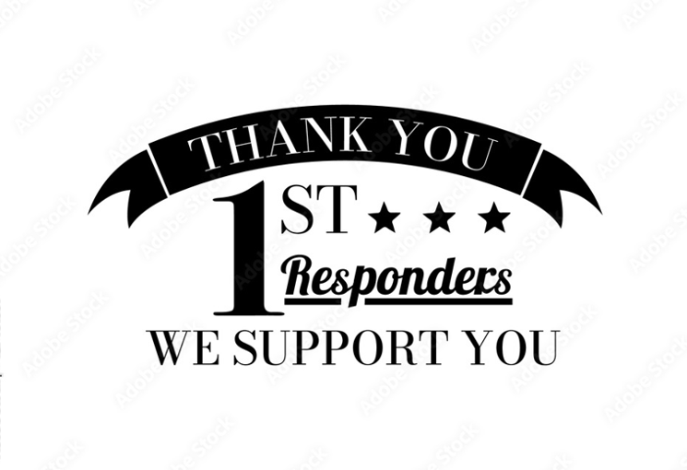

American Legion Post 112
General Membership Meeting
11/27/2025
NO MEETING THIS MONTH



American Legion Post 112
General Membership Meeting
12/25/2025

NO MEETING THIS MONTH



American Legion Post 112
General Membership Meeting
01/29/2026

Call to Order: The meeting was called to order at 6:00 pm. The Chaplain gave an opening prayer/invocation. With the colors in place, the flag was honored, and the Pledge of Allegiance was recited.

POW/MIA: The Sgt-at Arms placed the POW/MIA Flag on the empty chair, and we held a moment of silence.

Preamble: Members recited the preamble.

Roll Call: - No absences.

Minutes from the last meeting: Minutes of the 10-23-2025 General Membership meeting were read and approved by a show of hands.

Finance Report: Finance Reports for the months of November and December were given and approved by a show of hands.

OLD BUSINESS: There was no Old Business.

NEW BUSINESS:

- Membership & Honor Guard: Bryan Matthews, Craig Denbleyker, and Steven Johnson were sworn in as new members and volunteered to become the newest members of the Honor Guard.

Birthdays: We celebrated with members who had birthdays in November, December, and January.

Raffle: Six names were drawn and were awarded $50.00 each.

ANNOUNCEMENTS

- District 7 Oratorical Contest will be held at Post 112, Saturday, February 7, 2026, at 10:00 am.

- A Special Election Congressional District 14 & City of Dalton Candidate Forum will be held at Post 112, Saturday, February 14, 2026, at 4:00 pm.

Meeting Adjournment: The Chaplain gave a closing prayer. With the colors in place, the flag was honored. The meeting adjourned at 6:35 pm and a meal was served.

American Legion Post 112
General Membership Meeting
02/26/2026

Call to Order: The meeting was called to order at 6:00 pm. The Chaplain gave an opening prayer/invocation. With the colors in place, the flag was honored, and the Pledge of Allegiance was recited.

POW/MIA: The Sgt-at Arms placed the POW/MIA Flag on the empty chair, and we held a moment of silence.

Preamble: Members recited the preamble.

Roll Call: - Jr Vice Commander/Judge Advocate Ed Shiver was absent.

Minutes from the last meeting: Minutes of January 29, 2026, General Membership meeting were read and approved by a show of hands.

Finance Report: The Finance Report for the month of January was read and approved by a show of hands.

OLD BUSINESS: There was no Old Business.

NEW BUSINESS:

1. Oratorical Contest: Jackson Brown, Post 112, and District 7 contest winner gave his oration to the General Membership. Jack Staples, District 7 Commander, presented Jackson with a $400 scholarship. Jackson will advance to the Area Contest representing District 7. After the presentation Jack announced that he is stepping down as our District Commander and John Fortune is the interim District Commander.

2. League of Women Voters: Shannon Bearfield briefed the trip to the State Capitol with 13 students from Dalton High, Dalton Academy, and Northwest High School. She thanked Post 112 for the use of the bus and Lee Oliver for driving the group.

3. Election: The Commander reminded everyone that Post Officer elections will be held in May and if anyone is interested in running for office to let him know so we can get their names on the ballot.

4. Veterans Resource Fair: Post 112 will host a Veterans Resource Fair, Monday, March 9, 2026, from 4:00 pm – 7:00 pm.

Birthdays: We celebrated with members who had birthdays in February.

Raffle: Two (2) names were drawn and were awarded $50.00 each.

Meeting Adjournment: The Chaplain gave a closing prayer. With the colors in place, the flag was honored. The meeting adjourned at 6:45 pm and a meal was served.

American Legion Post 112
General Membership Meeting
03/26/2026

Call to Order: The meeting was called to order at 6:00 pm. The Chaplain gave an opening prayer/invocation. With the colors in place, the flag was honored, and the Pledge of Allegiance was recited.

POW/MIA: The Sgt-at Arms placed the POW/MIA Flag on the empty chair, and we held a moment of silence.

Preamble: Members recited the preamble.

Roll Call: - No absences

Minutes from the last meeting: Minutes of February 26, 2026, General Membership meeting were read and approved by a show of hands.

Finance Report: The Finance Report for the month of February 2026 was read and approved by a show of hands.

OLD BUSINESS:

1. Post 112 & District 7 Oratorical Contest. The Adjutant recognized Dalton Acdemy JROTC for their support as ushers and escorts during the Oratorical Contest. Each cadet was presented with a Certificate of Appreciation and a “Thank You” coin.

NEW BUSINESS:

1. Humana Health Care. Selena Sumter, a Humana Health Care Representative, addressed the membership and explained how Social Security, Medicate, Tricare programs work for the veterans and provided one-on-one conversations with everyone interested in signing up for Humana Health Care.

2. General Election. The Commander reminded everyone that the election of Officers is in May and anyone wanting to get involved, get with him to get their names on the ballot.

3. American Legion Birthday. We will celebrate the American Legion’s 107th Birthday Sunday, March 29, 2026. Post 112 will provide fried chicken and members ae asked to bring a “potluck” dish.

4. Military Signing Ceremony. There will be a Military Signing Ceremony at Northwest High School April 29, 2026, at 4:00 pm.
.
Birthdays: We celebrated one birthday in March.

Raffle: One name was drawn and won $50.00.

Meeting Adjournment: The Chaplain gave a closing prayer. With the colors in place, the flag was honored. The meeting adjourned at 6:45 pm and a meal was served.

American Legion Post 112
General Membership Meeting
04/30/2026

Call to Order: The meeting was called to order at 6:05 pm. The Chaplain gave an opening prayer/invocation. With the colors in place, the flag was honored, and the Pledge of Allegiance was recited.

POW/MIA: The Sgt-at Arms placed the POW/MIA Flag on the empty chair, and we held a moment of silence.

Preamble: Members recited the preamble.

Roll Call: - Sr. Vice Commander Lee Oliver was absent.

Minutes from the last meeting: Minutes of February 26, 2026, General Membership meeting were read and approved by a show of hands.

Finance Report: The Finance Report for the month of February 2026 was read and approved by a show of hands.

OLD BUSINESS – There was no old business.

NEW BUSINESS:

1. Election. Candidates were introduced and allowed to speak to the members. The Commander announced that officer elections would take place on May 28, 2026, with voting scheduled between 5:00 pm and 7:00 pm, and a meal will be provided. John Czerneski asked if any other members wanted to run before making a motion to close the ballot. Ernie Oventrop seconded the motion, and the ballot was closed without further discussion.

2. Legionnaire of the Year. The Legionnaire of the Year nomination form is now available. All nominations should be submitted to the Commander no later than June 15, 2026.

3. Membership Drive. A membership drive is scheduled for Saturday, May 2, 2026, at Food City on Walnut Ave from 10:00am to 2:00pm. Ernie Oventrop requested volunteers to help with the event.

4. Law Cadet Academy. This year’s Law Cadet Academy is scheduled for June 8–13, 2026. Steven Johnson reported that 29 cadets are enrolled and requested veterans to visit during lunch to speak with them.
.
Birthdays: We celebrated the birthdays of 3 members.

Raffle: Winners were Ed Shiver and Bob Oxford.
Meeting Adjournment: The Chaplain gave a closing prayer. With the colors in place, the flag was honored. The meeting adjourned at 7:15 pm and a meal was served.

American Legion Post 112
General Membership Meeting
05/28/2026
NO MEETING

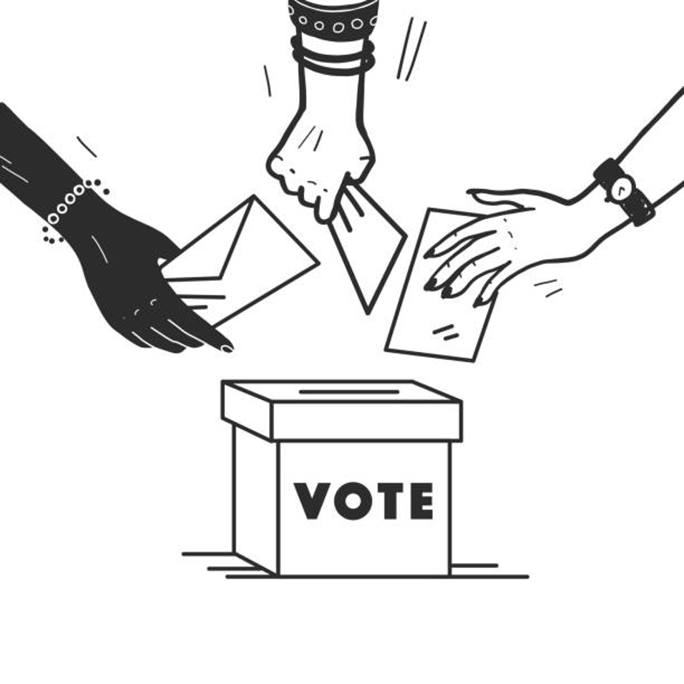

ELECTION NIGHT
2026-2027 POST OFFICERS

APPENDIX XIV
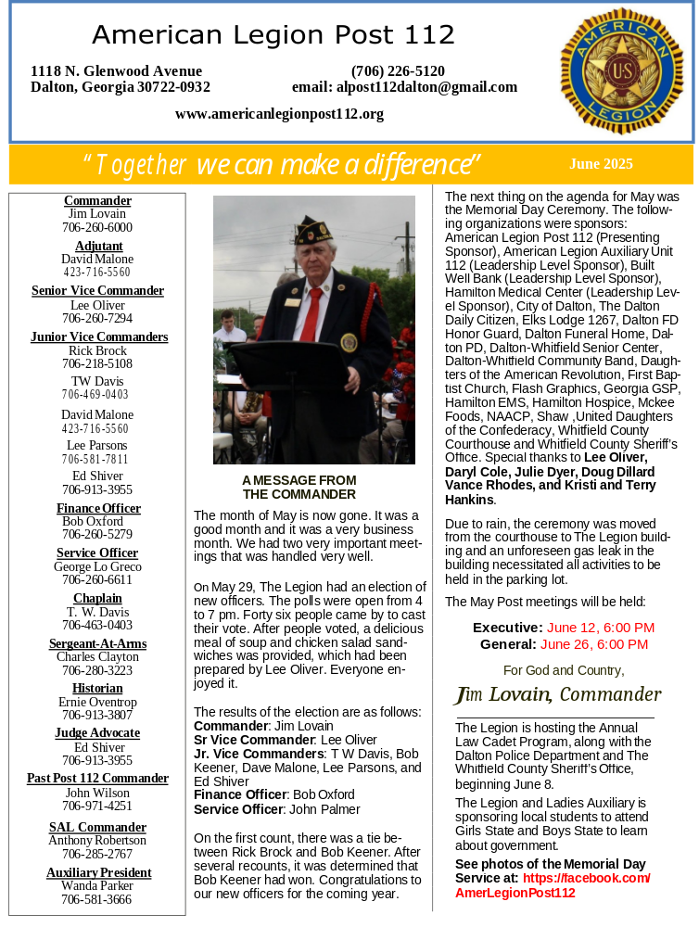
MONTHLY NEWSLETTERS

